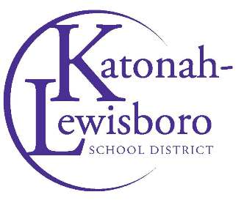

Contact: Sarah Studley
sstudley@syntaxny.com

John Jay Spirit Soars at Spring JayFest
John Jay High School athletic teams hosted a number of events from April 15-16

John Jay High School celebrated its 19th annual JayFest spring event on April 15 and 16 with a lineup of home athletic contests that brought out school spirit all weekend long.
Friday’s events included the John Jay Spring Track Invitational and a varsity men’s tennis match. On Saturday, fans enjoyed junior varsity and varsity men’s and women’s lacrosse, junior varsity tennis, junior varsity and varsity baseball, and junior varsity and varsity softball matches throughout the day.

Photo Captions: The John Jay High School community celebrated its school spirit during JayFest from April 15 to 16.

Photos courtesy of the Katonah-Lewisboro School District

