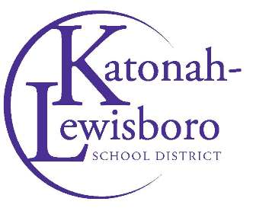

Contact: Sarah Studley
sstudley@syntaxny.com

JJMS MathCounts Places Third at Tournament of Champions
The MathCounts team competed against teams from across the tri-state area

John Jay Middle School’s MathCounts team represented the school well with an impressive third-place finish at the Museum of Mathematics Tri-State Area Tournament of Champions in May.
“The JJMS team of Matthew Collins, Stone Fenton, Jonathan Frantz and Raymond Zou bested 10 other schools that had won their county chapters from New York, New Jersey and Connecticut earlier this spring,” said team advisor James Edgeler, a seventh-grade math teacher.

Photo Caption: John Jay Middle School’s MathCounts team represented the district at the Museum of Mathematics Tri-State Area Tournament of Champions, ending with a third-place finish.

Photo Courtesy of the Katonah-Lewisboro School District

