SAFETY DATA SHEET
according to 1907/2006/EC, Article 31
Page 1/6
Screenwash Ready To Use
Revision 1
Revision date 2016-04-27
SECTION 1: Identification of the substance/mixture and of the company/undertaking
1.1. Product identifier
Product name Screenwash Ready To Use
1.2. Relevant identified uses of the substance or mixture and uses advised against
Product Use [SU21] Consumer uses: Private households (= general public = consumers); [PC4] Anti-Freeze
and de-icing products;
1.3. Details of the supplier of the safety data sheet
Company Active Brand Concepts Limited
Address The Forge
Crewe Hall Farm
Crewe
CW1 5UE
Web www.homecareproducts.co.uk
Telephone 0844 335 0816
Fax 0844 335 0854
Email sales@active-brand-concepts.com
Email address of the sales@active-brand-concepts.com
competent person
Local Supplier
Company Bulk Products Ltd
Address Unit 2 Marshfield Bank
Middlewich Road
Crewe
Cheshire
CW2 8UY
United Kingdom
Web www.homecareproducts.co.uk
Telephone 0844 335 0816
Fax 0844 335 0854
Email sales@active-brand-concepts.com
Email address of the sales@active-brand-concepts.com
competent person
1.4. Emergency telephone number
Emergency telephone number 08443350816
Company James Sharpe
8.30 - 5
SECTION 2: Hazards identification
2.1. Classification of the substance or mixture

Copyright © 2016 ChemSoft Limited. All rights reserved. Powered by Print date 2016-04-27

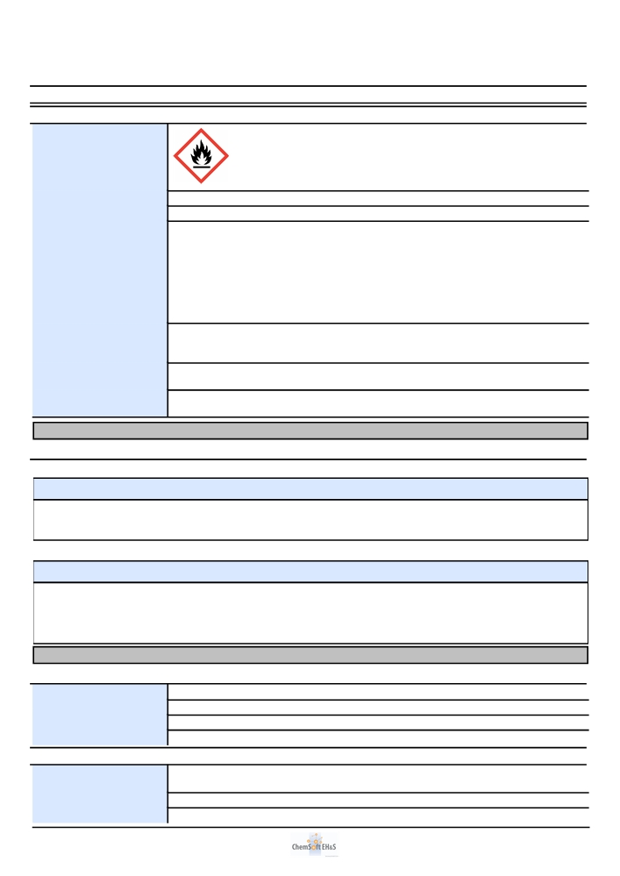
Page 2/6
Screenwash Ready To Use
Revision 1
Revision date 2016-04-27
2.1. Classification of the substance or mixture
2.2. Label elements
Hazard pictograms

Signal Word
Hazard Statement
Precautionary Statement: Prevention

Precautionary Statement: Response

Precautionary Statement: Storage
Precautionary Statement: Disposal

Warning
Flam. Liq. 3: H226 - Flammable liquid and vapour.
P210 - Keep away from heat, hot surfaces, sparks, open flames and other ignition sources. No smoking.
P233 - Keep container tightly closed.
P240 - Ground/bond container and receiving equipment.
P241 - Use explosion-proof electrical/ventilating/lighting// equipment. P242 - Use only non-sparking tools.
P243 - Take precautionary measures against static discharge.
P280 - Wear protective gloves/protective clothing/eye protection/face protection.
P303+P361+P353 - IF ON SKIN (or hair): Take off immediately all contaminated clothing. Rinse skin with water/shower.
P370+P378 - In case of fire: Use to extinguish.
P403+P235 - Store in a well-ventilated place. Keep cool.

P501 - Dispose of contents/container to

SECTION 3: Composition/information on ingredients
3.2. Mixtures
67/548/EEC / 1999/45/EC
Chemical Name Index No. CAS No. EC No. REACH Registration Conc. Classification M-factor.
Number (%w/w)
Isopropanol (Propan-2-ol) 603-117-00-0 67-63-0 200-661-7 1 - 10% F; R11 Xi; R36 R67

Methanol 603-001-00-X 67-56-1 200-659-6 1 - 10% F; R11 T;
R23/24/25-39/23/24/25
EC 1272/2008
Chemical Name Index No. CAS No. EC No. REACH Registration Conc. Classification M-factor.
Number (%w/w)
Isopropanol (Propan-2-ol) 603-117-00-0 67-63-0 200-661-7 1 - 10% Flam. Liq. 2: H225; Eye Irrit.
2: H319; STOT SE 3: H336;
Methanol 603-001-00-X 67-56-1 200-659-6 1 - 10% Flam. Liq. 2: H225; Acute
Tox. 3: H331; Acute Tox. 3:
H311; Acute Tox. 3: H301;
STOT SE 1: H370;
SECTION 4: First aid measures
4.1. Description of first aid measures
Inhalation Move the exposed person to fresh air.
Eye contact Rinse immediately with plenty of water for 15 minutes holding the eyelids open.
Skin contact Wash off immediately with plenty of soap and water. Remove contaminated clothing.
Ingestion DO NOT INDUCE VOMITING.
4.2. Most important symptoms and effects, both acute and delayed
Inhalation Harmful by inhalation. Inhalation may cause nausea and vomiting. May cause dizziness and
headache.
Eye contact May cause irritation to eyes.
Skin contact May cause irritation to skin. May cause dermatitis.

Copyright © 2016 ChemSoft Limited. All rights reserved. Powered by

Print date

2016-04-27

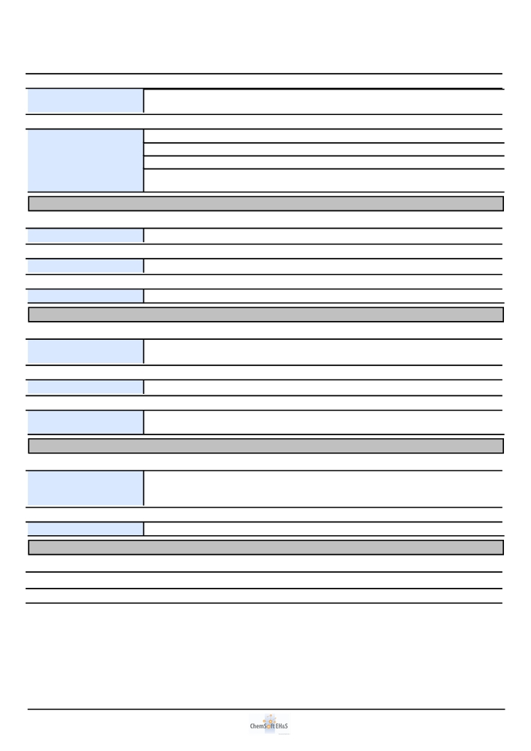
Page 3/6
Screenwash Ready To Use
Revision 1
Revision date 2016-04-27
4.2. Most important symptoms and effects, both acute and delayed
Ingestion Harmful by inhalation and if swallowed. Ingestion may cause nausea and vomiting. Ingestion is
irritating to the respiratory tract and may cause damage to the central nervous system.
4.3. Indication of any immediate medical attention and special treatment needed
Inhalation Seek medical attention.
Eye contact Seek medical attention if irritation or symptoms persist.
Skin contact Seek medical attention if irritation or symptoms persist.
Ingestion If swallowed, do not induce vomiting: seek medical advice immediately and show this container or
label.
SECTION 5: Firefighting measures
5.1. Extinguishing media
Use as appropriate: Carbon dioxide (CO2), Dry chemical, Foam.
5.2. Special hazards arising from the substance or mixture
. Burning produces irritating, toxic and obnoxious fumes.
5.3. Advice for firefighters
Wear suitable respiratory equipment when necessary.
SECTION 6: Accidental release measures
6.1. Personal precautions, protective equipment and emergency procedures
Ensure adequate ventilation of the working area. Eliminate all sources of ignition. Wear suitable protective equipment.
6.2. Environmental precautions
Do not allow product to enter drains. Prevent further spillage if safe.
6.3. Methods and material for containment and cleaning up
Absorb with inert, absorbent material. Transfer to suitable, labelled containers for disposal. Clean spillage area thoroughly with plenty of water.
SECTION 7: Handling and storage
7.1. Precautions for safe handling
Avoid contact with eyes and skin. Ensure adequate ventilation of the working area. Use explosion proof equipment. Keep away from sources of ignition - No smoking. Adopt best Manual Handling considerations when handling, carrying and dispensing.
7.2. Conditions for safe storage, including any incompatibilities
Keep in a cool, dry, well ventilated area. Keep containers tightly closed.
SECTION 8: Exposure controls/personal protection
8.1. Control parameters

8.1.1. Exposure Limit Values

Copyright © 2016 ChemSoft Limited. All rights reserved. Powered by Print date 2016-04-27

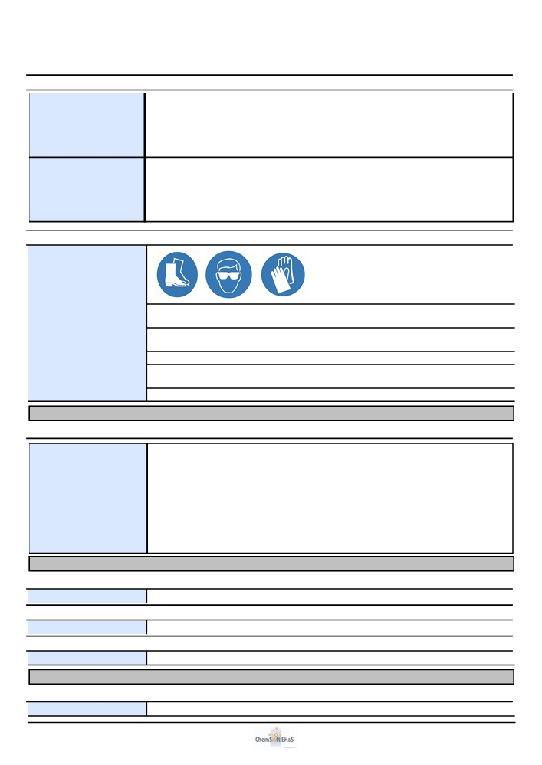
Page 4/6
Screenwash Ready To Use
Revision 1
Revision date 2016-04-27
8.1.1. Exposure Limit Values
Isopropanol (Propan-2-ol) WEL 8-hr limit ppm: 400 WEL 8-hr limit mg/m3: 999
WEL 15 min limit ppm: 500 WEL 15 min limit mg/m3: 1250
WEL 8-hr limit mg/m3 total - WEL 15 min limit mg/m3 total -
inhalable dust: inhalable dust:
WEL 8-hr limit mg/m3 total - WEL 15 min limit mg/m3 total -
respirable dust: respirable dust:
Methanol WEL 8-hr limit ppm: 200 WEL 8-hr limit mg/m3: 266
WEL 15 min limit ppm: 250 WEL 15 min limit mg/m3: 333
WEL 8-hr limit mg/m3 total - WEL 15 min limit mg/m3 total -
inhalable dust: inhalable dust:
WEL 8-hr limit mg/m3 total - WEL 15 min limit mg/m3 total -
respirable dust: respirable dust:

8.2. Exposure controls

8.2.1. Appropriate engineering
controls
8.2.2. Individual protection measures
Eye / face protection
Skin protection -
Handprotection
Respiratory protection

Ensure adequate ventilation of the working area.

Wear chemical protective clothing.

Approved safety goggles.
Chemical resistant gloves (PVC).

Self-contained breathing apparatus. Wear protective clothing.

SECTION 9: Physical and chemical properties

9.1. Information on basic physical and chemical properties

Appearance Liquid
Colour Blue
Odour Alcoholic
pH ± 7.5
Initial boiling point = 92 °C
Flash point = 58 °C
Relative density ± 0.985 (H2O = 1 @ 20 °C)
Viscosity ± 10 mPas (Cone & Plate)
Solubility Soluble in water
SECTION 10: Stability and reactivity
10.2. Chemical stability
Stable under normal conditions.
10.3. Possibility of hazardous reactions
Oxidising agents.
10.4. Conditions to avoid
Heat, sparks and open flames.
SECTION 11: Toxicological information
11.1.4. Toxicological Information
No data available

Copyright © 2016 ChemSoft Limited. All rights reserved. Powered by Print date 2016-04-27

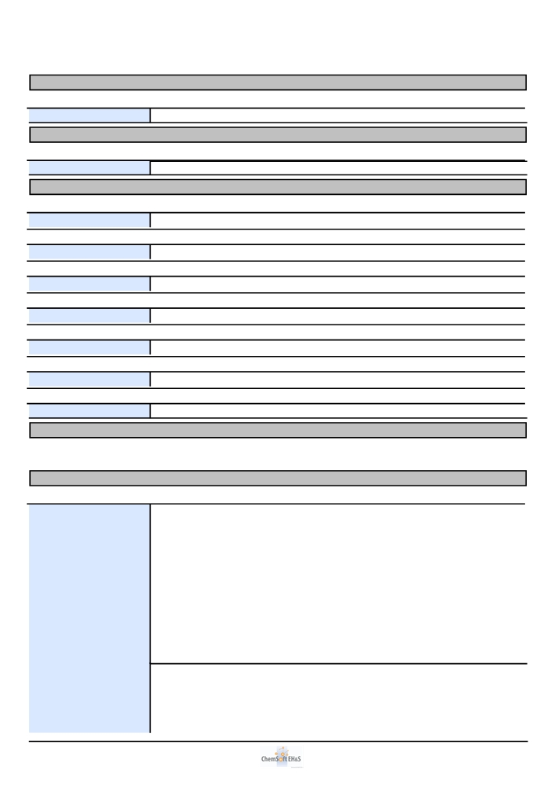
Page 5/6
Screenwash Ready To Use
Revision 1
Revision date 2016-04-27
SECTION 12: Ecological information
12.1. Toxicity
No data available
SECTION 13: Disposal considerations
General information
Dispose of in compliance with all local and national regulations.
SECTION 14: Transport information
14.1. UN number
The product is not classified as dangerous for carriage.
14.2. UN proper shipping name
The product is not classified as dangerous for carriage.
14.3. Transport hazard class(es)
The product is not classified as dangerous for carriage.
14.4. Packing group
The product is not classified as dangerous for carriage.
14.5. Environmental hazards
The product is not classified as dangerous for carriage.
14.6. Special precautions for user
The product is not classified as dangerous for carriage.
14.7. Transport in bulk according to Annex II of MARPOL 73/78 and the IBC Code
The product is not classified as dangerous for carriage.
SECTION 15: Regulatory information

SECTION 16: Other information
Other information
Revision This document differs from the previous version in the following areas:.
1 - Product Use.
2 - 2.1. Classification of the substance or mixture. 2 - 2.1.2. Classification - EC 1272/2008.
2 - Hazard pictograms.
2 - Signal Word.
2 - Precautionary Statement: Prevention. 2 - Precautionary Statement: Response. 2 - Precautionary Statement: Storage.
2 - Precautionary Statement: Disposal. 12 - 12.1. Toxicity.
15 - Labelling.
15 - Risk phrases.
15 - Safety phrases.
Text of risk phrases in Section R11 - Highly flammable.
3 R23/24/25 - Toxic by inhalation, in contact with skin and if swallowed.
R36 - Irritating to eyes.
R39/23/24/25 - Toxic: danger of very serious irreversible effects through inhalation, in contact with skin and if swallowed.
R67 - Vapours may cause drowsiness and dizziness.

Copyright © 2016 ChemSoft Limited. All rights reserved. Powered by Print date 2016-04-27

Page 6/6
Screenwash Ready To Use
Revision 1
Revision date 2016-04-27
Other information

Text of Hazard Statements in Section 3
Flam. Liq. 2: H225 - Highly flammable liquid and vapour.
Eye Irrit. 2: H319 - Causes serious eye irritation.
STOT SE 3: H336 - May cause drowsiness or dizziness. Acute Tox. 3: H301 - Toxic if swallowed.
Acute Tox. 3: H311 - Toxic in contact with skin.
Acute Tox. 3: H331 - Toxic if inhaled.
STOT SE 1: H370 - Causes damage to organs .

Further information
The information supplied in this Safety Data Sheet is designed only as guidance for the safe use, storage and handling of the product. This information is correct to the best of our knowledge and belief at the date of publication however no guarantee is made to its accuracy. This information relates only to the specific material designated and may not be valid for such material used in combination with any other materials or in any other process.

Copyright © 2016 ChemSoft Limited. All rights reserved. Powered by Print date 2016-04-27

