ow to Enter your teams/individuals availability:

Availability can be used to help other teams create challenges that meet your needs. In one example let’s say I want to reserve Saturday’s for a date with my wife and actually not play pickleball. (ugggghhhh)
I would mark Saturday as a day that our team is not available.

Here are the steps to enter your availability:

- Go to the GPN website on your phone or computer/ipad/mainframe whatever you use. Use the following website: EVPC Fall Flex League - Pickleball Event (globalpickleball.network)
- Select the league(s) you are playing in. In my case I would select the Mixed Doubles 3.5-4.0.

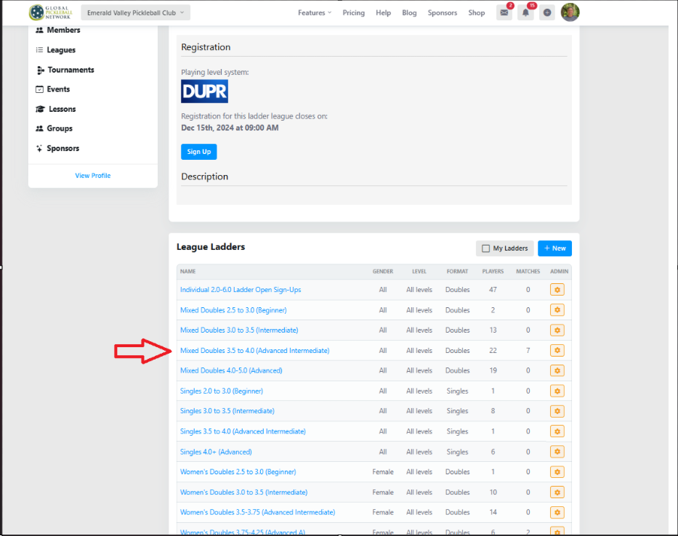

- This takes you to the Main page of your ladder. Look for the Blue “Ladder Menu” Button at the top right and press this button.
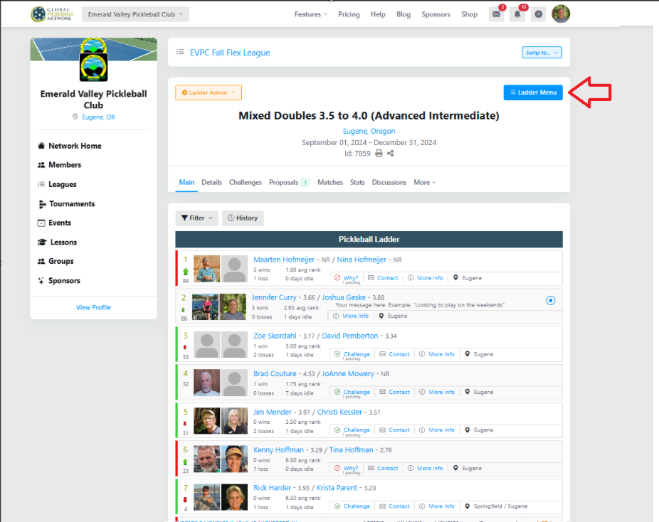

- On a computer this will open a new window to the right. On your phone it will be a window that covers your screen. In this window look for the “Dashboard” blue link at the top right and click it.

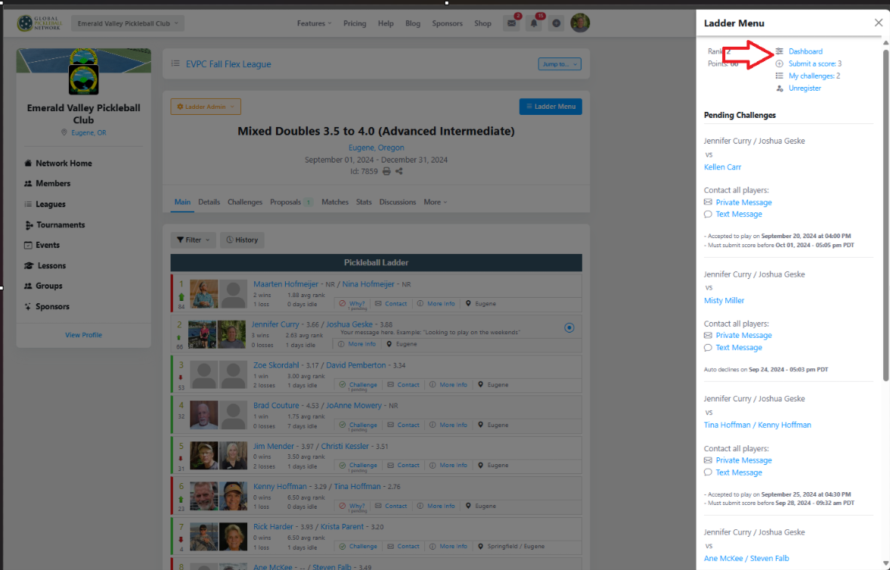

- This opens the availability window. Here you can enter when you and your teammate are available. You can also enter some other information like “Home Court” or if you are going to be unavailable for a specific time frame. Here is what Jenn Curry and I put for ours.
