
Dynamic Universal Pickleball Rating®

Understanding DUPR Ratings

______________________________________________________

For Use by Members of the E-Town DUPR® Group



Based on Postings From DUPR® Analytics Articles
Prepared By State of Franklin Pickleball


February 11, 2025

Contents
Introduction 1
Typical Questions* 1
Factors Considered For A DUPR Rating* 3
DUPR Compared To Other Pickleball Ratings* 3
DUPR Rating Qualifications* 4
How To Obtain A DUPR Rating* 4
Impact of Matches with Non-Rated (NR) Players* 4
DUPR Results Type* 4
Ratings Impact With Type of Match* 5
DUPR Posting Tips* 5
Rating Movement From A Match Result* 5
Rating Decrease After A Win* 6
DUPR Changes With Idle Play* 6
Difference In Partner Changes* 6
Impact of Withdrawals and Forfeits* 6
DUPR Ratings Growth+ 6
DUPR Reliability Score* 7
Passing Reliability Score* 8
Reliability Score Over Time* 8
Reliability Score Enhancement* 8
Achieving A 80% Reliability Score And Progress To 100* 9
DUPR GENIE+ 11
APPENDIX - Composing a DUPR Rating+ 12

Introduction
The DUPR® (Dynamic Universal Pickleball Rating) system utilizes a modified Elo algorithm to determine player ratings based on their performance. The DUPR rating system is becoming the most widely recognized pickleball rating system, and is used by many local ladders, leagues, and tournaments to place players in the appropriate divisions that will provide the best competition. The value of a rating is that it allows you to seek out competition close to your level and provides a basis for measuring your improvement. Leagues, ladders and tournaments are all better when the matches are competitive. The directors of these events can automatically submit results to DUPR, or you can submit your recreation results yourself. (Director submitted results have more weight than self-submitted results)

True tournament players represent about 3% of the total playing population. A guess is that tournament players might only want tournament results reflected in their rating. Players that do not play in tournaments might have to depend on these tournament players to provide a benchmark for their ratings, however, tournament players might not want their recreational play reflected in their ratings, thus raising the issue of the best way for non-tournament players to obtain an initial rating.

Below are some typical questions asked by players new to DUPR, followed by an in depth discussion about DUPR.

Typical Questions*

Qualify For A Rating
Question: Who can have a DUPR rating?
Answer: DUPR is free, and anyone can have a rating.

Getting Started:
Question: How do I get my first rating as a DUPR user?
Answer: Play a match. Once you've recorded your first game on DUPR, your rating will be generated based on factors like the skill level of your opponents and the outcome of the match.

Minimum Points
Question: What is the minimum number of points needed for a result to count for DUPR?
Answer: One player/team must score six points for a match to count towards DUPR, i.e. 3-6.

Type of Match Impacts
Question: Which matches impact my rating more?
Answer: Tournament, club, and league matches impact your rating more than self-posted scores. The greater number of sets in matches also wields a more significant influence on your rating.
The more expected a match result is, the less it will impact your rating. For example, if you win as the favorite, you will go up less than if you win as the underdog. It is encouraged that you play against similarly rated players, which gives both teams the opportunity to have a bigger impact with a win.

Playing Partners:
Question: Who should I play with to get an accurate rating?
Answer: Playing with rated players is ideal. However, playing with unrated players is still beneficial, even though it is less precise. The more matches you play, the more accurate your rating becomes.

Match Count:
Question: How many matches do I need to play for an accurate rating?
Answer: Aim for at least 10 to 20 matches. Quality matters too; ensure you're playing at the right level and experiencing a mix of wins and losses in close games.

Playing Dynamics:
Question: Can my rating go down if I win?
Answer: No, winning ensures your rating won't decrease. However, the magnitude of rating changes depends on factors like the disparity between player ratings and the match outcome.

Fair Play:
Question: How do I handle concerns about playing with unrated players?
Answer: DUPR considers the reliability of players based on factors like match count and recency. Playing with unrated players won't negatively impact your rating significantly.

Strategy Matters:
Question: Should I aim to beat lower-rated players to boost my rating?
Answer: While winning against lower-rated players will increase your rating, the most significant improvements come from competitive games against opponents at or slightly above your level.

Recording Matches:
Question: What if my match partner or opponents refuses to validate scores?
Answer: It's crucial to uphold fair play standards. Communicate with them beforehand and report any violations to DUPR for investigation.

Club Participation:
Question: How can joining a DUPR club benefit my rating?
Answer: Club matches provide consistent opportunities to play at a competitive level, contributing to the accuracy of your rating with verified match results.

Match Dynamics:
Question: How does match format (e.g., one game vs. best two out of three) affect my rating?
Answer: Longer match formats yield more data and have a greater impact on your rating, as they provide a better indication of your skill level.

Past Results:
Question: Can I input past match results to improve my rating?
Answer: Yes, past results can be added to your profile, but recent matches hold more weight in determining your current rating.

Rating Decay:
Question: What happens if I stop playing and logging matches?
Answer: Your rating remains stable, but the reliability of your rating decreases over time due to the decay of match recency. Returning to regular match logging will restore reliability.

DUPR Changes with Idle Time
Question: Can My DUPR Change Even Though I Haven’t Been Playing?
Answer: Changes in your DUPR rating can sometimes be unexpected and confusing. Your rating reflects your performance and can fluctuate due to various factors. In this article, we'll explain why your rating might change and how you can keep track of these changes to better understand your overall performance.

Match Impact
Question: How Can I Expect My Rating to Move from A Match?
Answer: The extent to which your rating changes after a match depends on various factors. Matches against opponents with well-established and reliable ratings can affect your rating differently than matches against newer or less consistent players. Moreover, the nature of the match—whether it's a casual game or a competitive event like a club match or tournament—also plays a role in how your rating adjusts.

Change Relative to Partner
Question: Can A Match Change My Partner and I’s Rating Different Amounts?
Answer: YES. You will both move up or down, but the amount could differ depending on each player’s match count and recency. If you are both consistently logging matches, you should not expect your rating to move too differently from the new match result.
For further insights into match count and recency, please look at this blog created by Scott Mendelssohn, our Head of Analytics.

DUPR Relative To Other Systems
Question: Why is DUPR better than other Pickleball Ratings?
Answer: DUPR is the only system that considers all results for each player, coming from different sources.

Withdrawals
Question: How does withdrawing affect my DUPR?
Answer: Withdrawals/forfeits do not affect your DUPR rating.

Factors Considered For A DUPR Rating*
DUPR considers various factors to ensure a fair and accurate reflection of a player's skill level.
The algorithm considers the following factors:
- Result: Whether you won or lost. If you win, your rating will go up and if you lose, your rating will go down. One player/team must score six points for a match to count towards DUPR, (e.g., 6-3).
2. Type of match: Whether this was a self-posted match, a club match, or a tournament result entered by DUPR. Self-posted matches will count less towards your rating change.
3. Rating Difference of Opponent: Were you the favorite or an underdog. If your opponent is higher rated than you and you win, you’ll increase more than if your opponent is lower rated and vice versa.
4. Match Score: How closely contested was the match. If you win by a large margin, you will go up more than if you barely close out your opponent.
5. Match Count: Have you played a lot of matches. If you have a lot of matches, each match will move you less than if you only have a few matches.
6. Recency: How recent are your matches. The more recent matches you have the better your rating represents your current playing ability.

A more detailed example of how these factors interact is shown in the APPENDIX.

Below is a visual guide to help identify skill levels based on DUPR rating.
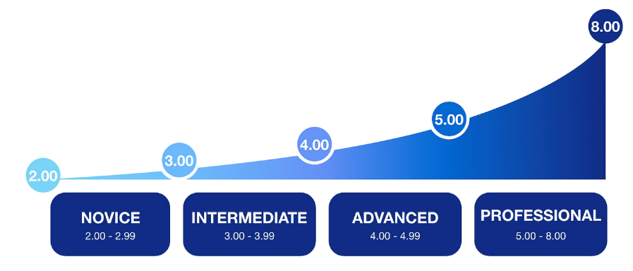

DUPR Compared To Other Pickleball Ratings*
DUPR claims statistically to be the most accurate Pickleball rating system in the world and the only Universal system, meaning that all players regardless of their age, gender or skill are on the same scale. DUPR is the only system that features a Reliability Score, that doubly ensures fair play and no “sandbagging”. DUPR is the only system that considers all results for each player, coming from different sources.

DUPR appears to be the winner in the ratings war with their large marketing campaign, tied in with star players and sponsorships, with tournaments listed in pickleballtournaments.com and picklebrackets.com starting to use it to set brackets.

The PPA said that they will use DUPR as the deciding factor in setting tournaments playing levels. The competing APP (not PPA) have announced a partnership with Universal Tennis to become its new Official and Exclusive Ratings Partner. They are going to create a new pickleball player rating system, the UTRP, modeled after the tennis rating system (UTR).

DUPR Rating Qualifications*
DUPR is free and anyone can have a rating. One match result is all it takes to have a DUPR rating, and with 10-20 match results you will have an even more accurate rating. If you’ve ever played in a Pickleball tournament, you might already have a DUPR rating and can claim your account by going to MyDUPR.com or by downloading the DUPR app in iOS or Android. If you do not have an account, you can register for an account at MyDUPR.com.

How To Obtain A DUPR Rating*
There's no longer a waiting period to receive your DUPR rating. Immediately after your first valid match is entered into the system, you will receive a rating reflective of your performance against rated players. This initial rating is just the beginning of your rating journey on DUPR. As you play more matches, your rating may fluctuate. This fluctuation is a normal part of the process as the system begins to understand your skill level better. Your rating will adjust based on the outcomes of your matches (victories will increase your rating, and losses will cost you points) and will start to stabilize once you are consistently logging matches., The maximum increase or decrease for self-posted matches is calculated for each game played in the match. This can lead to a scenario where your rating may decrease even after a win the overall match but has lost games during the match. Consistently playing above your level will still move your rating up as the algorithm learns your skill level increases.

Impact of Matches with Non-Rated (NR) Players*
The impact on established player’s rating from matches against unrated players will be minimal, regardless of the match outcome. Given that unrated players lack a match history, these matches carry less weight compared to those played against other rated players. Higher rated players are encourage to engage with new and unrated players to help them embark on their DUPR journey. This inclusive approach not only fosters community growth but also assists new players in integrating into the rating system.

The assumption is made that the level of play for NR players is 3.5. Following the match, the ratings are adjusted to reflect the performance shown during the match, with winners rated above 3.5 and losers below, to accurately represent the skill levels demonstrated.

All these decisions ensure that your rating is as accurate and personalized as possible from the start. As you continue to engage in matches, especially against rated players, your rating will become more stable and reflective of your true playing level. Most concerns regarding people's ratings are resolved once they've logged enough matches. If you have a concern regarding your rating, please submit a request (https://dupr.zendesk.com/hc/en-us/requests/new) and DUPR will assist you.

DUPR Results Type*
DUPR match results are categorized into two main types: self-posted/recreational matches and club/tournament/event matches. Each type of match affects your rating differently.

Tournaments, Events, and Club Matches
Matches submitted by third-party sources are automatically validated upon entering DUPR.
You'll notice their impact on your rating is noted in the top right corner of the match. This means that as soon as the match results are submitted to DUPR from these sources, they are considered official and immediately impact your rating.

Self-Posted/Recreational Matches
Matches where players use the "Add A Match" feature must first undergo validation by all players in the match except the player who created the match. Only after all players have validated the match will it officially count on DUPR. When a match is fully validated, the match impact will be found on the top right corner of the match. Until the match is validated, you will see an orange "pending" notice where the match impact is usually located.

Ratings Impact With Type of Match*
Tournament, club, and league matches impact your rating more than self-posted scores. The greater number of games in matches also wields a more significant influence on your rating.
The more expected a match result is, the less it will impact your rating. For example, if you win as the favorite, you will go up less than if you win as the underdog. You are encouraged to play against similarly rated players.

DUPR Posting Tips*
- If you are waiting for the results from a tournament, please contact your tournament director. DUPR no longer accepts missing tournament requests from players. If the results have already been added to DUPR, please contact DUPR for assistance. A bracket might be missing, or your matches may have been added to the incorrect account.
- You can check who still has not validated a match by logging into www.dupr.com through a computer. Players who have validated a match will have a checkmark (✓) next to their names. DUPR DOES NOT VALIDATE SELF-POSTED MATCHES.
- Kindly reach out to someone that has not confirmed your win and request their confirmation. You can reach out to other players by creating a chat on DUPR. You will have the ability to add up to three additional players to this chat.
- Because self-posted matches are not classified as tournament, club or event matches, they have less value in DUPR and must undergo the player validation process. It is recommended that players do not attempt to add their tournament matches through the “Add a match” function.

Rating Movement From A Match Result*
Your DUPR rating is designed to accurately reflect your playing ability and adjusts dynamically with each match you play. When you first start recording matches or return after a long break, you might notice significant changes in your rating. This is because the system is in a calibration phase, adjusting to align with your current skill level.

The influence of each individual match on their rating becomes less pronounced for players that regularly log matches. As the system gathers more data about your performance, the movement from each match played lessens, resulting in a more stable and accurate rating over time. The extent to which your rating changes after a match depends on various factors. Matches against opponents with well-established and reliable ratings can affect your rating differently than matches against newer or less consistent players. Moreover, the nature of the match—whether it's a casual game or a competitive event like a club match or tournament—also plays a role in how your rating adjusts.

Rating adjustments are proportional to the amount of new information the system gains about your playing ability. This approach allows new players to quickly achieve a rating that reflects their true skill level, while providing stability for established players who have logged numerous matches.

Rating Decrease After A Win*
Your rating will not decrease if you win. You will receive a rating increase for each victory. However, the extent of this increase or decrease is influenced by various factors, including your win probability, the reliability of all players involved, the score, the result type, and more.

NOTE: Self-posted matches are evaluated on a per-game basis rather than per-match and can result in a net loss even though you win. Therefore, it is possible to experience a net loss in your rating despite winning more games in a self-posted match. This specific evaluation method applies only to self-posted matches, underscoring the importance of consistent performance across all games to achieve a positive rating outcome.

DUPR Changes With Idle Play*
Changes in your DUPR rating can sometimes be unexpected and confusing. Your rating reflects your performance and can fluctuate due to various factors. Below is an explanation of why your rating might change and how you can keep track of these changes to better understand your overall performance.
A DUPR rating is generated from a formalized algorithm, ensuring that the ratings are as accurate and fair as possible. Ratings live in a dynamic environment, where matches are constantly being added and corrected. It is completely normal for your rating to change over time. Here are some common reasons why your rating might have moved:
A match you played in:
- Was added: Match results are added to the system, which can affect your rating.
- Was deleted: Duplicate match results or incorrect entries might be removed, leading to a change in your rating.
- Had the incorrect score that was corrected: If a match initially had an incorrect score, and it was later corrected, this can impact your rating.
- Had an incorrect player replaced with the correct player: If there was an error in player identification, correcting this can alter the match outcomes and subsequently your rating.
- Had a player who had two accounts that were merged: When a player’s duplicate accounts are merged, it can adjust the match results and affect your rating.

To gain more clarity, you can sort the matches on your DUPR account by match date and modified date. This will help you see which matches have been recently updated and how they might have impacted on your rating. If you have any further questions or need additional assistance, submit a request (https://dupr.zendesk.com/hc/en-us/requests/new) to DUPR support team.

Difference In Partner Changes*
You both move either up or down during a match, but the amount could differ depending on each player’s match count and recency. If you are both consistently logging matches, you should not expect your rating to move too differently from the new match result.

Impact of Withdrawals and Forfeits*
Withdrawals/forfeits do not affect your DUPR rating.
If you notice a match you forfeited/withdrew that shouldn't be in your account please submit a request and DUPR will get it deleted for you.

DUPR Ratings Growth+
Players will know they are at the correct DUPR level when they play players at a certain level and win as many games as they lose. If players are consistently winning at a level, they need to move up. If players are consistently losing at a level, they either need to improve their skills to those of the other players they are playing or move down a level. In the example below, Players A and B both start their ratings journey at 3.5. After 100 matches Player A must play higher rated players before reaching the level that he is winning as much as he is losing settling out at about 4.1. After 100 matches Player B must play lower rated players before reaching the level that he is winning as much as he is losing at about 3.2.

NOTE It is important to note that players that become too protective of their rating might never reach their appropriate level and therefore could be disadvantaged in leagues, ladders and tournaments because they might be playing with players of a different skill level. These players are tending to guard their DUPR as a point of honor and they lose sight of the fact that DUPR is being used to make sure play is competitive.
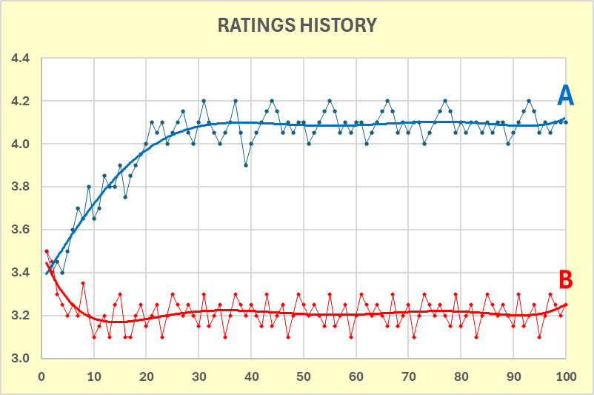

DUPR Reliability Score*
The Reliability Score was developed to enhance the reliability and trustworthiness of player ratings. This guide will help you understand what the Reliability Score is, how it works, and why it's important. The Reliability Score measures the confidence in a player’s rating based on their match history and connectivity to the broader DUPR population. It ranges from 0% to 100%, where 100% means very high confidence that the player’s rating is reliable, and lower percentages indicate less confidence. This score helps ensure that a player’s rating is an accurate representation of their current skill level. Each player will have separate Reliability Scores for singles and doubles. These scores will be displayed alongside, but in smaller font than the main DUPR rating. The following screenshots show how the reliability score is displayed on a player's profile.
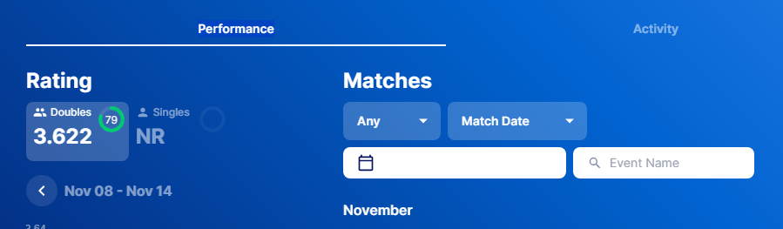
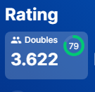

The introduction of the Reliability Score aims to boost confidence and trust in player ratings based on how many matches they have played and their connectivity to the rest of the pickleball population. By establishing a threshold for event entry based on the Reliability Score, it can be ensured that only players with dependable ratings participate, thereby maintaining the integrity of competitions. Additionally, this score encourages users to engage actively with their ratings, motivating them to play more matches and keep their ratings reliable and up to date.

Passing Reliability Score*
A passing Reliability Score is 80%, which is the score DUPR encourage clubs to require for participation in DUPR leagues and tournaments. But achieving this score is just the beginning of the journey as the next step is to aim for a fully reliable rating, which is reached at 100%. This higher score reflects the confidence DUPR has in your rating, ensuring it accurately represents your skill level.

NOTE: The Reliability Score will be updated every Tuesday on a weekly basis. Therefore, if you play your first matches on a Wednesday, your reliability score will not be reflected in your profile until Tuesday of the following week.

Reliability Score Over Time*
Your Reliability Score will typically increase with each match you play. However, the extent of the increase depends on various factors that consider the amount of information gained from the match. The Reliability Score measures DUPR’s confidence that your rating accurately reflects your current skill level. Therefore, if you do not consistently record your matches over time, your reliability score will gradually decline.
Growth Experience:
- Players start with a low reliability score.
- As they play more matches, their reliability score grows quickly up to a certain point (80%).
- After reaching 80%, the score continues to grow but at a slower pace until it hits 100%.
Decay Experience:
- If a player stops playing, their reliability score starts to decay.
- Initially, the decay is slow, but it speeds up as the reliability score drops towards 80%.
- Below 80%, the decay slows down again.

Reliability Score Enhancement*
To enhance the reliability of your rating, the general rule is to play more matches. Both the number and recency of your matches significantly impact your Reliability Score. However, not all matches contribute equally to your rating’s reliability. To make your score more reliable, focus on playing matches that meet the following criteria:
- Play with various partners and opponents: this helps in assessing your skill across different playing styles and strategies.
- Play against similarly rated opponents matches against players of similar skill levels provide more meaningful data for accuracy.
- Play Club/Tournament Matches: these matches are often more competitive and structured, providing better quality data.
- Play against highly reliable players: opponents with high Reliability Scores offer more dependable information for your rating.

Achieving A 80% Reliability Score And Progress To 100*
The DUPR Reliability Score gives players more insight into how close they are to achieving a reliable rating. If your Reliability Score is above 80%, your rating is reliable, and you can be confident that you’ll have competitive experience playing with others at a similar level. If you’re under 80%, whether that’s because you’re a new player, or you haven’t played in a while, it means you have more playing to do. There are a variety of ways to reach a 80% Reliability Score, and, for overachievers, progress from 80% to 100%.
Here are some paths you can take to get a good reliability score. Each match represents one game. Matches with more games will count more and progress you to reliability faster because there will be more information input into the rating system. Remember, the biggest takeaways are playing frequently (and inputting your results!) and playing with a variety of players.

Reliability Progression Paths
Just starting out or have less than 10 games under your belt? Here’s how to get to a reliable rating (80% Reliability Score).
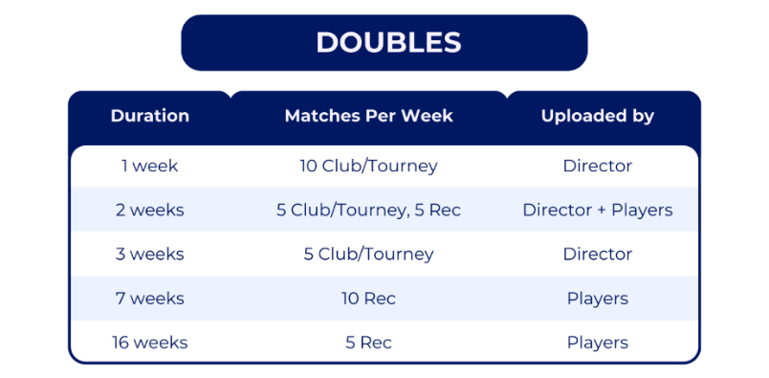
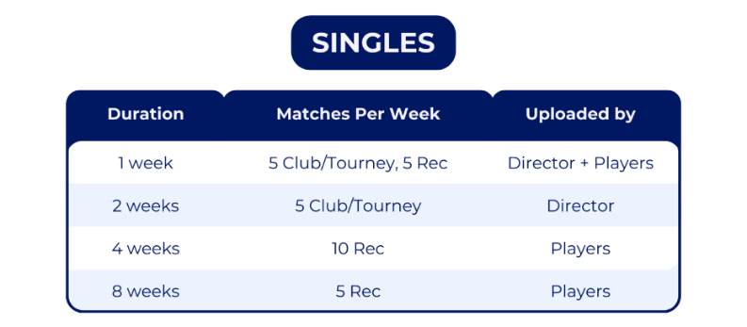
These paths assume the following:
- Opposing player or team ratings are all within 0.5 of your player or team rating.
- Teammates and Opponents are reliable (i.e. have a 80% Reliability Score).
- Matches are with 2 or more unique partners (Doubles only) and against 6 or more unique teams.
- Matches are each one game.

Here’s how to achieve a 100% Reliability Score if you already have a reliable rating.
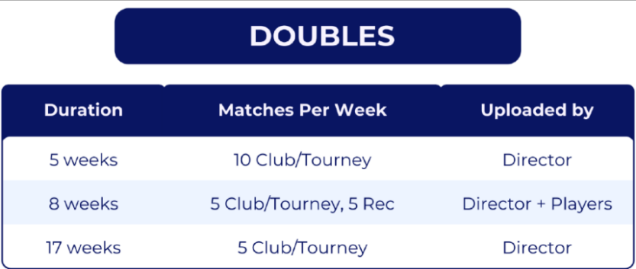

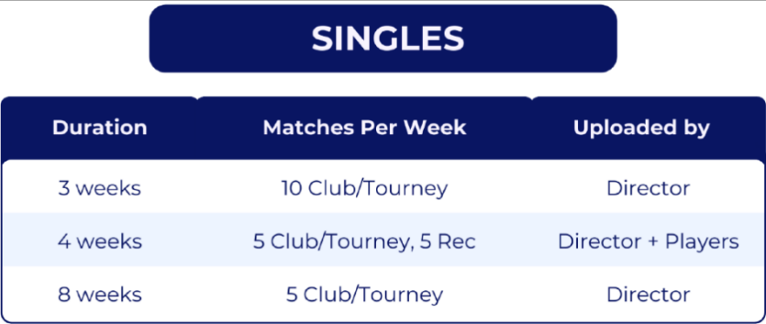

These pathways assume:
- Opposing player or team ratings are all within 0.5 of your player or team rating.
- Teammates and Opponents have a 80% Reliability Score (or higher).
- Doubles matches are with 4 or more unique partners.
- All matches are against 12 or more unique teams.
- Matches are each 1 game.

NOTE: The biggest takeaway is more is better! Play more games, play more with similarly rated players, play more with players who are more reliable than you and play with a wide variety of players. Again, these are the key factors in increasing your Reliability Score.

DUPR GENIE+
DUPR Genie creates theoretical matches so you can see how any match would affect a player’s DUPR Rating. From DUPR.com under “Ratings” select “DUPR Genie”. (See the Composing A DUPR Rating for details on how the changes are constructed)

Consider the following players and teams playing in a tournament. Each player’s current DUPR, games played and ½ Life (explained later) are shown below along with the Team’s starting DUPR and expected win percentage indicating that Team 1 should win based on their higher average DUPR and resulting win percentage (91%).

To use the Genie, enter the following information
- Under “Match Type” you would select “Tournament” (other option is “Recreation”)
- Select the names of each player. Team 1 has Player A1 and A2. Team 2 has Player B1 and B2.
- Enter game score. In this case Team 2 beat Team 1 11-6

As would be expected Team 2 DUPR should go up because they won, and Team 1 should go down. Comparing the changes for each player on a team demonstrates that the more games and more recent games players have results in less dramatic changes in DUPR for any given game.

Team 1 - Player A2 (-.015) went down less than Player A1 (-.024) because Player A2 has more matches (games) and more recent matches (1/2 Life) than Player A1.

Team 2 – Player B2 (+.015) went up less than Player B1(+0.59) because Player B2 has more matches (games) and more recent matches (1/2 Life) than Player B1.

APPENDIX - Composing a DUPR Rating+
Below is an example of how a change in DUPR rating is constructed. The actual coefficients for these factors are a closely held secret, therefore coefficients are assumed in this example

A DUPR rating is schematically determined using the following relation:

NEW DUPR = CURRENT DUPR + (WIN FACTOR) X (TYPE OF RESULTS COEFFICIENT) X (WIN INTENSITY COEFFICIENT) X (RECENCY COEFFICIENT) X (COUNT COEFFICIENT)

CURRENT DUPR – A player’s DUPR going into a match is averaged with their partner’s to determine the starting DUPR for the team.

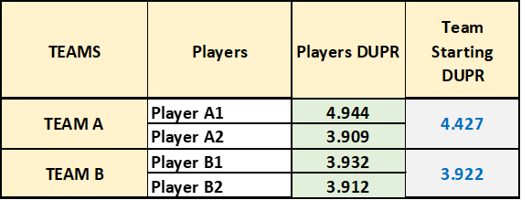

WIN FACTOR – This factor considers whether you won the match. Win you go up. Lose you go down. The value of this factor is determined by the difference in the average ratings of the teams and the resulting probability of each team winning the match.

The probability of winning is determined by the following:
PROBABILITY CALCULATION

PWW = 1
________________
( 1 + 20^{(3/LOR-WOR))})

PWW = Probability Winning Player Would Win
LOR = Losing Player’s Old Rating
WOR = Winning Player’s Old Rating

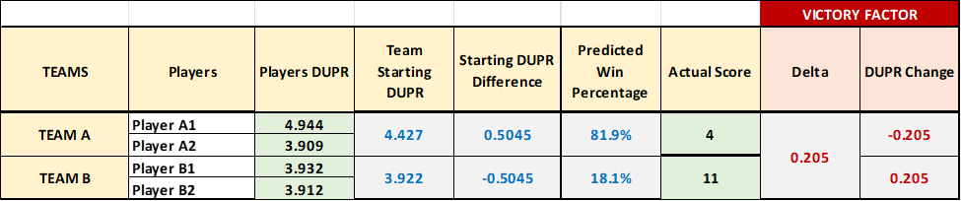
In the example using the difference of the starting DUPRs of the teams, Team A has an 81.9% chance of winning and Team B has an 18.1% chance of winning. In fact, Team B won 11-4 and based on the probabilities and the starting delta Team DUPRs this would lead to +.205 change for Team B and -.205 for Team A. In systems that only use this factor, such as Generation 2 DUPR and the USA Pickleballs UTPR, that is where that would end with each winning player’s DUPR go up by the same amount. Performance against the predicted score did not matter.

TYPE OF RESULTS COEFFICIENT – DUPR has arbitrarily said that organized play matches such as in tournaments, leagues or ladders should matter more than recreation matches and have said on several occasions that the factor is that recreation matches are only worth ½ of what organized matches are worth. For our example, assume that the match was played in a ladder and therefore it’s Results Coefficient would be 1 and the DUPR change would still be .205
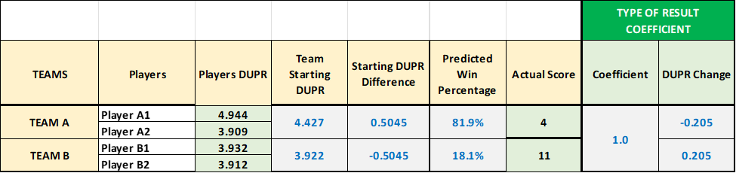

WIN INTENSITY COEFFICIENT – DUPR uses the term Win Intensity to describe margin of victory. DUPR previously had shared the relation they used to determine the effect of margin of victory using a term defined as DUPR POINTS which are the points a team gets divided by the total points of both teams. The difference in DUPRs of the teams leads to the expected DUPR points they should get.

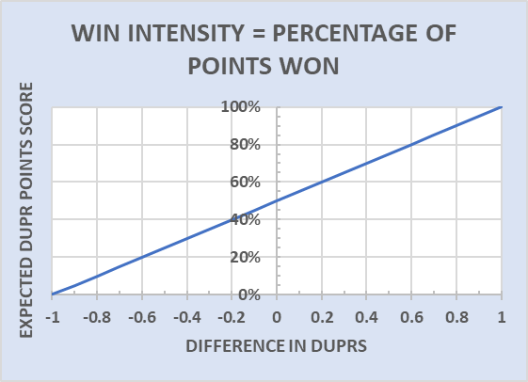

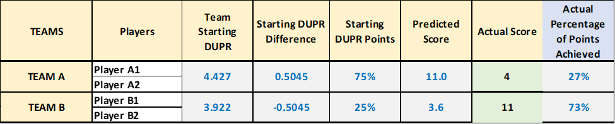
In the example, Team A was .5045 better than Team B so they should have won 75% of the points. For an 11-point game this meant the score should have been 11.0 – 3.6 (excuse the decimal points). The score was 4-11 against Team A so they only won 27% of the points. In early versions of DUPR (Generation 1), this was the critical parameter and led to the occurrence of teams winning but not winning big enough so their DUPRs went down. In the current Generation of DUPR (Generation 3) this becomes a coefficient against the Victory Factor so it can only change the magnitude of the change but not the direction (DUPR up or down) of change. How DUPR calculates how to apply this is not known, so some logic was used to determine this coefficient, and this was applied against some recent DUPR data to calculate the coefficient.

For the winner it is straight forward
• If you win and you win bigger than expected, then the coefficient should be >1.
• If you win and win by less than expected, then the coefficient should be <1.
For the loser it is not as obvious because you are dealing with a negative Victory Factor
• If you lose but do better than expected, the coefficient should be <1
• If you lose but do worse than expected, the coefficient should be >1
A form fit factor was introduced based on looking at recent DUPR matches to help in assigning the correct coefficients

RECENCY COEFFICIENT – Up to this point the DUPR changes have applied to both partners equally. DUPR uses the concept of half-life to measure the recency of your matches. Half-life is a measurement of how much data DUPR has on you, and hence it is related to the confidence they have on your rating based on your data. Each match played and entered (on the day of) has a half-life of 1. That number decays as the match gets older. A match entered sometime after it is played will start with a smaller half-life than 1, since the recency of that match has already decayed. DUPR had previously published a chart of ½ life versus time. So, a match that was 91 days old was worth 0.5.
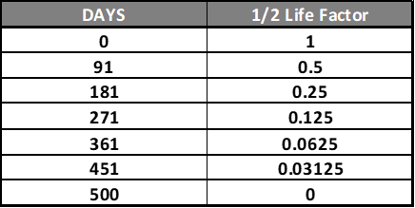

The player's overall half-life is simply the sum of the half-lives of each match. A higher half-life usually indicates greater confidence in a player's rating, so the tendency is that players with a higher half-life are affected less (smaller positive/negative rating impacts) by the results of a given match (regardless of it was a victory or a loss) compared to the other players in that match.

A player’s ½ life vs coefficient was postulated to be governed by a ln relation and look like below.
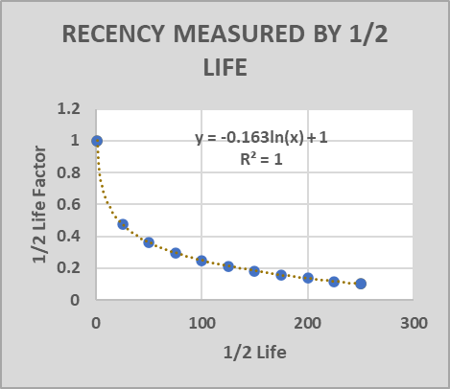
Each player’s ½ life was entered and this results in different changes in their DUPR from their partner.

COUNT COEFFICIENT – The presumption is that the more matches players have recorded the better estimate of their ability. Having many matches should mean that the outcome of a single match should not move your rating as much as if you had fewer matches. Again, a relation was postulated between match count and coefficient.
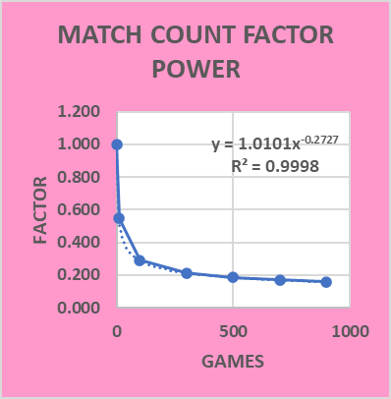
Applying this coefficient to the victory factor gives the final DUPR change for each player where it can be noted that winners went up and losers went down but how much each partner moved was dependent on their match history.

NEW DUPR – Combining all these factors gives a new DUPR for each player

NOTE: For matches that contain multiple games, the maximum increase or decrease is calculated for each game played in the match. This can lead to a scenario where a rating may decrease after a match win.
To illustrate how a rating can decrease after winning a match. Suppose you are rated at a 4.5, and your opponent is rated at a 3.0. In a match where you win the first game 11-1, lose the second game 2-11, and win the third game 11-4. Despite winning the match, your team's rating may still decrease due to losing one game out of three since your team was a heavy favorite.

*Articles were taken from DUPR Analytics Articles with minor modifications +Articles were developed by Pickleball Leagues and Training

