**Moscow ~ Gastronomic Tour**

**Itinerary**

3 nights / 4 days

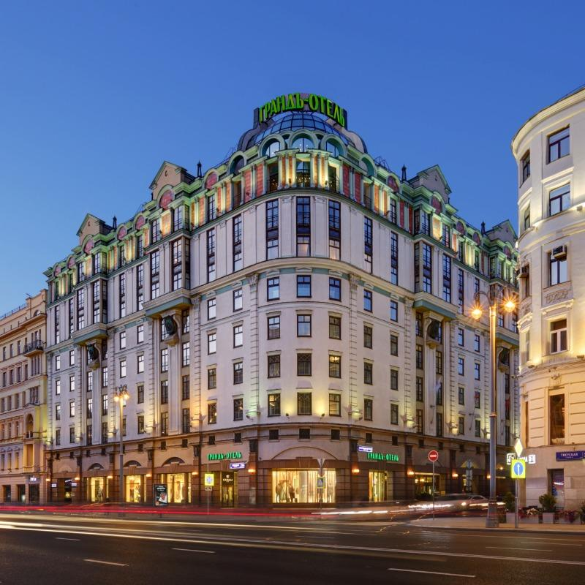

**Day 1**

Arrival in Moscow

Guided transfer to the Safmar Grand Hotel

14:00 Guaranteed check-in

The end of the program at the Hotel

Overnight at the Hotel

Guide& transport for transfer

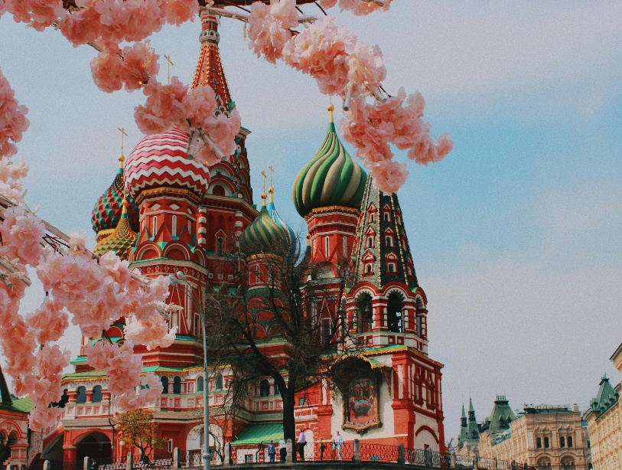**Day 2**

Breakfast at the Hotel

Meet with the guide, departure to the program

City tour with photo stops. Discover the main sights and hidden corners of Moscow. You will take a walk along the avenues, gardens, and squares, including, the Bolshoi Theater and Tverskaya Street, and learn the history of the city, explore the Kitay Gorod quarter, see the Cathedral of Christ the Savior, St. Basil’s Cathedral, Sparrow Hills and the Novodevichy Convent.

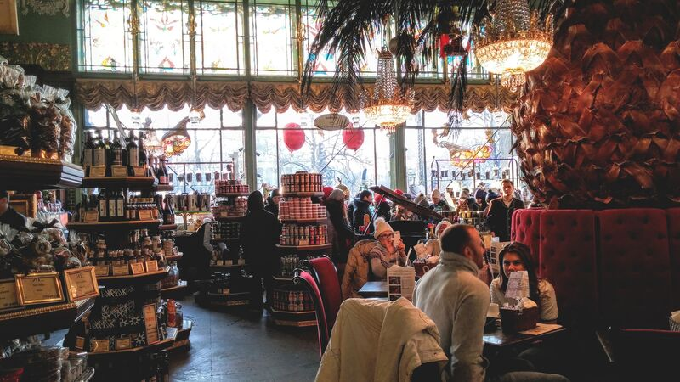**Visit Depo food mall + Lunch**

The biggest food mall in Europe occupies the territory of 11 thousand sq. m. and accommodates 75 restaurant concepts and 60 farm stores.

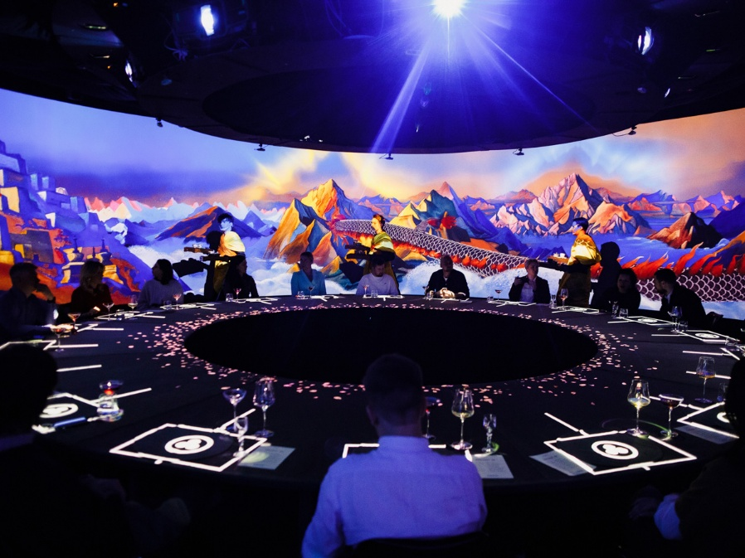Kremlin visit – heart of the country. You will see the famous Tsar Bell, and Tsar Cannon. Cathedral Square or Sobornaya Square is the central square of the Kremlin. Cathedral Square is famous as the site of solemn coronation and funeral processions of all the Russian tsars, patriarchs, and Grand Dukes of Moscow. Even today, the square is used in the inauguration ceremony of the President of Russia.

Walking at Red Square

**Dinner at Krasota restaurant** – immersive gastronomic project that combines visual art, gastronomy and space design.

The end of the program at the Hotel

Overnight at the Hotel

Guide & transport for 11 hours

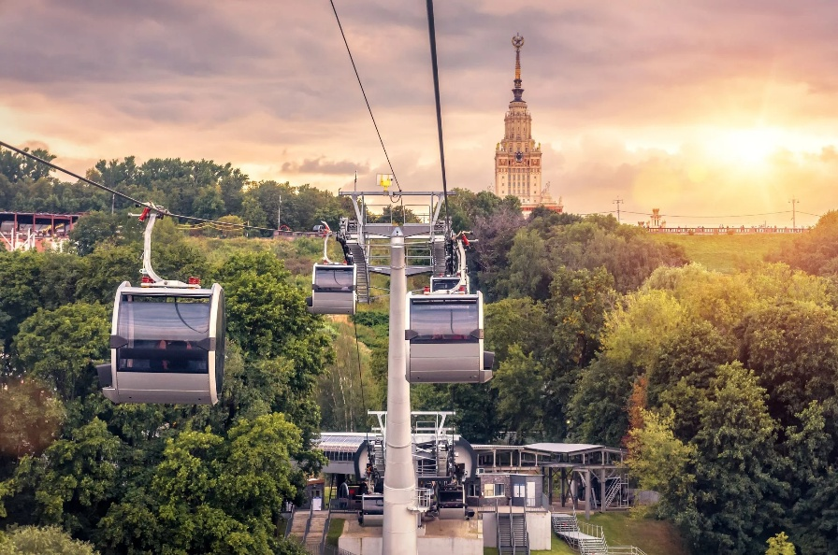

**Day 3**

Breakfast at the Hotel

Meet with the guide, departure to the program

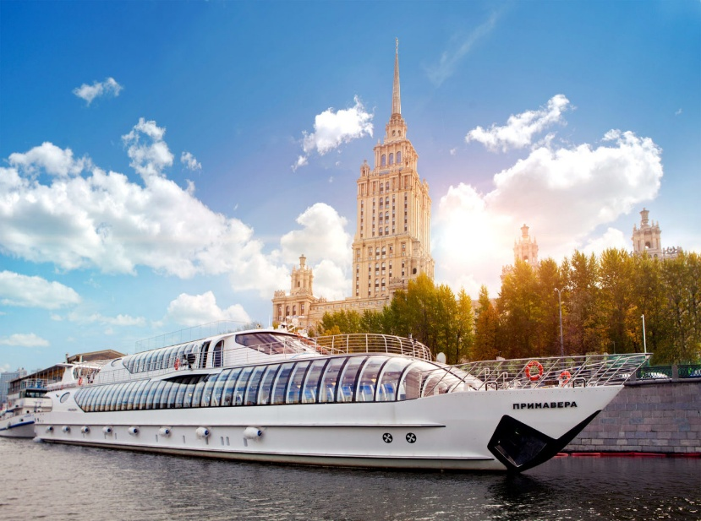**Cable Car on Sparrow Hills** which are located the right bank of the Moskva River and one of the highest points in Moscow. On top of the hill, 85m above the river, is the observation platform which gives a beautiful panoramic view of the city.

**Radisson cruise along Moskva River + Lunch on the board**

In summer or in winter, during the day or at night, discover Moscow by cruising along the Moskva River. For those lovers of luxurious cruises and refined leisure, or anyone simply looking for a new way to discover the Russian capital, a Radisson cruise is an essential part of your stay and is not to missed under any pretext.

**Visit Panorama 360 + Ice-cream tasting**

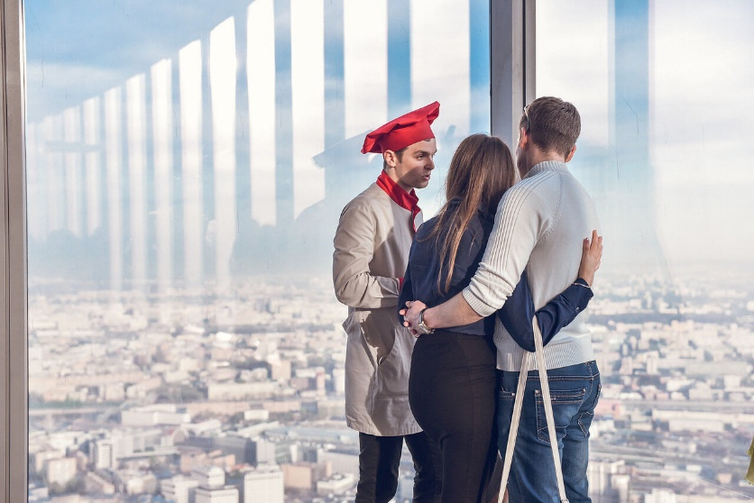The highest observation deck in Europe offers a breathtaking panoramic view of Moscow: Poklonnaya Hill, Moscow State University, Zaryadye Park and other sights are right in front of you. More than that, here you will find the world’s highest chocolate production and ice cream factory, where you can not only see how the sweet delicacies are made, but also taste them without any limitations.

**Dinner at Ruski restaurant**

The restaurant is located on the 85th floor of the OKO Tower and offers the splendid view. The trick of this place is an open kitchen with an eight–meter Russian oven. It creates a special atmosphere and gives an unforgettable taste of traditional Russian cuisine.

**Optional: Caviar tasting and sturgeon show (recommended for the groups)**

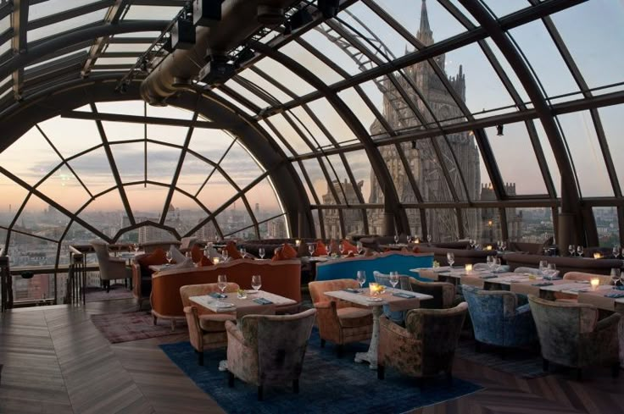For the show is used live sturgeon weighing 10 kilos, 10 years old. It contains 1-1,5 kilos of premium black caviar. The show includes demonstration and photo session with the live sturgeon, fish processing & salting caviar master–class, tasting of baked fish steaks and caviar. The whole process is accompanied with a story about the traditions of the caviar consumption and what kind of beverages is suitable for this dish.

Return to hotel

Overnight at the Hotel

Guide & transport for 11 hours

**Day 4**

Breakfast at the Hotel, check-out

Guided Transfer to the airport

Flight back

**Included:**

1. Travel Insurance
2. Return Airport Private Transfer
3. Hotel 5* with BB/ 3 Night
4. Sightseeing Moscow with Entrance tickets as per program (Kremlin grounds and cathedrals, Radisson cruise, cable car on Sparrow Hills, Panorama 360)
5. English speaking Guide on City Tour days

**Excluded:**

1. Visa Service
2. International Flights
3. Personal Expenses

**Additional Service:**

1. Visa Services from Green Apple Travel & Tourism!
2. Flight Tickets – Economy and Business Class / DXB or DWC – Domodedovo (DME), Vnukovo (VKO), Sheremetyevo (SVO)
3. Travel Insurance
4. Executive Vehicle Class / Private Sedan and Private Mini-Van
5. Private Arabic Speaker Guide
6. Optional Tours in Moscow and Moscow Region
7. Additional Meals - Lunch and Dinner
8. Early Check-In and Late Check-Out

**GROUP 14 PAX**

**Hotel Safmar Grand 5-Star** price per person- from 1,700 aed

**Hotel Holiday Inn Lesnaya 4-Star** price per person- from 1250 aed

**GROUP 4 PAX**

**Hotel Safmar Grand 5-Star:** price per person-from 2,250 AED

**Hotel Holiday Inn Lesnaya 4-Star:** price per person- from 1,850 AED