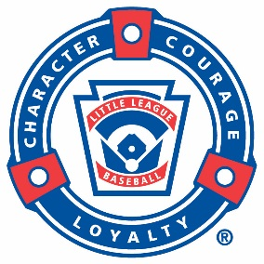
MEDIA ALERT

Place Local League
or District Logo
& URL here

For Media Planning Only MONTH HERE, DATE HERE, 2017

MEDIA ALERT: (Headline About Your Event)

NAME OF YOUR TOWN, STATE NAME (i.e. SOUTH WILLIAMSPORT, Pa.). (MONTH DATE, 2017) – BRIEF INTRO ABOUT YOUR EVENT, EXPLAIN HERE WHY THE MEDIA SHOULD BE INTERESTED IN THE EVENT.

What: DESCRIBE THE EVENT
When: MONTH, DAY, AND TIME OF YOUR EVENT
Where: PLACE and ADDRESS OF YOUR EVENT
Who: LIST WHO THE EVENT IS FOR, AND WHO WILL BE ATTENDING
Contact: CONTACT NAME, EMAIL, PHONE NUMBER, AND WEBSITE.

About Little League®
Founded in 1939, Little League® Baseball and Softball is the world’s largest organized youth sports program, with nearly 2.4 million players and one million adult volunteers in every U.S. state and more than 80 other countries. During its nearly 80 years of existence, Little League has seen more than 40 million honored graduates, including political leaders, professional athletes, award-winning artists, and a variety of other influential members of society. Each year, millions of people follow the hard work, dedication, and sportsmanship that Little Leaguers® display at our seven baseball and softball World Series events, the premier tournaments in youth sports. For more information, visit LittleLeague.org, and follow Little League on Facebook (facebook.com/LittleLeague), Twitter (twitter.com/LittleLeague), and Instagram (Instagram.com/LittleLeague).

###
For more information contact:

YOUR LEAGUE CONTACT INFORMATION (NAME, TITLE, PHONE, EMAIL AND LEAGUE WEBSITE) HERE THAT WOULD HANDLE QUESTIONS FROM THE MEDIA

