For Immediate Release

May 3, 2011

Contact: Carolyn Payne, Manager of Operations, History Museum of Western Virginia

540-342-5724 or [manager.hswv@cox.net](mailto:manager.hswv@cox.net)

Jeanne Bollendorf, Executive Director, Historical Society of Western Virginia

540-224-1229 or [director.hswv@cox.net](mailto:director.hswv@cox.net)

**History Museum of Westen Virginia Announces FREE Admission for May and kicks off Capital Campaign!**

(Roanoke, VA) – The History Museum of Western Virginia is pleased to announce the final phase of our Capital Campaign: ***Crossroads of History!* T**o celebrate this momentousoccasion and prepare for relocation in June, the **History Museum will be FREE to the public from May 3 - May 29, 2011.** Take the opportunity to check out the “old museum” one last time before we **relocate to Hotel Shenandoah on Campbell Avenue (the former Twists & Turns location downtown)** in preparation for renovations at Center in the Square.*The History Museum will reopen in August at Hotel Shenandoah with a new exhibit, “Hometown Stars”.*Upon completion of renovations in 2013, the History Museum will return to the third floor of Center in the Square.

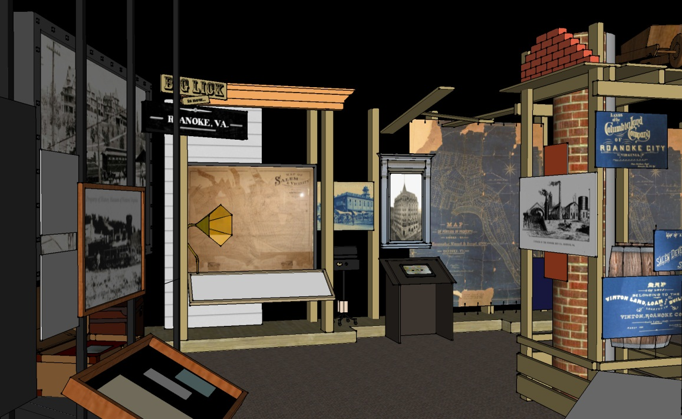

When Center in the Square opened in 1983 in a renovated 1914 warehouse (the McGuire Building) in the old city market, the History Museum became one of five nonprofit “anchor tenants” of this revitalization project. Commencing in 2007 the Historical Society of Western Virginia began a capital campaign to renovate the History Museum with the goal of increasing accessibility to collections and exhibitions in order to better fulfill the Museum’s education mission and reconnect with new audiences in a more meaningful way. To date, we have raised $1.2 million and renovated the Museum’s research facility (Watts Library), education workshop (Barbara and E. Wilson Watts Education Gallery), and administrative areas. Additionally, we have created the Virtual Museum, an online research resource available through the world-wide web.

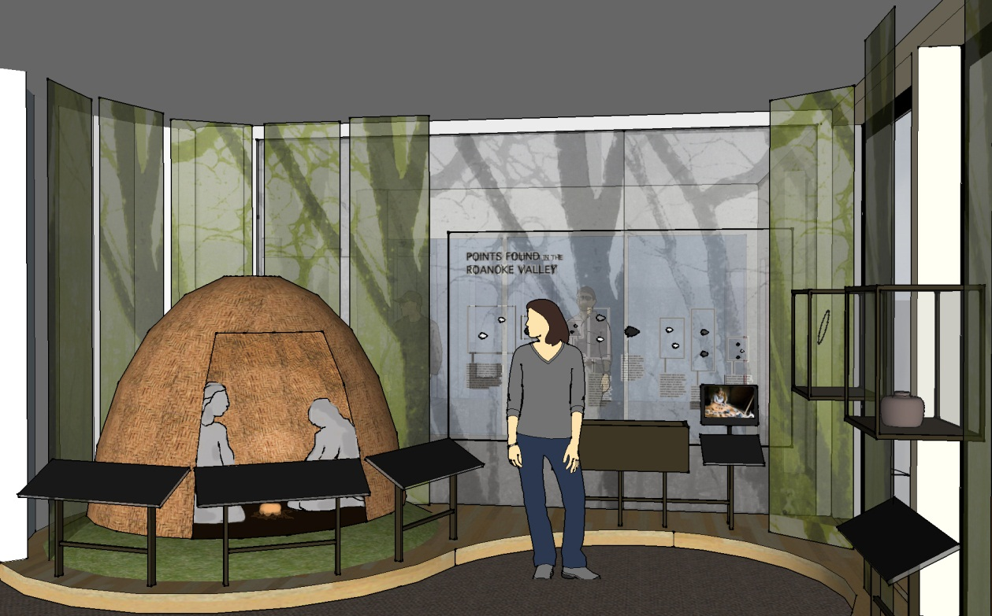

We are now seeking an additional $1.5 million to renovate the exhibition galleries in the History Museum and upgrade our collections and archival storage areas. A new continuing exhibition will incorporate the best in interpretive and technical standards while revealing 10,000 years of our region’s cultural heritage through artifacts that span the whole human experience from prehistoric times to the present day. Modified collections storage will allow the History Museum to better house and care for its collections; our organization is a repository for the material culture southwestern Virginia and we are entrusted with the care of the region’s memory in perpetuity.

The first three phases of our campaign have been completed and paid for and remaining unexpended funds have been transferred to the fourth and final phase of the campaign. In 2011, during our silent campaign, we have raised a significant amount of new campaign pledges – including a $50,000 gift from an anonymous donor to pay for the *Crossroads Central Timeline Exhibit.* We invite you to make a gift to our campaign today and help be a part of history!

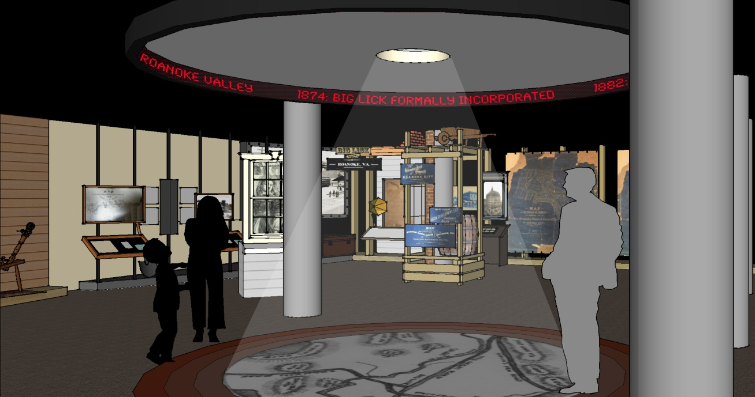

***About the History Museum of Western Virginia***

The History Museum of Western Virginia is the oldest museum within the Historical Society of Western Virginia’s operations. The collections of the History Museum include “A Crossroads of History,” which interpret southwestern Virginia’s heritage through artifacts that span the whole of peoples’ known experience throughout the region. A full schedule of rotating exhibits and programs allows the Museum to focus on a variety of people, industries and events that have influenced the development of western Virginia. Find us on Facebook!

**The History Museum of Western Virginia is located at**



**Center in the Square, One Market Square, Third Floor, Roanoke VA 24011.**

**Tel: (540) 342-5770 E-mail:** [**info.hswv@cox.net**](mailto:info.hswv@cox.net)**; Website:** [**www.history-museum.org**](http://www.history-museum.org)

**Hours: Tuesday – Friday 10am-4pm, Saturday 10am – 5pm, Sunday 1-5pm**