

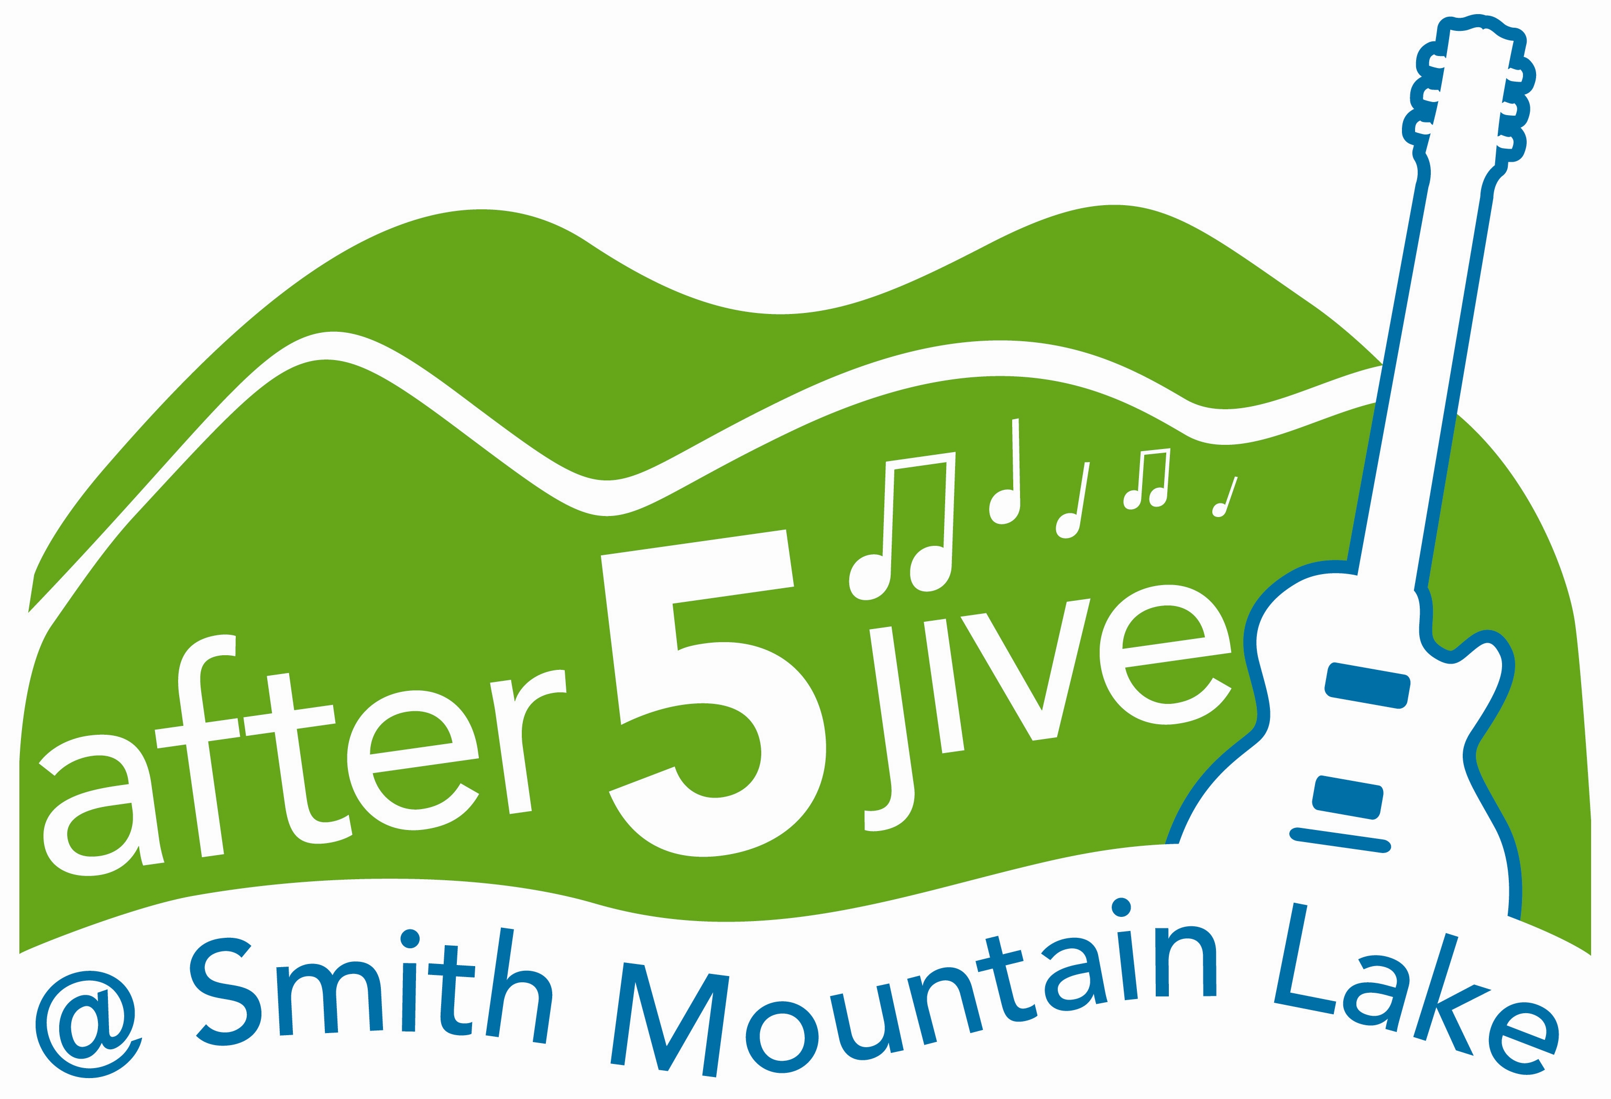

PRUDENTIAL WATERFRONT PROPERTIES PRESENTS

AFTER 5 JIVE AT SMITH MOUNTAIN LAKE SUMMER CONCERT SERIES

Smith Mountain Lake, VA (April 29, 2011) – Prudential Waterfront Properties is pleased to once again headline the ‘After 5 Jive at Smith Mountain Lake’ 2011 summer concert series. The first outdoor event will kick-off on Thursday, June 2, 2011 with “The Holiday Band” performing at Westlake Towne Center, next to Kroger. Gates open at 5 p.m. with live music getting underway at 5:30 p.m. through 8:30 p.m. All proceeds will benefit the United Way of Franklin County.
Dates, bands and times for the 2011 ‘After 5 Jive at Smith Mountain Lake’ concerts series are as follows:
- Thursday, June 2 “The Holiday Band” 5 – 8:30 p.m.
- Thursday, July 7 “The Embers” 5 – 8:30 p.m.
- Thursday, August 4 “Key West Band” 5 – 8:30 p.m.
- Thursday, September 1 “Part Time Party Time Band” 5 – 8:30 p.m.
‘After 5 Jive at Smith Mountain Lake’ is sponsored by Prudential Waterfront Properties, Carilion Clinic, Appalachian Power, Western Virginia Water Authority, Smith Mountain Building Supply, Kroger, Ferguson Kitchen & Bath, Laker Media, WDBJ-7, Budweiser, and Coca-Cola.
According to Christopher Finley, event coordinator, “We are very excited to bring this event back to the greater Smith Mountain Lake region. Our goal is to continue providing entertainment options for local residents, draw visitors to the area, and provide an attraction for vacationers while at the same time generating proceeds that will benefit the United Way of Franklin County whose 18 partner agencies serve a comprehensive range of human needs.”
Admissions for Adults is $5, children 10 and under are admitted free. Valid ID required for 21 and older. There will be a children’s play area with an inflatable slide and other activities.
Participating food and drink vendors include Homestead Creamery, Hot Shots, Brooks Mill Winery, Budweiser and Coca-Cola. Lawn chairs welcome. No coolers, outside food or drinks, rollerblades, skateboards or pets are allowed on the premises. Events are subject to cancellation and possible rescheduling due to inclement weather. For additional information, contact (540) 721-5288.
###

