

**PRESS RELEASE FOR IMMEDIATE RELEASE**

**December 14, 2011 Contact: Karyn McAden**

**Roanoke, VA**  email: [kmcaden@hollins.edu](mailto:kmcaden@hollins.edu)

office: 540.362.6496

**Two New Winter Exhibitions Opening at the Eleanor D. Wilson Museum on January 12th**

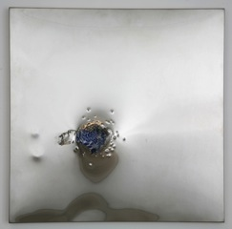 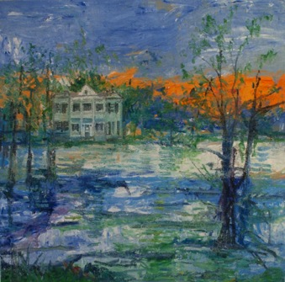

Left: Hunt Slonem, Albania Plantation (from the Bayou Teche series), 2009. Oil on canvas. Courtesy of the artist and Marlborough Gallery, New York.

Above: Margaret Evangeline, *Britania*, 2010. Gunshot brushed stainless steel with porcelain. Courtesy of the artist and Stux Gallery, New York.

The Eleanor D. Wilson Museum will kick off its 2012 season with two new exhibitions: *Bayous and Ghosts: Work by Margaret Evangeline and Hunt Slonem*, and *Treasures from the Vault* willboth open on Thursday, January 12.

*Bayous and Ghosts* features work by internationally recognized artists and friends Margaret Evangeline and Hunt Slonem. With ties to the American South, both artists are inspired by romantic aesthetics that originate particularly in Louisiana and play into the larger history of the United States. Their shared vision as artists and friends dovetail into their evocative and painterly work.

Margaret Evangeline is a New York based, Louisiana born painter who experiments with resistant materials. Fluctuating between creating works with aluminum punctured with bullet holes and heavily worked oil on canvas paintings, she is often inspired by beloved authors of the South coupled with an interest in beauty and wreckage.

*Continued*

The museum’s 2011-12 exhibitions and related programs are supported in part through our community partners:



Page 2

Hunt Slonem is a New York and Louisiana based artist whose fascination with exotica and spirituality pervades his work. Inspired by various legends of history and Victorian gothic, the exhibited paintings focus on his beloved historic plantation along the Bayou Teche. Evangeline’s and Slonem’s shared vision as artists and friends dovetail in the evocative and painterly work featured in the exhibition.

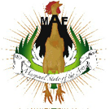Slonem and Evangeline will give a joint lecture discussing their exhibition at the museum at 6:00 pm on Thursday, February 16. A reception will follow. A collaborative reception with the Hollins Theatre department will immediately follow at the museum, and will include Pulitzer Prize-winning poet Natasha Trethewey. This event is organized in partnership with, and is the opening event for, the Marginal Arts Festival.

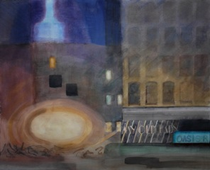***Treasures from the Vault*,** a continuing exhibition series, will showcase many of the new works given by generous donors to the museum’s collection 2010 and 2011. This edition will feature works created in a variety of media and styles, from such varied artists as Jack Beal, Tanja Softic, Fiona Ross, Suzanne Fields, Margaret Evangeline, Hunt Slonem and others. Wilson Museum Director Amy Moorefield comments, “We are fortunate to have received several gifts created by important artists who have contributed greatly to the global artistic landscape.” *Treasures from the Vault* underscores the Eleanor D. Wilson Museum’s mission as a repository of significant works of modern and contemporary art.

Moorefield will present a lecture entitled “Why Should University Museums Collect?” on Thursday, January 12, the evening that both exhibitions open, in the Niederer Auditorium of the Visual Arts Center. The lecture will begin at 6:00 pm and be followed by a reception.

Above: Darragh Park, *One Night the Empire State Building was Blue- 7th and 22nd, #1* (detail), 1995. Watercolor on paper. Gift of the Estate of Darragh A. Park. Collection of the Eleanor D. Wilson Museum at Hollins University, 2011.028.

The museum’s 2011-12 exhibitions and related programs are supported in part through our community partners:

