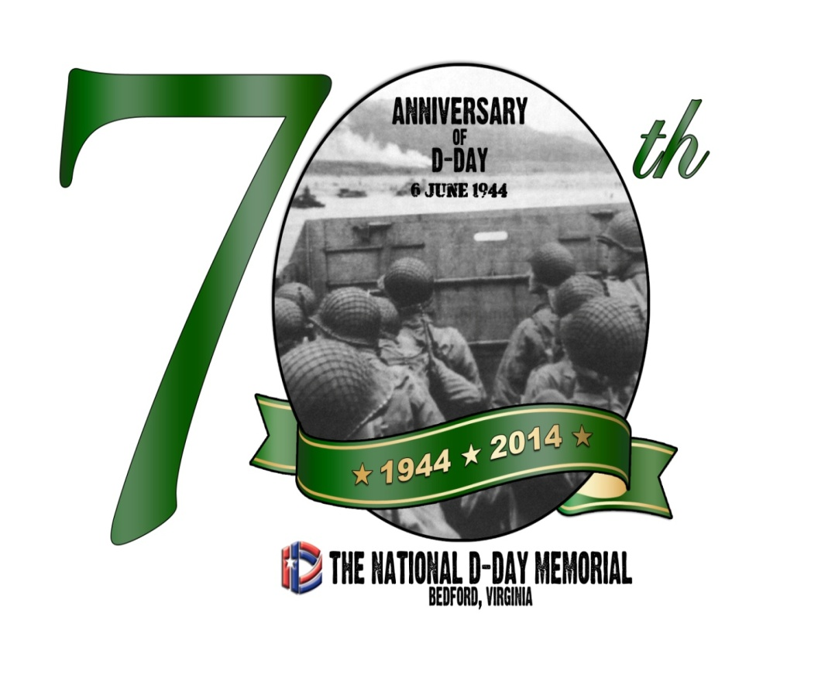

**70th Anniversary of D-Day Commemoration - Friday, June 6 – 11AM**

The 70th Anniversary of D-Day will be observed in a special ceremony at the National D-Day Memorial in Bedford, Virginia. Program highlights include an honor guard, recognition of D-Day veterans, guest speakers, dignitaries, music, and more.

The commemoration begins with a morning ceremony featuring the laying of wreaths by D-Day units. Other activities include:

* Veterans oral history stations * A USO show at 2PM

* Reunion Tent * Food vendors

* Displays by Living Historians

**Outdoor Movie Night and Canteen - Fri., June 6th, 2014**

The public is invited to the Memorial for an outdoor movie night with a 1940s theme. The Canteen will offer the best of period refreshments and the featured film will be “Casablanca.” The film begins at dusk.

[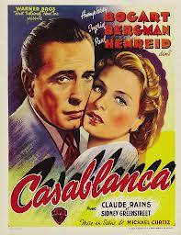](http://www.google.com/url?sa=i&rct=j&q=&esrc=s&frm=1&source=images&cd=&cad=rja&docid=9Ed3lQK9qtcquM&tbnid=mMEBzdQfa5YnhM:&ved=0CAUQjRw&url=http://do512.com/event/2013/02/14/casablanca-2&ei=qSjUUYG6Kfel4AO6n4H4BQ&bvm=bv.48705608,d.dmg&psig=AFQjCNHTqMC6GSuyX1Jl8KggWYjlg7aHXg&ust=1372944856412114)

**D-Day Parade – Saturday, June 7th, 2014 – 10am**

The community of Bedford will host a 1940s parade on the morning of June 7th. Antique cars, bands, veterans, living historians, and more will parade through town. At 11am, a bell will toll marking the 19 from Bedford killed on June 6, 1944. Walking tours will be available for those interested in visiting some of the more famous Bedford Boys sites as mentioned in Alex Kershaw’s award winning book “The Bedford Boys: One American Town’s Ultimate Sacrifice.”

**Jimmy Dorsey Orchestra Performance – Saturday, June 7th, 2014**

Come out and hear the Jimmy Dorsey Orchestra for a fun filled night that will transport you back to the 1940s. Advance tickets go on sale May 1.

[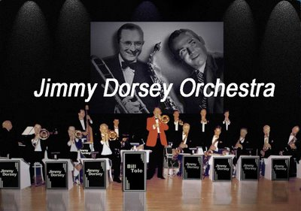](http://www.google.com/url?sa=i&rct=j&q=&esrc=s&frm=1&source=images&cd=&cad=rja&docid=MLi-86Pm9v7aUM&tbnid=B5P76KZfr-b0wM:&ved=0CAUQjRw&url=http://yellowstoneplace.blogspot.com/2009_04_01_archive.html&ei=wSvUUaOUGPO84APS4YHADA&bvm=bv.48705608,d.dmg&psig=AFQjCNGZOwzwAfoicMAfNqK-KcNcmyVeLg&ust=1372945683359400)

**Veterans’ History Project at National D-Day Memorial June 6-7, 2014**

D-Day veterans attending 70th Anniversary events are also invited to contact the Foundation in advance to schedule an interview to have their wartime experiences recorded as part of the Veterans History Project. The Memorial is seeking oral histories from veterans of Operation Overlord and civilians on the homefront with memories of D-Day. Interviews will be recorded on DVD and housed in the archives of the National D-Day Memorial for use in educational programming. Interviews will be conducted throughout the day on June 6 and 7th, but preregistration is required. Contact the Memorial’s Resource Center at (540) 586-3329 to schedule an interview.

**Field Chapel Service – Sunday, June 8th – 11am**

Conclude the 70th anniversary observance with an authentic WWII field chapel ecumenical service. A unique and moving experience. The service begins at 11am.

**NOTE:**

**ATTENTION EDUCATORS: Operation THANK YOU! Nov. 1 – January 10**

Operation “THANK YOU” is one way educators can get their students involved in the observance of the D-Day anniversary. The purpose of Operation THANK YOU is to have students offer messages of thanks to our WWII and D-Day veterans in highly visual formats. Educators are invited to have their students spell out “THANK YOU” as creatively as possible and submit a photograph of their results. A panel of judges will select the most creative “THANK YOU” image, which will then be used in the program for the 70th Commemoration of D-Day at the National D-Day Memorial in June 2013. The key is creativity – use the student body to spell out “THANK YOU” in giant letters on the football field, or spell it out with a collage of images from WWII. Get creative and say thanks!

Submissions must be in the form of color photographs or digital submissions – no original artwork or videos will be accepted. Entries must be received by January 10st, 2014 to be considered. All submissions become property of the National D-Day Memorial. Send your submission to the National D-Day Memorial, PO Box 77, Bedford, VA 24523 or via email at [dday@dday.org](mailto:dday@dday.org).