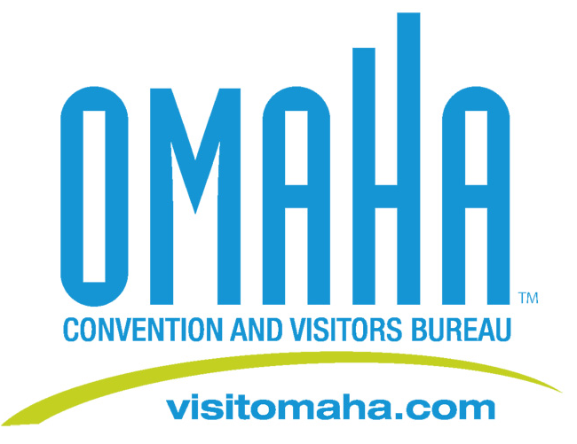

Omaha Convention and Visitors Bureau Receives National Honor

FOR IMMEDIATE RELEASE:
Honored for her hard work and dedication to the tourism industry, Omaha Convention and Visitors Bureau Director of Sales, Cathy Keller received the Shawn Corwin Award from the Association for Convention Marketing Executives (ACME).

ACME is a national organization made up of more than 100 CVBs and Convention Center sales and marketing professionals dedicated to strengthening relationships in the convention industry. Each year ACME honors one member who displays the values, enthusiasm, work ethic and passion for the industry embodied by ACME’s past president, Shawn Corwin, who succumbed to cancer in October 2006.

“What an honor to receive this award from an organization that works to find real solutions to our industry’s biggest challenges,” says Keller. “Shawn was a tremendous role model to all in our industry and I am humbled to be recognized in her honor”

Media Contact:
Deborah Ward
Director of Marketing/Public Relations
(402) 444-4665
dward@visitomaha.com

