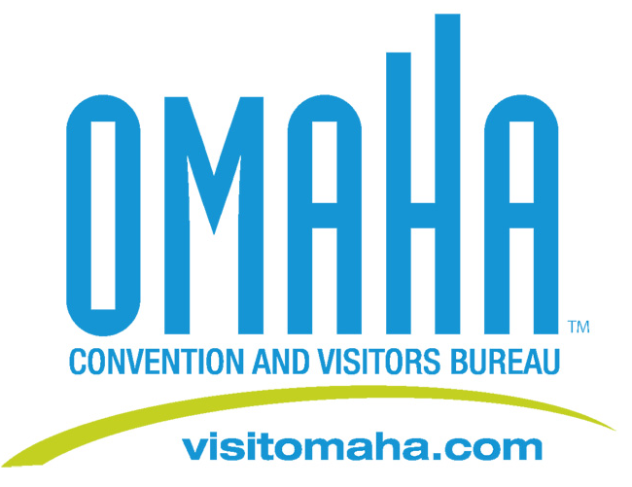

Omaha Holiday Gift Ideas

FOR IMMEDIATE RELEASE:
For those searching for a unique gift, the Omaha Convention and Visitors Bureau suggests sending a little piece of Omaha to family and friends this holiday season.

The Omaha Visitors Center at 10th and Farnam offers more than 40 unique Omaha products that can be mixed and matched to create distinctive gift packages.

Here are four gift ideas:
1. Wine Lover – Omaha engraved wine glasses, wine charms and engraved silver wine opener. Buy a bottle of wine from one of the local wineries to complete the theme.

2. College Student – Omaha sweatshirt, T-shirt and yoga pants, an Omaha water bottle and a ceramic, hard-to-break Omaha coffee mug. Throw in original music from one of Omaha’s home grown indie rock bands and you instantly turn into the cool relative.

3. Child/Grandchild – Omaha princess T-shirts for girls or Omaha train T-shirts for boys. A stuffed Omaha bear for the younger kids and Omaha wristbands for the tweens, Omaha ball caps, playing cards and Omaha board game are also popular among children who come in to the Visitors Center.

4. Food Lover – Combine Omaha chocolates, jams, jellies, root beer and cookbooks to create a one-of-a-kind gift for the foodie in the family.

You can find all of these products and more at the Omaha Visitors Center. Open everyday, the Omaha Visitors Center also features a coffee shop serving specialty coffee drinks, smoothies and frappes, the perfect pick-me-up as you head out to do your holiday shopping.

Omaha Visitors Center Hours:
Monday through Friday: 8am – 4:30pm
Saturday: 9am – 4:30pm
Sunday: Noon-4pm

Media Contact:
Deborah Ward
Director of Marketing/Public Relations
(402) 444-4665
dward@visitomaha.com

