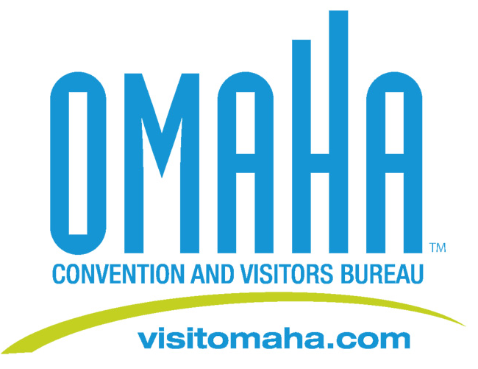

VisitOmaha.com Adds New Visitor-Friendly Features

FOR IMMEDIATE RELEASE:
It is now easier for visitors to see what Omaha has to offer and plan a trip to the city. VisitOmaha.com, the official tourism website for the City of Omaha, has added a number of new visitor-friendly features, along with a new look.

“More than 710,000 visitors from across the country utilized the VisitOmaha.com website in 2011, and viewed close to 3 million pages,” said Dana Markel, Executive Director of the Omaha Convention and Visitors Bureau. “The new features provide visitors with even more tools useful during all aspects of their trip planning process.”

In addition to the visual intensity of the website, new visitor-friendly features include:
- Mapping features that allow visitors to search for ‘what’s nearby’ a hotel, an attraction or event, making it easier to plan their experience.
- An online booking engine, which provides visitors the ability to search a variety of Omaha hotel options all at once and then book directly with the hotel of their choice. It also allows users to view hotel availability two months at a time so they can compare rates surrounding their selected dates.
- Independent visitor reviews and blog posts
- A Social Lounge that connects visitors directly to Facebook, Twitter and YouTube without leaving the website
- A ‘share’ feature which allows visitors to easily share information they find on the website via social media.
- Digital editions of Omaha brochures, such as the official Omaha Visitor Guide, which can be easily downloaded for use on iPads, iPhones and iPods.
Bottom of Form

Media Contact:
Deborah Ward
Omaha Convention & Visitors Bureau
Director of Marketing/Public Relations
(402) 444-4665
dward@visitomaha.com

The Omaha Convention and Visitors Bureau (OCVB) is the tourism division of the City of Omaha and Douglas County. The OCVB’s mission is to strengthen the positive awareness of Omaha/Douglas County as a convention and visitor destination which will increase revenues and stimulate economic development and growth for the community.

