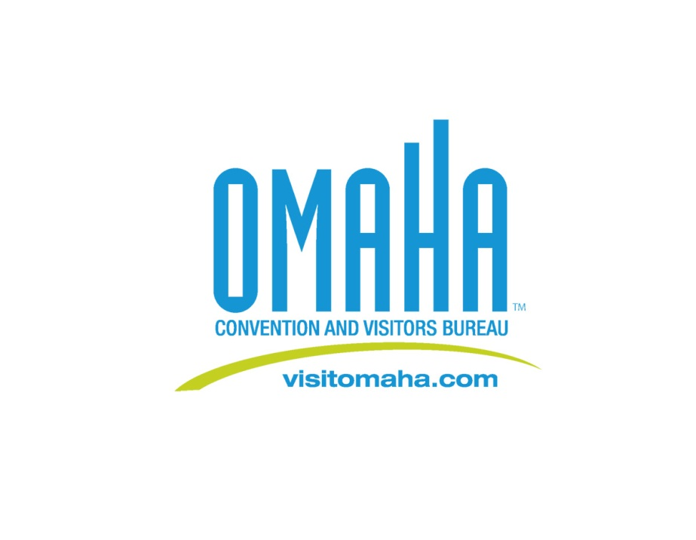**Media Contact:**

Deborah Ward

Omaha Convention & Visitors Bureau

Director of Marketing/Communications

(402) 444-4665

[dward@visitomaha.com](mailto:dward@visitomaha.com)

**Welcome to the Weekend Video Campaign Provides Chance to Be on TV**

*Omaha residents and visitors encouraged to capture their best weekend moments   
for a chance to win Omaha prize packages, TV commercial*

OMAHA, NEB. – June 7, 2012 – The Omaha Convention and Visitors Bureau (OCVB) announces the “Welcome to the Weekend” video campaign, an opportunity for Omaha visitors and residents to capture what they feel are the great things to do in Omaha. In addition, they have a chance to be featured in an upcoming “Visit Omaha” commercial. From June 7 through July 31, entrants can submit videos of their fun-filled Omaha weekend moments online at [www.OmahaWeekend.com](http://www.OmahaWeekend.com).

“Show us something new – off the beaten path places, shops and restaurants that make the weekend uniquely Omaha,” said OCVB Executive Director Dana Markel. “We want to see this city’s attractions, events and hidden gems through your eyes.”

During June and July, one grand prize winner each month will receive a two-night stay at an Omaha hotel, $100 restaurant gift card and passes to Omaha attractions. Additionally each month, four second prize winners will receive passes to Omaha attractions. In August, a select number of videos will be chosen as “Welcome to the Weekend” commercials for the Visit Omaha campaign, to be aired regionally starting this fall. “We’re looking for great videos of people embracing the freedom of a weekend in Omaha,” Markel said. “We want to see you, your family and your friends doing what you do best – having a great time.”

For more information on creating and submitting your “Welcome to the Weekend” video, visit [www.OmahaWeekend.com](http://www.OmahaWeekend.com).