
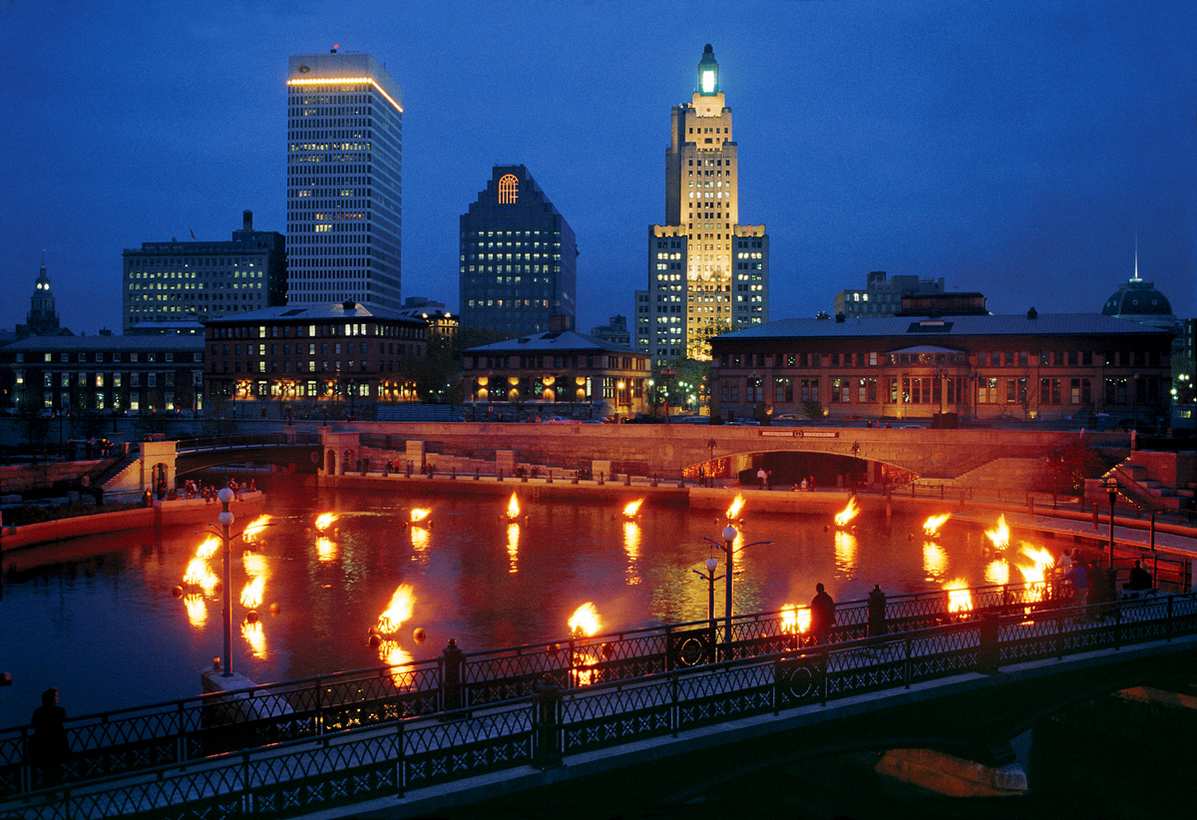

PROVIDENCE Lights up the night with 16th season of waterfire
Award-Winning Art Installation A Feast for the Senses

Providence, RI, June 15, 2011 – The familiar crackle of scented fire wood, the scented smoke snaking through downtown Providence, the ambient music and spicy salsa ballroom spiking the air. These tempting tactile treats can only mean the return of WaterFire.
WaterFire, the award-winning art installation created by Brown University graduate Barnaby Evans, prepares for its 16th season in Providence, Rhode Island. The installation is comprised of more than 100 bonfires that wind through the downtown’s three rivers. Lightings occur at select dates throughout the summer and early fall and bring astonishing visual aesthetics, live music, costumed performers and living art installations to the city known as “The Creative Capital.” Lightings have been scheduled for the following dates and times:
- Saturday, July 2 - 8:24 p.m.
- Saturday, July 16 - 8:19 p.m.
- Saturday, July 30 - 8:07 p.m.
- Saturday, August 13 - 7:50 p.m.
- Saturday, September 10 - 7:05 p.m.
- Saturday, September 24 - 6:41 p.m.
- Saturday, October 8 - 6:17 p.m.
Additionally, for a limited time only, WaterFire sponsor Tiffany & Co. is selling the "Providence" charm. Inspired by the uniqueness of the event, only 200 of these sterling silver charms will be available for purchase. Customers may purchase this special token at Tiffany & Co. in the Providence Place Mall and a portion of sales will be donated to this year’s festival.
“It’s an event that attracts more than one million people from around the country,” Evans said. “The fires are a symbol of the energy, beauty and spirit this city embodies. We’re excited to kick off another spectacular season.”

- more -

A spectacular way to view WaterFire is from the river itself. Visitors can embark on $159 Venetian gondola rides for two people. This wondrous 30-minute trip also glasses filled with a drink of choice.
Recently cited in Travel + Leisure as one of America’s hottest culinary destinations, Providence’s famed dining scene marks another reason to visit. While some reservations will be difficult to come by for WaterFire, the following restaurants remain a bit off the beaten path, but an easy walk to the flames.
- Bacaro Restaurant - Bacaro is a split concept Italian restaurant from renowned Chef Brian Kingsford. Chef Kingsford, formerly of world famous Al Forno restaurant, offers guests “more of what you want and less of what you don’t.” Patrons select from various salami, charcuterie and cheeses, both house made and imported. There are also grilled pizzas, made in the style in which Kingsford helped pioneer, and an adventurous, high-end menu. The restaurant also features dramatic views of the Providence River. For more information, visit www.bacarorestaurant.net.
- Parkside Rotisserie & Bar - Located on South Main Street, Parkside is only a short walk for visitors to see and experience WaterFire. This cozy, convivial local eatery features a wonderful rotisserie oven, as well as inventive twists on local favorites. For more information, visit www.parksideprovidence.com.
- New Rivers – This much beloved restaurant is a favorite among locals and tourists alike. The James Beard nominated New Rivers was recently renovated and now features dramatic views of the city skyline and makes an ideal location for WaterFire. Chef Beau Vestal has helped fortify the state’s farm-to-table movement and the menu beautifully reflects the area’s fabulous food options. More information on New Rivers can be found here: www.newriversrestaurant.com.

For more information on WaterFire or Providence, visit www.waterfire.org or www.GoProvidence.com.
~ The Creative Capital ~
Providence is a vibrant and energetic destination boasting some of the country’s finest educational institutions paired with a pulsating artistic landscape. The city’s history of innovation, dating back to its founding father Roger Williams, drives a strong sense of place and encourages residents and visitors alike to view Providence as a leading arts and cultural destination. Providence seamlessly blends the urban sophistication of a big city with the graceful charm of a small town replete with internationally-acclaimed restaurants and a thriving arts scene. Media can also visit http://www.facebook.com/louhammondpr or follow on Twitter @LouHammondPR for the latest client news.
# # #
Contacts: Melanie York /Terry Gallagher Brian Hodge
Lou Hammond & Associates Providence Warwick CVB
Tel: (212) 891-0223 / (212) 891-0211 Tel: (401) 456-0245
E-mail: melaniey@lhammond.com / terryg@lhammond.com E-mail: bhodge@pwcvb.com

