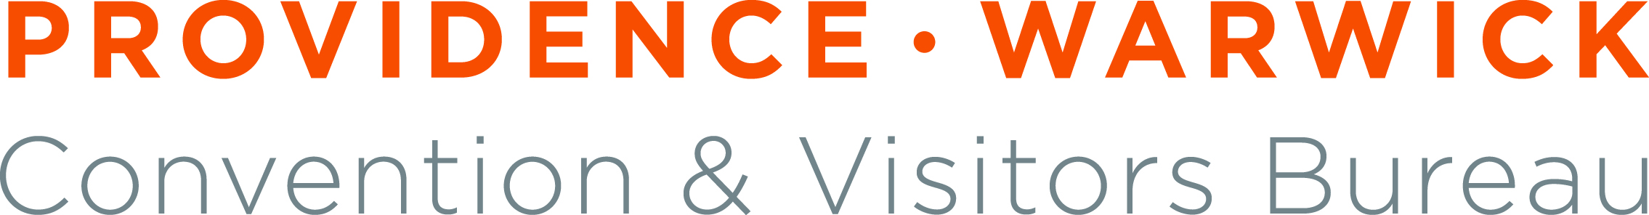
FOR IMMEDIATE RELEASE Contact: Brian Hodge
August 17, 2011 (401) 456-0245
BHodge@pwcvb.com

PWCVB President Sheridan Named Secretary-Treasurer
of National Tourism Organization
PROVIDENCE – Providence Warwick Convention & Visitors Bureau (PWCVB) President and CEO Martha Sheridan has been named Secretary-Treasurer of the Destination Marketing Association International (DMAI) Board of Directors.

“This is an honor not only for Martha but also for the entire PWCVB,” said John Palumbo, chairman of the PWCVB Board of Directors. “It confirms what we have long known, namely that Martha is a talented and dedicated leader and a well-respected and influential voice within the industry.”

Headquartered in Washington, DC, DMAI is the world’s largest and most reliable resource for official destination marketing organizations (DMOs) and is dedicated to improving the effectiveness of over 3,300 professionals from nearly 650 destination marketing organizations in over 30 countries. The appointment was announced at the DMAI’s 97th Annual Conference in New Orleans in July.

“I look forward to working closely with Martha and such a dedicated group of leaders,” said Kevin Kane, 2011-12 DMAI Board Chair. “I know that our thought leadership and passion for destination marketing will continue to drive us in strengthening the association and the positioning of destination marketing organizations on a global level.”

Sheridan oversees all day-to-day operations at the PWCVB and is a spokesperson and advocate for the Rhode Island tourism industry, both locally and nationally. In 2010 Sheridan spearheaded efforts to form the Rhode Island Sports Commission, now a division of the PWCVB. Prior to her current position, Sheridan served as vice president of sales at the Newport County Convention and Visitors Bureau.

She is a graduate of the University of Rhode Island and lives in Wakefield with her husband, Arthur and three children.

The Providence Warwick Convention & Visitors Bureau is a 501(c)(6) nonprofit organization whose mission is to create vibrant growth for the local hospitality economy by promoting, developing, and expanding a united visitor industry. The PWCVB is a graduate of the Destination Marketing Association Program, an independent international body defining quality and performance issues in destination marketing and recognizing DMOs that meet or exceed industry standards. For more information, contact 401-456-0200 or visit www.pwcvb.com.

