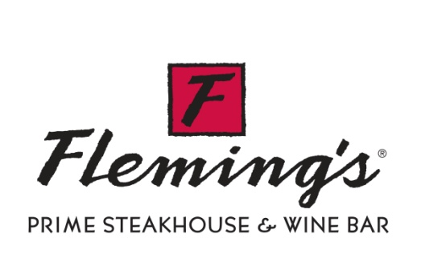

FOR IMMEDIATE RELEASE

Contact: Larisa Kupris, Regan Communications Group
401/351-8855

Fleming’s Prime Steakhouse & Wine Bar
Honored By Wine Spectator Magazine
All 64 Restaurants Recognized with Awards of Excellence

Providence, Rhode Island, September 6, 2011 – Wine Spectator magazine has recognized Fleming’s Prime Steakhouse & Wine Bar with 64 (one for every restaurant) of its coveted Awards of Excellence. The August 31, 2011 issue, announcing the annual awards, is considered to be the definitive guide to the best restaurants in the world for wine.
The Awards of Excellence are given by the Wine Spectator’s judging panel of wine experts, connoisseurs, and editors and are based on “a well-chosen selection of quality producers, along with a thematic match to the menu in both price and style.”
“The Awards of Excellence reflect our continued commitment to wine and we’re honored to receive them once again,” says Fleming’s Director of Wine Maeve Pesquera. “Wine is a huge part of the Fleming’s dining experience, and we strive to make recommending or selecting a wine for dinner easy and fun. Our progressive lists are organized first by grape varietal, then by flavor intensity within that type. This gives our guests a road map for making their selections.”
“The Fleming’s 100 – our list of 100 wines served by the glass - is an honor roll of excellence from around the world. We look for balanced wines that complement our food, have a sense of place and are a good value,” says Pesquera.

About Fleming’s Prime Steakhouse & Wine Bar

The nationally acclaimed Fleming’s Prime Steakhouse & Wine Bar offers the best in steakhouse dining – prime meats and chops, fresh fish and poultry, generous salads and side orders—with a unique wine list known as the Fleming’s 100TM that features 100 wines served by the glass. Fleming’s was launched in Newport Beach, California in 1998 by successful restaurant industry veterans Paul Fleming and Bill Allen. Today there are 64 restaurants nationwide. Fleming’s is the recipient of numerous prestigious awards, including Wine Spectator’s annual Awards of Excellence and Wine Enthusiast’s annual Awards of Distinction.

For more information about Fleming’s Prime Steakhouse & Wine Bar and the Fleming’s 100, please visit FlemingsSteakhouse.com.

###

