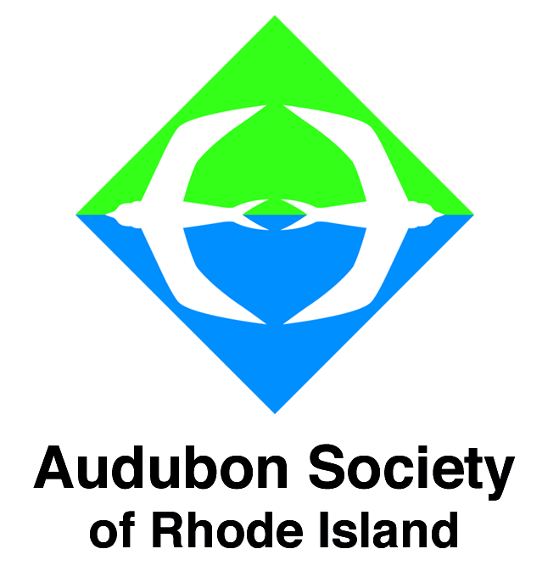 | Contacts: Anne DiMonti  Director, EEC  401-245-7500 ext. 3116  adimonti@asri.org  Hope Foley  Media Relations Coordinator  401-949-5454 ext. 3019  hfoley@asri.org  Photos available upon request
FOR IMMEDIATE RELEASE

Audubon Society of Rhode Island
From Climbing Everest to Saving the Right Whale...
Fall Lecture Series
At the Audubon Environmental Education Center
1401 Hope Street (Route 114), Bristol, RI
October 6, 13, 20, November 17 and 26, 2011

(September 13, 2011) - Come hear, first-hand, about the life-threatening first expedition up Mt. Everest’s most dangerous isolated side in Tibet. Join experts and learn about how top naturalists document their adventures in the natural world, or discover the remarkable adaptations that have made the turtle so successful for over 200 million years. So bring a friend, expand your knowledge by taking in a lecture or two, and simply enjoy an autumn outing at Audubon! Registration is required for all except the North Atlantic Right Whale Lecture on November 26, 2011.

The Secrets of Field Notes: Capturing Science, Nature, and Exploration
Lecture by Michael R. Canfield
Ranging across continents and disciplines, this presentation delves into the notes and drawings kept by field scientists. How do eminent field scientists and naturalists like E. O. Wilson and Kenn Kaufman actually record their work? And how should you cultivate your own skills as a birder, citizen scientist or adventurer? Michael R. Canfield, editor of “Field Notes on Science and Nature” and instructor at Harvard University, shares field stories, anecdotes, maps, photographs, and drawings from historical and contemporary field notes to reveal scientific knowledge, exhilarating expeditions, and important discoveries. He also provides practical advice on common practices, pitfalls, and basic techniques for documenting adventures in the natural world. Registration is required.
Audubon Environmental Education Center, 1401 Hope Street, Bristol, RI; October 6, 2011; 7:00-8:00 pm; Program Fee: $8/member, $10/non-member; Ages: Teen to Adult. Course Number: 164333-543.

My Storm Years On Everest / Everest the Hard Way: A Photographic, Personally narrated Lecture by Ed Webster
In 1988, American mountaineer Ed Webster achieved and survived the impossible. With three partners, he ascended a new, never-before-attempted route up Mt. Everest’s most dangerous isolated side in Tibet — and without the usual assistance of oxygen bottles, radios, and Sherpa climbers to carry the necessary food and equipment. Ed reached the mountain’s South Summit—at 28,700 feet, just 300 feet shy of the main summit. Then, somehow, Ed led his partners down a storm-bound, avalanche-plagued, four-day descent off the mountain, without any food, badly frostbitten, and very near death. Sir Chris Bonington called Ed Webster’s four-month Mt. Everest expedition “amongst the finest examples of survival in Himalayan mountaineering.” Join Ed as he leads you on a photographic and personal narration of his fascinating journey. After the lecture Ed will be available to sign copies of his book "Snow in the Kingdom."
Audubon Environmental Education Center, 1401 Hope Street, Bristol, RI; October 13, 2011; 7:00-8:00 pm; Program Fee: $12/member, $15/non-member; Ages: Teen to Adult.
Course Number: 164333-544.

The Mythology of Watersheds and Untouchable Trees: Lecture and Multimedia Presentation by Peter C. Stone
Author, artist and educator Peter C. Stone will offer a fascinating and entertaining view on our connections with the watersheds that sustain us. Selected oil paintings will be on display from his recent book "The Untouchable Tree, An Illustrated Guide to Earthly Wisdom & Arboreal Delights." From trees and glaciers to marine ecosystems, Peter’s presentation reveals the language of symbolism in living systems through the shared lens of art and science. After the lecture Peter will be available to sign copies of his books including "The Untouchable Tree." Registration is required.
Audubon Environmental Education Center, 1401 Hope Street, Bristol, RI; October 20, 2011; 7:00-8:00 pm; Program Fee: $8/member, $10/non-member; Ages: Teen to Adult. Course Number: 164333-545

Life in a Shell: Lecture and book signing by Donald Jackson
Turtles are iconic animals familiar to everyone, but less well known are some of their remarkable traits that have enabled them to survive virtually unchanged for over 200 million years. Donald Jackson, author of "Life in a Shell: A Physiologist’s View of a Turtle," will touch on a number of aspects of a turtle’s physiology. Don will focus on some of the remarkable adaptations that have made the turtle so successful as well as highlight qualities such as its deliberative nature and persistence that we humans could take to heart.
Audubon Environmental Education Center, 1401 Hope Street, Bristol, RI; November 17, 2011; 7:00-8:00 pm; Program Fee: $8/member, $10/non-member; Ages: Teen to Adult.
Course Number: 164333-547.

Saving the North Atlantic Right Whale
Fewer than 500 North Atlantic Right Whales remain in our oceans. These creatures have been faced with constant challenges for survival since the 1600s. Today, the Right Whales’ habitat along the eastern US and Canada is heavily industrialized and under increasing pressure from human activities. Mortality from ship-strikes and fishing-gear entanglements is driving the species toward extinction and the expected birth rate is less than the annual death rate. So, what can be done? Come learn how we can make a difference.
No registration is required. Audubon Environmental Education Center, 1401 Hope Street, Bristol, RI; November 26, 2011; 2:00-2:45 pm; Program Fee: Free with Admission; Ages: 10+.

# # #
12 Sanderson Road ~ Smithfield, RI 02917-2600 ~ Phone: (401) 949-5454 ~ Fax: (401) 949-5788
www.asri.org email: audubon@asri.org

