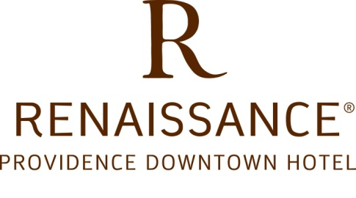

#### Renaissance Providence Downtown Hotel to Serve as Canvas for

**One-of-a-Kind Exterior Tape Art Exhibit**

*Special Q&A Presentation Session with Artists Schedule for Thursday, June 14 in Temple Lounge*

Renaissance Providence Downtown Hotel is encouraging Rhode Islanders to “Get Out & Discover” the unique jewels that make our capital city special.

In celebration of their 5th Anniversary, large-scale Tape Art drawings will engulf the top and Francis Street side of the Renaissance Hotel; laying tribute to the site that has been a landmark for generations. The Tape Art crew will be given free-reign to use the building as their canvas throughout the week of June 11.

Before its opening in 2007 as an arts-inspired luxury hotel, the former Masonic Temple laid idle for more than seven decades. In its final incarnation, it became a safe-haven for graffiti artists around the world to come and produce sprawling works of art. As a result, Renaissance Providence has reached back into the artistic archives to find the spirit of freedom, exploration and mystery that the once abandoned building became famous for.

On Thursday, June 14, Renaissance Providence will host a special Q&A and presentation session with Tape Art artists Michael Townsend and Collin Bliss – who are also known for having built the secret apartment in Providence Place. The session will be held in the Temple Lounge from 5-7pm and is open to the public.

For over twenty years, Tape Art has been spear-heading collaborative drawings using low-adhesive tapes that can be stuck on facades, sidewalks, walls; just about any surface, without permanent repercussions. What began as nightly guerrilla art raids on the surfaces of Providence grew into Tape Art being invited to install over 500 creations on walls around the world. For more information on Tape Art, visit [www.TapeArt.com](http://www.TapeArt.com).