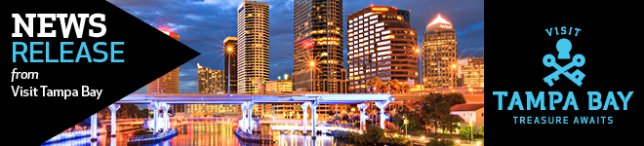

Unlock Tampa Bay with the latest news from Florida’s hip, historic, urban tourism destination. With new hotels, amazing dining and thrilling attractions, the treasures of Tampa Bay are yours to discover! For more information and photography go to [.](http://www.visittampabay.com/media-room/)

**Unlock Florida’s Most in Tampa Bay at the Outback Bowl**

***Discover your treasure in the hip, urban heart of Florida’s Gulf coast***

TAMPA (December 7, 2015) – With great weather, sparkling water, fabulous food and creative craft beers, Tampa Bay has plenty of treasures to discover during your trip to the Outback Bowl to watch the game on January 1, 2016.

So get out and explore the hip, urban heart of Florida’s Gulf coast. A [**Tampa Bay CityPASS**](http://www.visittampabay.com/tampa-deals/tampa-bay-citypass/) makes it simple to see our top attractions, including **Tampa’s Lowry Park Zoo** and **The Florida Aquarium**, for one low price. Or build your own plan from Florida’s Most diverse list of experiences.

[**OUTDOORS**](http://www.visittampabay.com/play/tampa-outdoors-nature/)

Tampa Bay’s sunny days and mild weather make it the perfect place to get out and about. Take advantage of Florida’s Most variety of outdoor activities.

* Race like a cheetah and dive like a falcon at **Busch Gardens Tampa**. 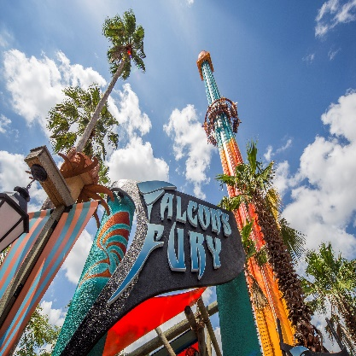
* Tampa Bay’s signature theme park will set your pulse pounding with Florida’s Most exciting roller coasters and thrill rides. Looking for a slower pace? Buy a ticket for the Serengeti Safari and tour the park’s sprawling African plain where you can offer lettuce leaves to a hungry giraffe. Add in an all-day dining pass and catch a musical show to make your visit complete.
* With a smartphone and a credit card, you can rent some two-wheeled transportation from **Coast Bike Share**, and tackle Florida’s Most adventurous bike paths. Cruise the 2.4-mile Tampa Riverwalk from The Florida Aquarium to Ulele restaurant. Ride the waterfront along Bayshore Boulevard, the longest continuous sidewalk in the world. Bike the newly opening Selmon Greenway to explore historic Ybor City.
* In the shadow of the **Tampa Marriott Waterside Hotel & Marina**, you’ll find Florida’s Most options for getting in touch with Tampa Bay’s watery side. Pedal, don’t paddle, your way around 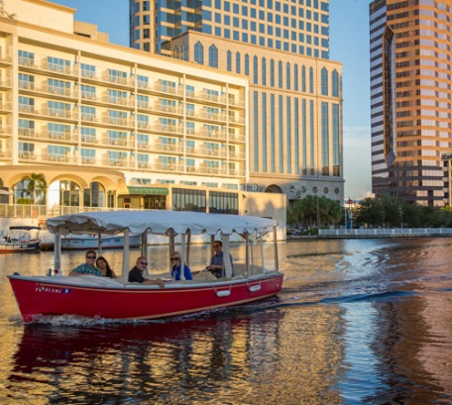the bay on a rental from **Tampa Water Bike Co.** Get together with some friends and rent a self-drive **Tampa eBoat** and see the city from a whole new angle. Take a dolphin-spotting tour of the bay with Capt. Larry Salkin aboard the **Tampa Water Taxi.**

**For extra fun, go out at dusk and watch downtown’s bridges and buildings light up for the night**.

* Go wild at **Canoe Escape**, which will send you down paddling down the untamed upper reaches of the Hillsborough River. Slip silently among the cypress trees and spy on the wildlife – including alligators, turtles, and migrating birds – that call the river home.

[**SHOPPING**](http://www.visittampabay.com/play/tampa-shopping/)

Florida’s Most diverse shopping options await you in Tampa Bay, with purchases for every price point.

* **International Plaza & Bay Street** has more than 200 stores filled with luxury brands, including Tiffany & Co., Hugo Boss, and Louis Vuitton. Test drive the latest gadget at the Apple Store. Or imagine yourself living in your dream home at the newly opened two-story **Restoration Hardware** showcase.
* **WestShore Plaza**, located a mile south of International Plaza, houses loads of well-known, affordable brands, including Macy’s and H&M. The mall’s 14-screen AMC theater has its own in-house bar, McGuffins, lets you enjoy your movie with an adult beverage in hand.
* **Hyde Park Village** sits in the heart of South Tampa’s toniest neighborhood. It’s biking distance from downtown, and has plenty of high-end shopping to fill your afternoon. Big brands like Williams-Sonoma, Tommy Bahama, and Brooks Brothers fill the stores, along with locally owned boutiques such as Salt Pines, which specializes in classically Southern men’s fashions.
* Twenty minutes north of downtown, **Tampa Premium Outlets** has nearly 100 big-name brands at steeply discounted prices. You’ll find enough shoes to outfit an army of millipedes, along with brands like Michael Kors, Columbia and Saks Fifth Avenue’s Off 5th outlet.

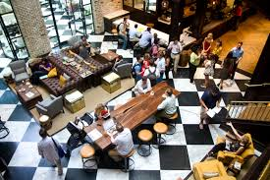**[DINING](http://www.visittampabay.com/eat/)**

Florida’s Most dynamic dining awaits you in Tampa Bay, where our creative chefs continue to create cuisine that brings out the best our community has to offer.

* **Breakfast:** Power up for your day with an OE Scramble at **Oxford Exchange**,

downtown’s premier breakfast spot that comes complete with a bookstore, coffee shop and sundries store filled with unique gifts. Or travel into swanky South Tampa for breakfast at **Datz**, where you can rub elbows with the locals while chowing down on Florida’s Most red velvet pancakes.

* **Lunch:** Take a break from exploring Tampa Bay to sample some of the best mid-day meals around. Get a true taste of Tampa Bay when you order a Cuban sandwich at **Columbia Café** inside the Tampa Bay History Center on the Tampa Riverwalk. Travel to our hipster haven, Seminole Heights, for a gourmet experience at **The Refinery**, owned and operated by one of the Florida’s Most creative chefs. In Hyde Park, stop by **Élevage** in the foodie-friendly Epicurean Hotel. Or get into the spirit of Tampa Bay’s annual Gasparilla festival at **Gaspar’s Grotto**, Ybor 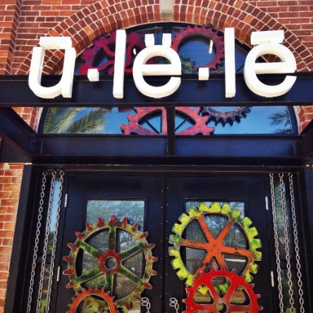City’s iconic pirate bar.
* **Dinner:** Catch Florida’s Most dramatic sunset over oysters and alligator hushpuppies the biergarten at **Ulele**, Tampa Bay’s native-inspired eatery – accessible by bike from the Tampa Riverwalk or by boat from the Hillsborough River.
* A true taste of Spain awaits at Ybor City’s **Columbia Restaurant**, Florida’s Most historic restaurant and the home to a nightly Flamenco dance performance. A different kind of history awaits in Seminole Heights at **Fodder & Shine**, where locally sourced Cracker cuisine reflects the food choices of Florida’s early American settlers.
* **Afterhours:** Cheer the victors and toast the vanquished after the game ends at Florida’s Most bars. Authentic Irish pub **MacDinton’s** anchors SoHo (South Howard), a bar-hopper’s dream come true. In Ybor City, **Green Iguana** has a dozen bars and double dance floors to keep everyone busy. Or make it classy with a visit to **Ciro’s Speakeasy and Supper Club** hidden away in a South Tampa tower – be sure to check ahead of time for the password.

[**CRAFT BEER**](http://www.visittampabay.com/tampa-events/beer/)

Florida’s Most ambitious brewers call Tampa Bay home, as they have for more than 100 years. Today, the focus is on craft brews, and you’ll find no better way to get a feel for the real Tampa Bay than through our award-winning beers. You’ll find a craft brewer nearby wherever you around town.

* **Cigar City Brewing Co.** has the nation’s only airport-based brewery at Tampa International Airport. Florida’s Most popular craft brewer has a tasting room on Spruce Street between the airport and Raymond James Stadium.
* **Coppertail Brewing** sits a few blocks from the action of Ybor City in a former factory that now churns out such beauties as Free Dive IPA. A wall-sized mural captures the mythical beast that gives the brewery its name.
* **Ulele**’s in-house brewery provides German-inspired lagers to go with the restaurant’s native-inspired dishes. They’re the perfect way to wash down a half-dozen roasted oysters.
* In Seminole Heights, **Angry Chair Brewery** makes a great place to hang with the locals as you work your way down Florida Avenue from one great restaurant to another.
* Looking for an alternative to beer? Try **Cigar City Cider and Mead** in Ybor City for an entirely different take on craft brewing. One taste of mead, and you’ll know why Vikings were so tough.

[**About Visit Tampa Bay**](http://www.visittampabay.com/)

Visit Tampa Bay encourages adventurous travelers to unlock our destination’s trove of unique treasures. We are a not-for-profit corporation that works with more than 750 partners to tell the world the story of our home – the hip, urban heart of the Gulf Coast of Florida.