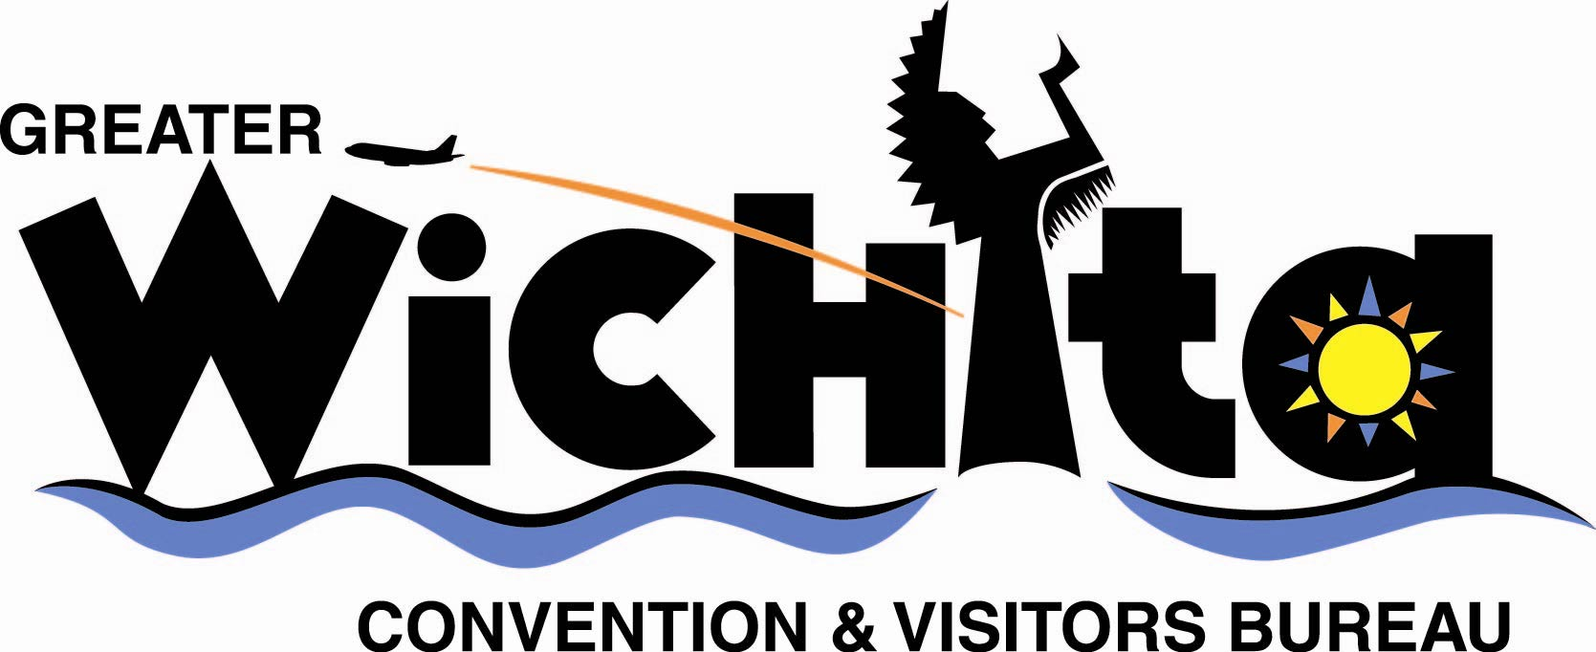

Contact:
Carrol Hassman
Publicity Chair
Wichita Chapter AGO
e-mail chas4345@cox.net
phone 316.220.6345 weekdays, 316.264.8756 evenings

Oct. 13, 2008
For immediate release

CONCERT CELEBRATES ‘INTERNATIONAL YEAR OF THE ORGAN’

(Wichita, Kan.) – The Wichita Chapter of the American Guild of Organists (AGO) is celebrating the “International Year of the Organ” (IYO) with a special concert at the First United Methodist Church, 330 N. Broadway, Tuesday, Oct. 21, 7:30 p.m.

The “Organ Spectacular” will feature the Singing Quakers of Friends University, the Wichita Brass Quintet, oboist Catherine Mitchell, and organists Brett Valliant, David Josefiak, Anna Jeter, and Carrol Hassman. The Wichita event is one of 250 similar concerts sponsored by local AGO chapters around the world to focus on the unique value of the organ and its contribution to culture. It also is designed to introduce the organ and its music to people from all ages and backgrounds.

The concert is free and open to the public.

Other International Year of the Organ events include educational outreach and visits to organ shops along with special programs featuring the organ with dance companies, brass and other instrumental ensembles, choral groups, marching bands and symphony orchestras.

The American Guild of Organists will conclude its IYO celebration with AGO regional conventions, including the Region IV convention that will take place in Wichita, June 15-18, 2008.

The American Guild of Organists, founded in 1986, is the national professional association serving the organ and choral music fields. The Guild currently serves more than 20,000 members in more than 340 local chapters throughout the United States and abroad.

For more information, contact Anna Jeter, program chair, Wichita Chapter AGO, at 316.722.2226.

# # #

