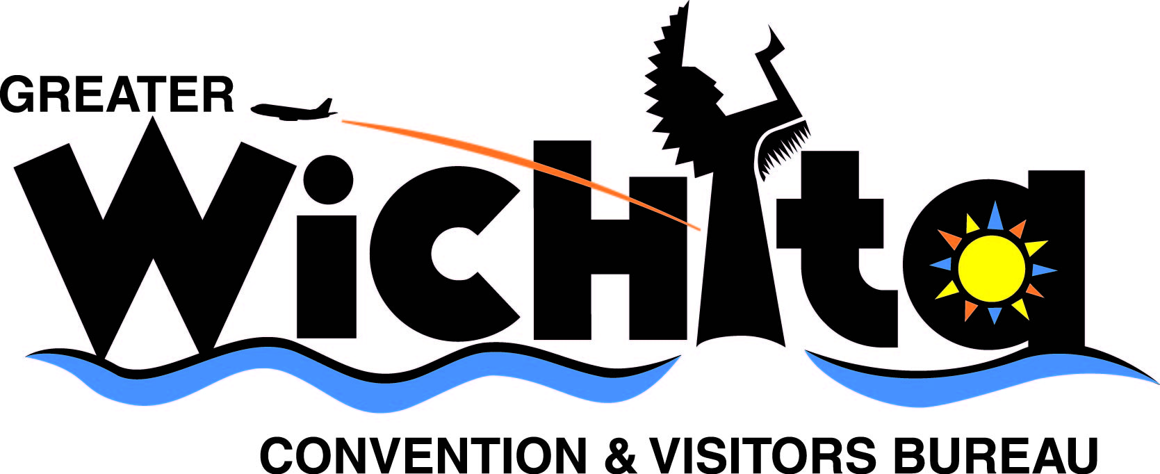

Contact:
Ken Stitt
Chairman, Central Plains E-Fly Spectacular
e-mail ken@clearviewfield.com
phone 316.680.5239 or 620.456.2291

Dec. 1, 2008
For immediate release

RADIO-CONTROL AIRCRAFT TO TURN EXPO HALL INTO FREE-FLY ZONE

(Wichita, Kan.) More than 100 pilots will be demonstrating their airmanship skills by flying their electric-powered, radio-controlled aircraft inside Expo Hall during the inaugural Central Plains E-Fly Spectacular, Dec. 13-14, 2008.

Three-time world champion radio-control helicopter pilot Curtis Youngblood is among the registered participants from Kansas, Colorado, Oklahoma and Texas. Youngblood’s flying skills also earned him 16 U.S. championships between 1983 and 2005. The mechanical engineer and businessman from College Station, Texas, is one in only a handful who has succeeded in turning his love of the radio-control hobby, flying and designing helicopters, into his profession.

The event is sanctioned by the Academy of Model Aeronautics and showcases radio-control airplanes and helicopters. Flying activities include pylon races, combat, night flying and freestyle air shows.

“There is an amazing amount of skill needed to control these aircraft while flying inside a building, but it’s a skill that is easily learned,” said Ken Stitt, event organizer and owner of Clearview Field, a radio-control aerodrome near Conway Springs, Kan. “We’re creating an event for radio-control pilots from this part of the country. We would have to travel to Champaign, Illinois, to participate in a similar event.”

The Central Plains E-fly Spectacular is open to the public Saturday, Dec. 13, 8 a.m-9 p.m. and Sunday, Dec. 14, 8 a.m.-8 p.m. General admission is $7 each day with children less than 10 years old admitted free.

For more information, go online to www.clearviewfield.com or call Ken Stitt at 316.680.5239 or 620.456.2291.

# # #

NOTE: Some of the nationally ranked pilots attending the Central Plains E-Fly Spectacular are available for telephone interviews prior to Dec. 11 or in person after 1 p.m., Friday, Dec. 12, during set up for the event. Contact Ken Stitt at 316.680.5239 or 620.456.2291 to arrange interviews.

