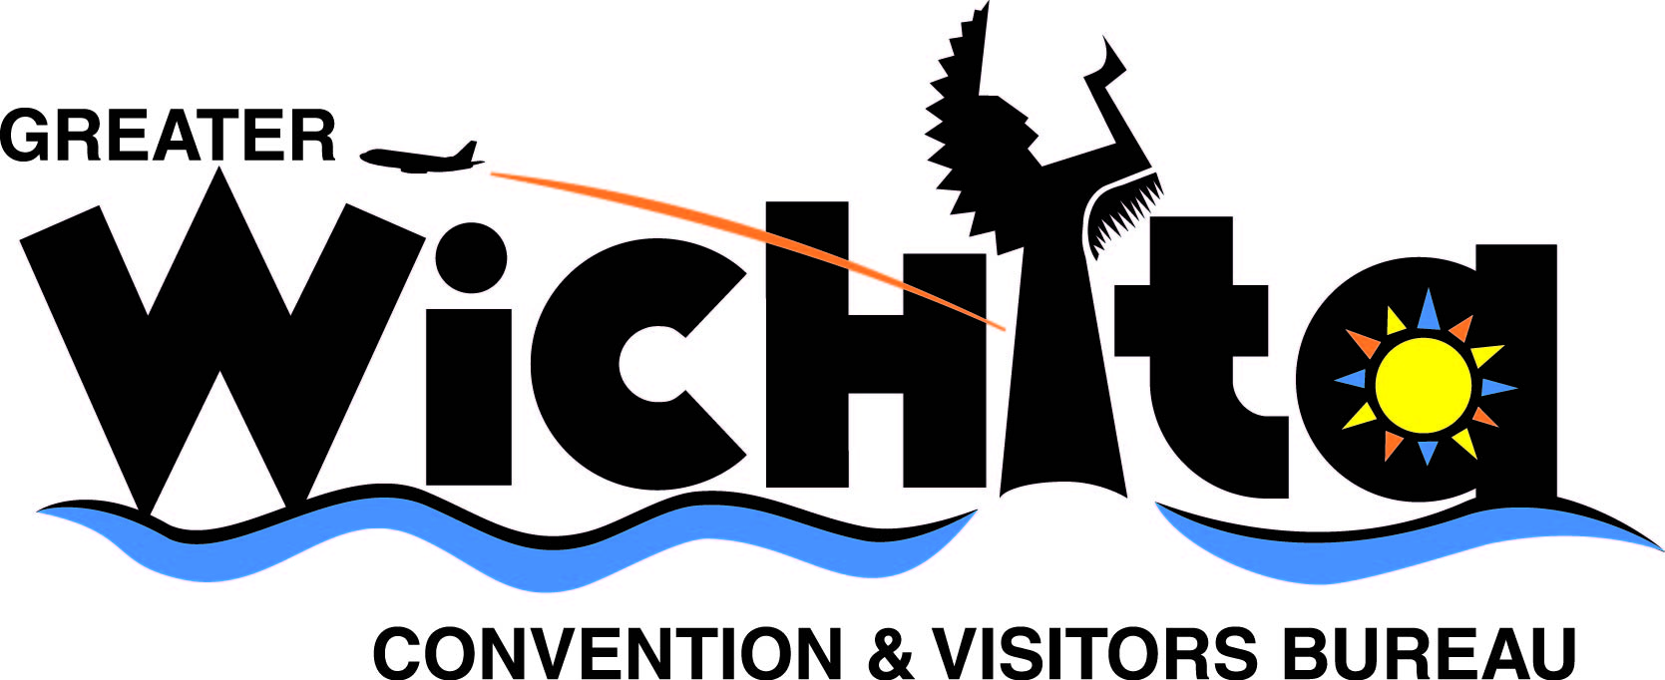

Contact:
Kevin Janke Olivier Bernier
Producer, “The Sunset Sky” Director, “The Sunset Sky”
e-mail shootinjersey@gmail.com e-mail finitemedia@gmail.com
phone 908.246.8772 phone 908.872.9489

Aug. 5, 2008
For immediate release

CAST, CREW NEEDED FOR “THE SUNSET SKY”

(Wichita, Kan.) – The producers of a feature-length film to be shot this month in Kansas are holding an open casting call for actors and working to hire production crew members.

Several scenes for "The Sunset Sky" will be shot on locations within a 50-mile radius of Wichita Aug. 18-25.

The open casting call will take place at IMG-Integrated Media Group, 143 N. Rock Island, 3rd Floor, Aug. 10-12, 2008. The producers are casting four roles with speaking parts. The movie that tells the story of a young woman who finds it difficult to care for her autistic brother after her mother’s death. After being evicted from their home, she decides to drive her brother to their father’s motel in New Jersey.

In addition to actors, the producers need production crew interns to assist with the filming. Film set experience is required and applicants must have a valid driver’s license. Two of the positions will be paid:
- Sound mixing
- Hair and makeup
Other intern positions are unpaid:
- Grip and electric
- Camera assistant familiar with the Panasonic HVX200
- Production design/set dressing
- Hair and makeup
- more -

“Sunset Sky”
Aug. 5, 2008
Page 2

Actors or production crew members interested in scheduling an interview appointment should contact Kevin Janke, producer, via e-mail at shootinjersey@gmail.com.

For more information about the production, visit www.thesunsetsky.com, or contact Kevin Janke, producer, at 908.246.8772 or shootinjersey@gmail.com.

The Wichita Film Commission, a division of the Greater Wichita Convention & Visitors Bureau is assisting the production company by coordinating the site for the casting call, finding production crew members and scouting locations. For more information on the Wichita Film Commission, contact Olivia Simmons at 316.660.6308 or osimmons@visitwichita.com.
# # #

