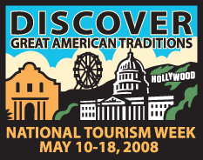
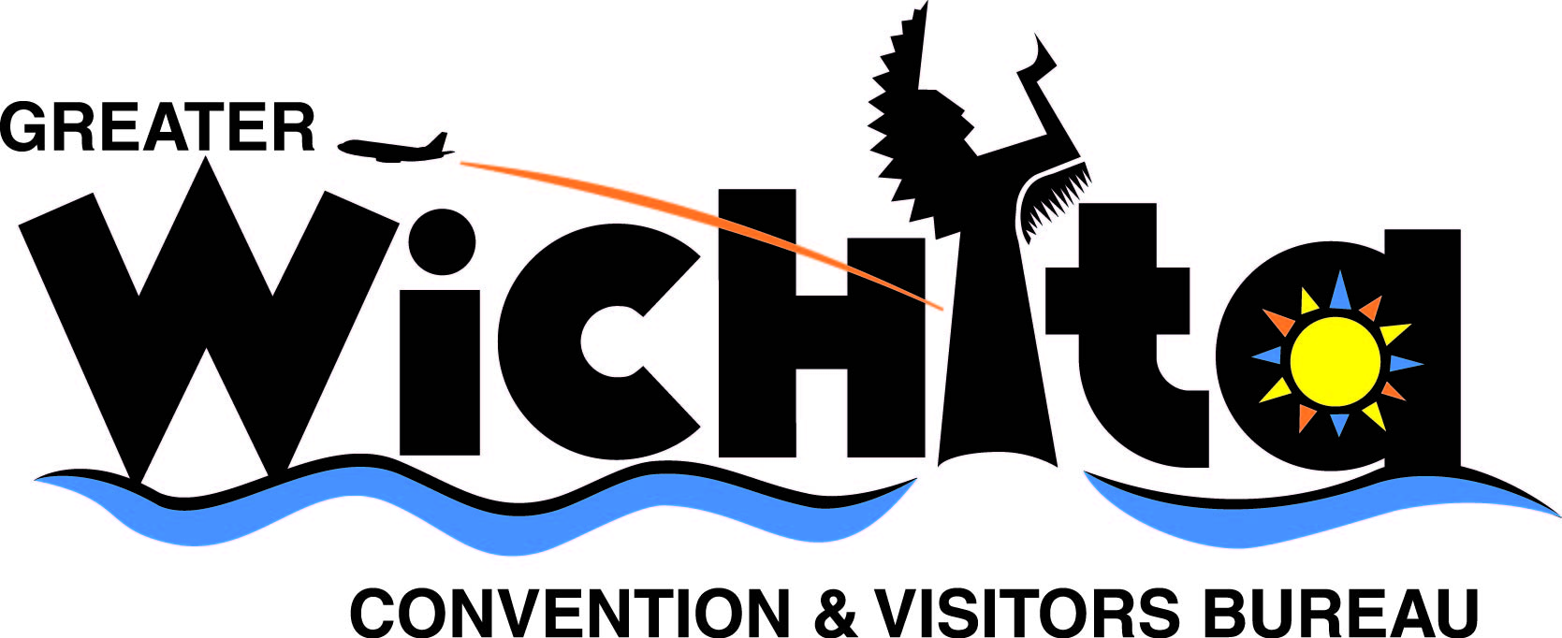

Contact:
Ken Vandruff
Director of Communications & Marketing
Greater Wichita Convention & Visitors Bureau
e-mail kvandruff@visitwichita.com
phone 316.660.6305

May 8, 2008

BE A TOURIST IN YOUR OWN TOWN

“Discover Great American Traditions” in Wichita during National Tourism Week

(Wichita, Kan.) – The Greater Wichita Convention & Visitors Bureau urges Wichita families trying to balance vacation plans with rising fuel prices to plan a “Stay-cation” and look at their hometown with the eyes of a tourist. The average family of four can save at least $200 on a three-day “Stay-cation” that never leaves southcentral Kansas.

The “Stay-cation” idea is just one way that the GWCVB is celebrating the 25th Annual National Tourism Week – “Discover Great American Traditions.” The week calls attention to the value and scope of the nation’s $740 billion travel and tourism industry. The week also recognizes the economic and social contributions that travel and tourism bring to Wichita and Kansas.

This year’s theme, “Discover Great American Traditions,” encourages travel to American locales and highlights the role that tourism plays in discovering the icons of a destination. The GWCVB will deliver coupons for free McDonald’s® apple pies along with packets of coffee from the Spice Merchant to Transportation Security Administration employees, ambassadors and airline personnel at Wichita’s Mid-Continent Airport to show appreciation for their work to make a visitor’s arrival or departure as stress free as possible.

The GWCVB also urges Wichitans to wear red shirts on May 9 to show support for tourism. The leisure and hospitality industry employs more than 27,000 people in the Wichita area and generates an annual payroll of $323 million. Nearly 3.5 million travelers visit the area each year contributing an economic impact of $356 million a year.

“All Wichita businesses, not just hotels and meeting facilities, attractions, restaurants and transportation providers, benefit from the economic impact generated by people visiting our city,” said John Rolfe, GWCVB president and CEO. “This week celebrates the people who visit here, the workforce that provides services for them and the business development created as a result.”

Nationwide, the U.S. travel industry directly employees 7.5 million people, generates payroll of $178 billion and tax revenues of about $110 billion. TIA ranks travel fifth among 20 major private industry sectors. Visitors to the U.S. spent more here than U.S. residents traveling abroad, creating a positive balance of trade of $8.3 billion for the national economy. Travel expenditures within the United States total $740 billion.

Local sponsors for National Tourism Week include McDonald’s® Restaurants of Wichita, the Spice Merchant and Company and George Lay Signs. The week is sponsored nationally each year by the Travel Industry Association, a Washington, D.C.-based trade association that represents the common interests and concerns of travel in America.

# # #

