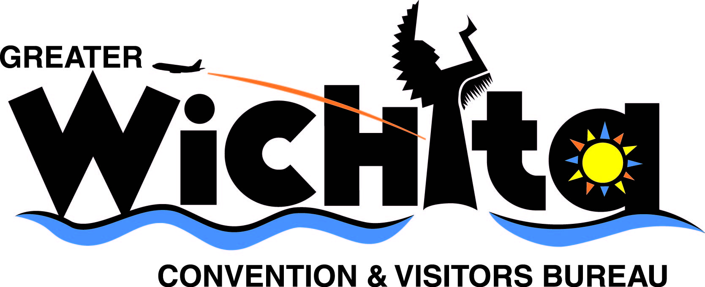

Contact:
Ken Vandruff
Director of Communications & Marketing
e-mail kvandruff@visitwichita.com
phone 316.660.6305

Feb. 12, 2008
For immediate release

MEDIA REMINDER

GWCVB 2008 TRAVEL INDUSTRY OUTLOOK ANNUAL MEETING

(Wichita, Kan.) Maximizing travel and tourism’s impact on the Wichita economy is the centerpiece for the Greater Wichita Convention & Visitors Bureau’s 2008 Travel Industry Outlook Annual Meeting. The event is scheduled 7:30 a.m., Thursday, Feb. 19, 2009, at the Hyatt Regency Wichita.

Keynote speaker is Peter Yesawich, chairman and CEO of YPartnership, one of the nation’s most-respected tourism marketing agencies. Peter’s keen insight on national travel trends makes him the go-to resource for such publications as “The New York Times,” “The Los Angeles Times” and “The Wall Street Journal,” and he can be seen on CNN, CNBC and MSNBC, as well as heard on National Public Radio.

Sam Williams, managing partner, P. Scott Flemming, vice president and creative director, and Jennifer Whetzel, senior brand strategist, Sullivan Higdon & Sink will present the results of research into what travelers think of Wichita, then unveil a new destination marketing campaign for the region.

Additionally, Wichita Mayor Carl Brewer will share his vision for the revitalization of the downtown area and its impact on tourism.

Tickets are $45 for individuals or $360 for a table of eight. For more information, go online to VisitWichita.com or call 316.265.2800.

# # #

