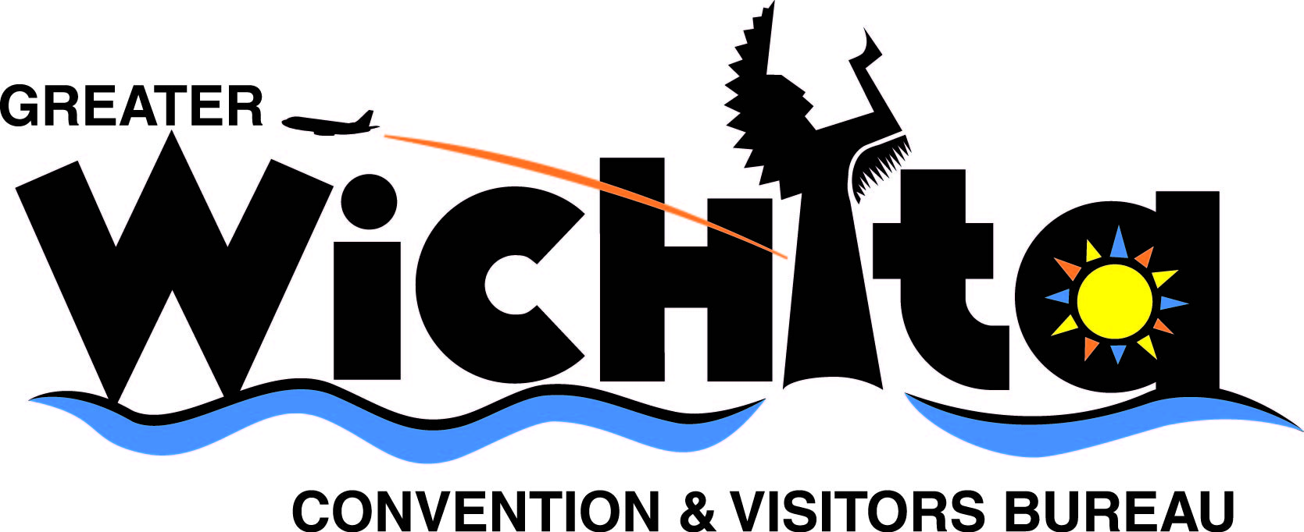

Contact:
Ken Vandruff Mark Boardman
Director of Communications & Marketing True West Magazine, Features Editor
kvandruff@visitwichita.com mboardman@twmag.com
316.660.6305 765.491.4063

Jan. 16, 2009
For immediate release

True West Magazine Picks Wichita as a 2009 Top Western Town

Back in the early 1870s, Wichita, Kan., became one of the first cowtowns, the destination for the great Texas cattle drives.

The drives have been history for over 130 years. And Wichita has become a center for airplane manufacturing (Boeing, Cessna, Hawker Beechcraft, Bombardier Learjet, Spirit AeroSystems and Airbus North America are all located here). But the rough and tough heritage has not been forgotten; it’s being saved and celebrated.

That’s why Wichita was named one of True West Magazine’s 2009 Top Ten True Western Towns.

The evidence is clear. The Old Cowtown Museum re-creates the town in its 1865-1880 period, featuring the first log home, the home of the founder of The Wichita Eagle newspaper (which is still printed today), and a Presbyterian church. It also hosts special events—including re-enactments of cattle drives and shoot-outs.

Locals are staying on top of maintaining the more than 100 historic sites in town. The 1922 Orpheum Theatre is currently being restored. Wichita recently completed a $20.6 million beautification project along the Big and Little Arkansas Rivers. The land between the rivers is sacred to the Wichita Indians; it is home to the Mid-America All-Indian Center, which has undergone a $700,000 renovation.

“Wichita is one of those legendary names of the Old West—but local folks haven’t rested on that,” says True West Executive Editor Bob Boze Bell. “Their dedication to preserving and promoting history encourages a modern kind of drive—tourism—that city founders would be proud of.”

Past top town recipients are St. Joseph, Missouri (2008), Helper, Utah (2007) and Sheridan, Wyoming (2006).

Wichita was nominated for the award by the Greater Wichita Convention & Visitors Bureau. The GWCVB and City of Wichita submitted information about the city’s history and preservation efforts to support the nomination.

“Wichita is a modern, progressive city that also understands the importance of its history,” says John Rolfe, president and CEO of the Greater Wichita Convention & Visitors Bureau. “It is an honor to be included on the list of Top True Western Towns.”
- MORE -
Wichita Top Western Town
Jan. 16, 2009
Page 2

True West editors determine winners for this annual award based on criteria demonstrating how each town has preserved its history through old buildings, museums and other institutions, events, and promotion of historic resources.

The feature includes Towns to Watch for their good works in historic preservation and several legendary locales that folks should know.

True West magazine is in its 56th year of leading the way in presenting the true stories of Old West adventure, history, culture and preservation. For subscriptions and more information, visit www.twmag.com or call 888-687-1881.

Contact: Mark Boardman, True West features editor, 765.491.4063, mboardman@twmag.com

# # #

