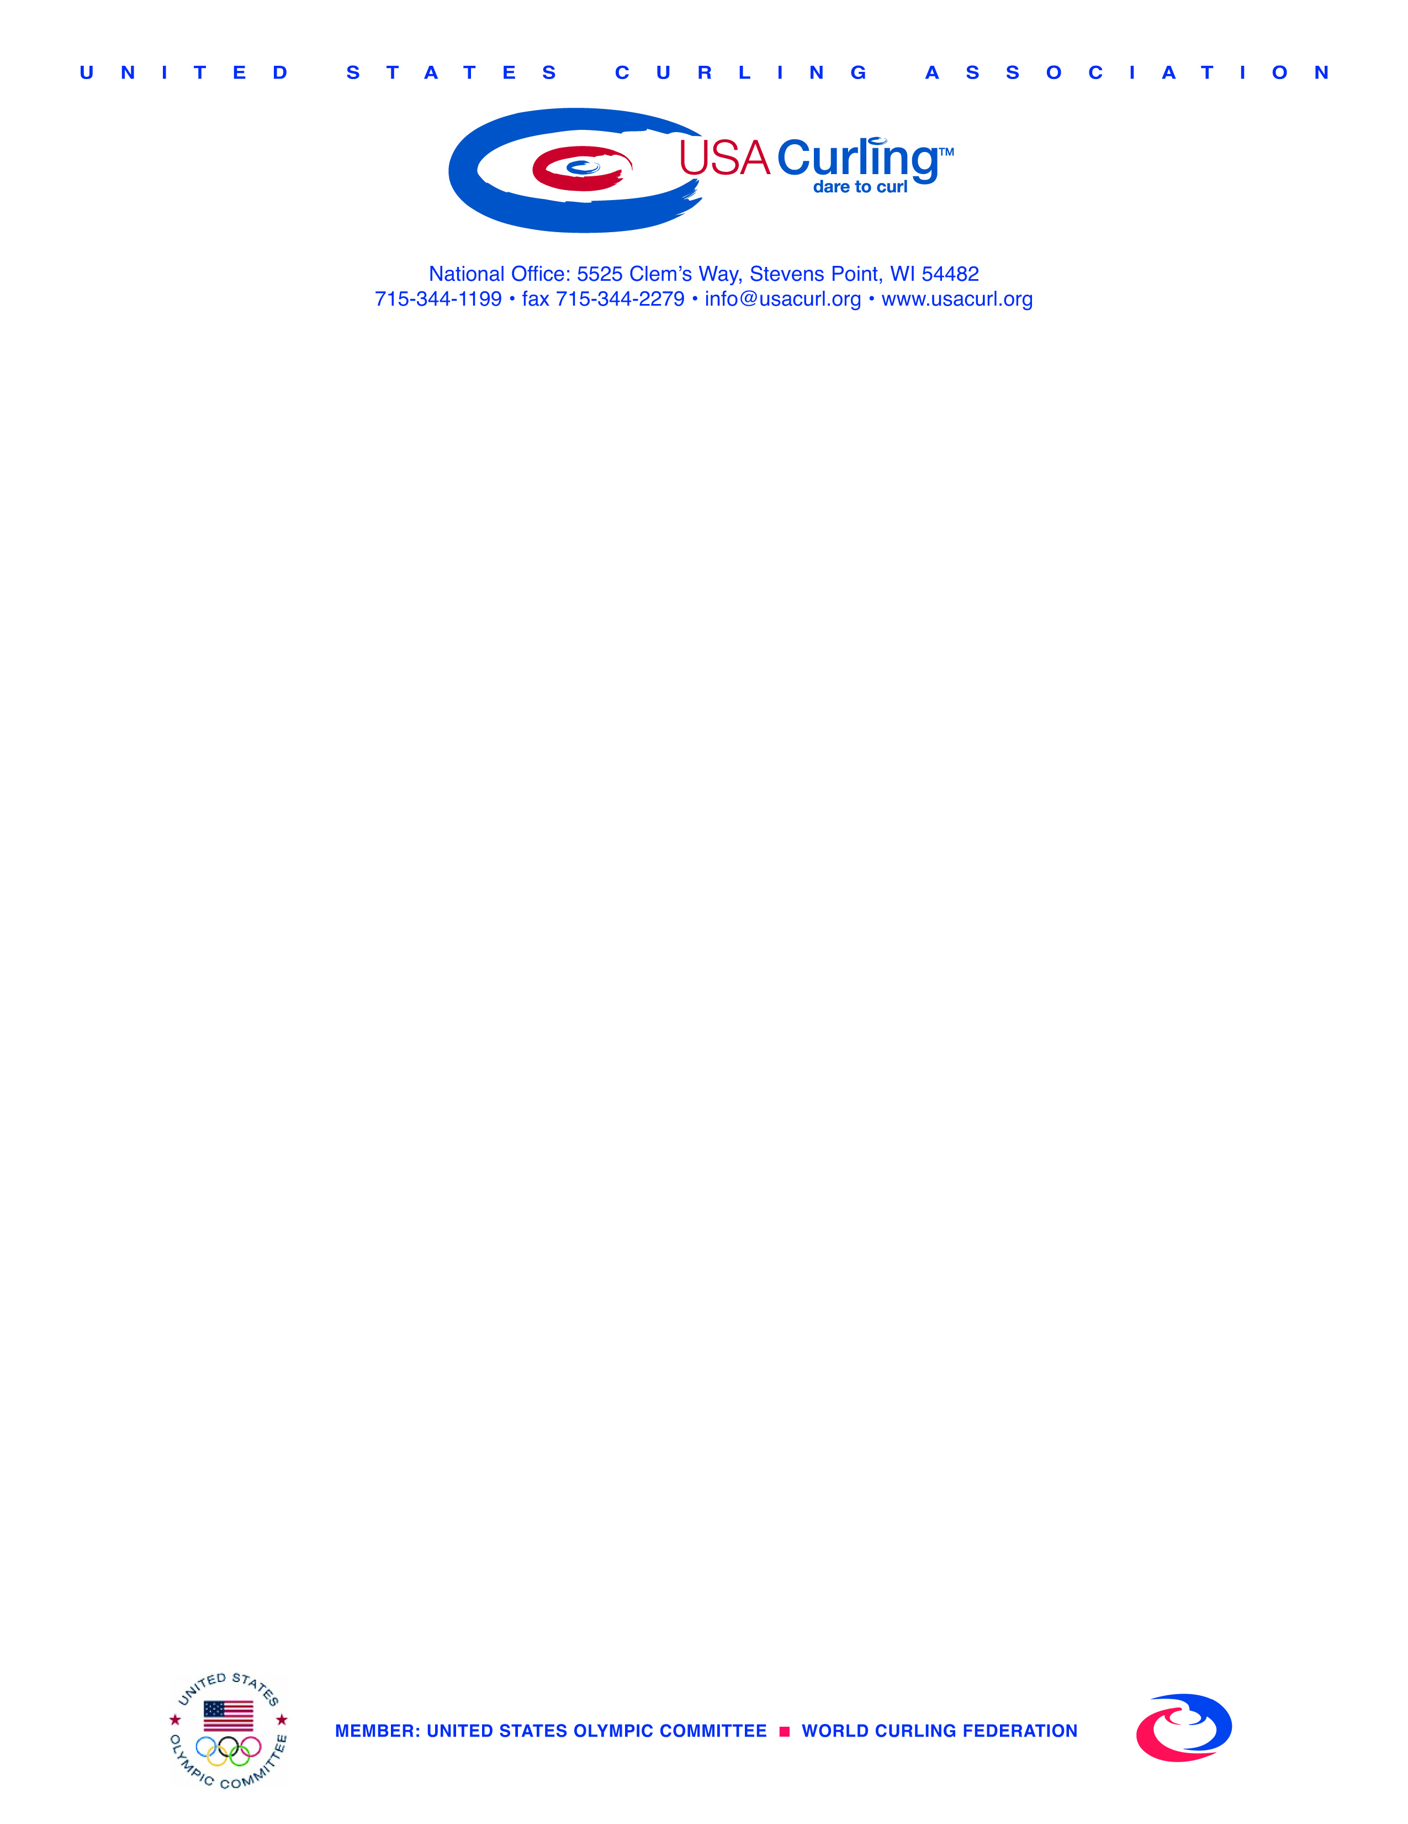

FOR IMMEDIATE RELEASE
July 18, 2016

Omaha set to host 2018 U.S. Olympic Team Trials for Curling

(STEVENS POINT, Wis.) – Omaha, a city very familiar with hosting Olympic Trials, has been selected as the site for the 2018 U.S. Olympic Team Trials for Curling.

“We are very excited about the potential for our sport’s growth in Omaha and across the United States as we bring the upcoming U.S. Olympic Team Trials for Curling to Nebraska for the first time. Much like when Omaha was selected to host its first of what has now been three straight Olympic Trials for USA Swimming, I suspect this announcement may cause a little head scratching around the curling community. Especially since we had very strong bids from several cities that have done a great job hosting major championship curling events previously,” said Rick Patzke, USA Curling’s chief executive officer. “Along with our entire selection panel, I was highly impressed by the professionalism of the bid, the facilities to be used, and the partnership between the Omaha Sports Commission, University of Nebraska Omaha’s Baxter Arena, and the Aksarben Curling Club. The additional information gathered in a site visit confirmed that Omaha is serious about making these the best Olympic Trials ever for curling, and we believe that the competing athletes and fans in attendance will ultimately find that to be true.”

The event will be hosted by UNO’s Baxter Arena and the Omaha Sports Commission, in partnership with the Aksarben Curling Club.

“We are very excited to host our first winter Olympic Trials, building on the success of the recent 2016 U.S. Olympic Team Trials for Swimming,” said Wesley Hall, Chief Operating Officer of the Omaha Sports Commission. “We worked closely with University of Nebraska Omaha officials and the Aksarben Curling Club in putting together this bid and believe Baxter Arena will be a great venue for the Olympic Curling Trials.”

“Hosting the 2018 U.S. Olympic Team Trials for Curling in Omaha is sure to get Omaha excited about curling,” said Steven Taylor, president of the Aksarben Curling Club, which currently has 136 members. “Centrally located in the Mid-America Region, Omaha is well-positioned to provide facilities, instruction, and competitive opportunities for junior, college, and adult curlers from Texas to South Dakota to develop the skills and experience necessary to compete on the national and international level. Aksarben is delighted to be able to work with Baxter Arena, our Nebraska universities, and local schools to leverage the upcoming Olympic buzz to grow our community into a regional curling hub.”

The Trials will take place Nov. 12-19, 2017*, at Baxter Arena, a 7,800-seat multi-purpose facility that opened in 2015 on the University of Nebraska Omaha campus across from Aksarben Village. The 2018 Olympic Team Trials for Curling will mark the first time that Omaha, which hosted the 2016 U.S. Olympic Team Trials for Swimming earlier this month, will host a major curling event.

“Omaha has been the first stop for many world-class athletes on their way to the Olympic Games and we are grateful the University of Nebraska Omaha will be a part of that tradition,” said Trev Alberts, University of Nebraska Omaha Vice Chancellor of Athletics. “We can’t wait to welcome local and national fans to experience this unique Olympic event and have the chance to show off UNO's Baxter Arena to a world audience."

“Before building Baxter Arena, we toured some of the most highly-regarded arenas in the nation to guarantee we’d get it right,” said Mike Kemp, University of Nebraska Omaha Associate Athletic Director. “This is more proof that we did just that. Everything from humidity levels to ice temperature are accounted for at Baxter. For Curling, in particular, these world-class ice conditions are critical, especially at an event like the Olympic Trials. Future Olympians will soon learn UNO offers some of the best competition ice in the nation.”

Also in the running to host the Trials were Jacksonville, Fla.; Ogden, Utah; Philadelphia, Pa.; and Provo, Utah. The Olympic Team Trials Selection Panel of Shawn Olesen, Allison Pottinger, Sam Williams, Jennifer Stannard, Derek Brown, Mike Dellemann, and Rick Patzke reviewed the bids and made the final site selection.

The 2018 Olympic Winter Games will take place Feb. 9-25, 2018, in PyeongChang, South Korea. A field of a maximum five men’s teams and five women’s teams will compete at the 2018 U.S. Olympic Team Trials for Curling for a chance to represent the U.S. in South Korea.

Teams can begin qualifying for the Olympic Team Trials in 2017. To read the complete team selection procedures, go to www.usacurl.org.

*final event dates contingent on number of competing teams

About the Omaha Sports Commission: Created in 2003, the Omaha Sports Commission is a not-for-profit entity dedicated to making Omaha one of the premier sports communities in the United States. The Commission works closely with area businesses and community leaders to recruit and promote amateur sporting events. The OSC is a “total service event team”, meaning that it is involved in all aspects of event management from bid preparation and selection to event hosting and event enhancement to post-event evaluation.

About the Aksarben Curling Club: The Aksarben Curling Club boasts 136 members and has a college program that includes teams from the University of Nebraska Lincoln, University of Nebraska Omaha, University of Nebraska Medical Center, Creighton, and Wayne State, with UNL and Wayne State having competed in the 2016 College National Championship. Starting this fall, the club’s Junior Program will include three age groups, elementary through high school, and is open to all students. Aksarben runs beginner’s leagues and learn-to-curls October through March. Open houses will take place October 2 and Oct. 23 at Baxter Arena. For more information, visit CurlAksarben.com or follow the club on Facebook at facebook.com/CurlAksarben or on Twitter @CurlAksarben.

(30)

For more information: Terry Davis, Director of Communications, terry.davis@usacurl.org, 608-338-9900 (mobile) or 715-344-1199, Ext. 202 (office). In Omaha, contact Doug Parrott, dcparrott@cox.net, 402-305-1625.

