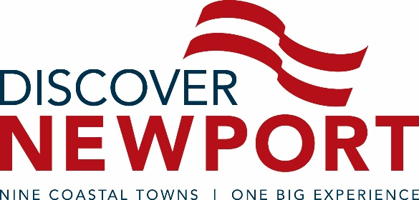

**FOR IMMEDIATE RELEASE**

CONTACT: Andrea McHugh, 401-845-9151

Marketing & Communications Manager

Discover Newport

[amchugh@discovernewport.org](mailto:amchugh@discovernewport.org)

**Discover Newport Announces New Board of Directors Appointments**

*New leadership brings fresh expertise and strategic direction to the tourism agency.*

Newport (R.I.) December 22, 2016 – Discover Newport, the official destination marketing organization for Newport and Bristol counties, has appointed three new members to its Board of Directors in accordance to the organization’s governing bylaws. The board has also elected new leadership to various board committees.

T.R. McGrath, president of McGrath Clambakes, holds a Bachelor of Science in Environmental Engineering from Virginia Tech and spent several years in that field before returning to take over the family business. The native Newporter has been featured on the Food Network as well as several other national television programs and publications showcasing the “art of a traditional, old fashioned clambake.”

Marco Camacho has been appointed by and will represent the City of Newport. A graduate of Providence College, Camacho served as a captain in the U.S. Army and later worked in the finance industry in New York City. Today, Camacho is Managing Director and equity partner for New England Sports Marketing Group, LLC, a sports entertainment venture.

Kristine Cox has served as general manager at The Newport Harbor Hotel and Marina in Newport since 2013. She holds an associate degree in hospitality from Horry Georgetown Technical College in Myrtle Beach, SC, and was awarded General Manager of the Year for Shaner Hotel Group in 2014. Cox also has a seat on the boards of the Rhode Island Hospitality Association and The American Hotel Lodging Association.

Active board members with newly appointed leadership positions include Brewer Rowe, who has been elected Chairman of the Discover Newport Board of Directors. Rowe serves Senior Vice President of Tennis Operations at the International Tennis Hall of Fame. He holds a Bachelor of Arts in French from the University of Vermont. The appointment was made by election amongst the board’s 18 members. Kathleen Seguin, owner of Bristol House Bed and Breakfast in Bristol, has been elected Vice Chair. Keith Chouinard, Director of Sales & Marketing at the Hotel Viking in Newport, will serve as treasurer. Matt Gineo, general manager of Old Port Marine Services, will serve as secretary.

President and CEO of Discover Newport, Evan Smith, is enthusiastic about the new appointments. “There are many important issues facing our industry today and I am confident our board is up to the challenge. I am both excited and inspired by our new leadership,”

###

**ABOUT DISCOVER NEWPORT**

Discover Newport is the official destination management organization (DMO) dedicated to promoting the City of Newport and the eight surrounding coastal townships in Newport and Bristol counties, Rhode Island. These include Barrington, Bristol, Jamestown, Little Compton, Middletown, Newport, Portsmouth, Tiverton and Warren. As a non-profit organization, Discover Newport partners with stakeholders throughout our tourism and hospitality industry to market the region as a premier destination for business and leisure travel. DiscoverNewport.org