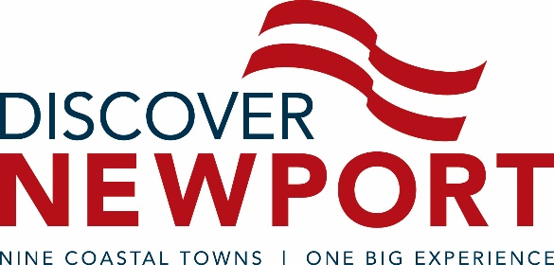

FOR IMMEDIATE RELEASE
CONTACT: Andrea McHugh, 401-845-9151
Marketing & Communications Manager
Discover Newport
amchugh@discovernewport.org

Guest Speaker Jill Marinelli to Kick Off Discover Newport’s 2017 Marketing Meetings
The stylist will offer insightful solutions for professionals looking to make a lasting impression.

Newport (R.I.) January 6, 2017 – Discover Newport, the official destination marketing organization for Newport and Bristol counties, will launch its 2017 monthly marketing meeting schedule on Wednesday, January 11, at 11 a.m., at Rosecliff in Newport. Following a short industry briefing, professional stylist Jill Marinelli will present, “The Power of Personal Style: How to Make a Memorable First Impression While Boosting Your Confidence – and Your Bottom Line.”
“It’s true: you never get a second chance to make a first impression. Countless studies have shown that, unfair as it may be, in as little as a tenth of a second people may determine one’s trustworthiness, intelligence and competence,” said Marinelli. “No matter your company culture, what you wear in the workplace represents you, your title, your company and your colleagues. I’m excited to share my strategies with area marketing and hospitality professionals so that their style will project confidence and competency, and that most importantly, their experience, effectiveness and excellence will shine though.”
Discover Newport began hosting monthly marketing meetings more than a decade ago to offer a platform where hospitality and tourism marketing professionals could gather, inform, educate, network and exchange ideas. The meetings, which typically unfold on the first or second Wednesday of the month at 11 a.m., are free and open to the public. Meeting venues rotate as to showcase the myriad diverse event spaces throughout the destination. To receive monthly marketing meeting updates, professionals can sign up at discovernewport.org (bottom on the homepage).
Rosecliff, a property of The Preservation Society of Newport County, is located at 548 Bellevue Avenue in Newport.
###
ABOUT DISCOVER NEWPORT
Discover Newport is the official destination management organization (DMO) dedicated to promoting the City of Newport and the eight surrounding coastal townships in Newport and Bristol counties, Rhode Island. These include Barrington, Bristol, Jamestown, Little Compton, Middletown, Newport, Portsmouth, Tiverton and Warren. As a non-profit organization, Discover Newport partners with stakeholders throughout our tourism and hospitality industry to market the region as a premier destination for business and leisure travel. DiscoverNewport.org

