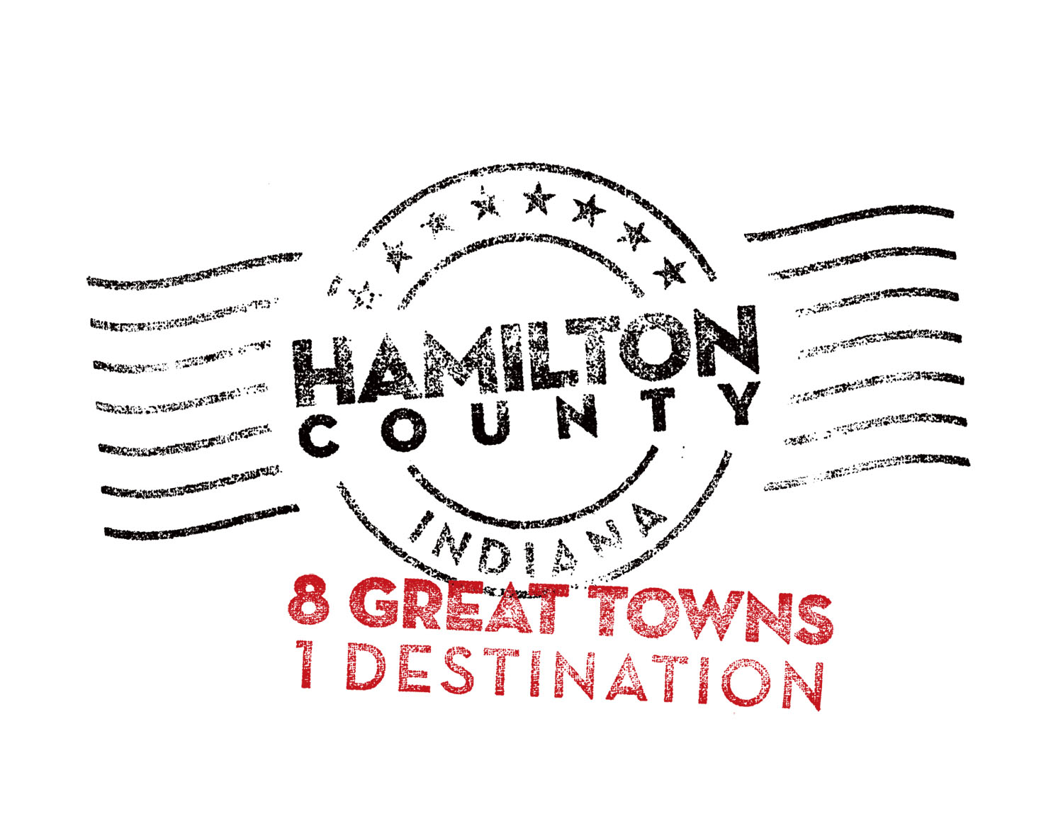

For immediate release

Contact: Jo Ann Klooz

317-258-2087

**$70,000 in Tourism Development Grants to Support Hamilton County Venues**

CARMEL, Ind.– More than $70,000 in grants from the Hamilton County Convention and Visitors Bureau will support 14 non-profit organizations and everything from a chili cook-off to a national vocal competition.

The grants, specifically earmarked for projects supporting tourism development and marketing, are part of an annual overall investment of almost $500,000 in tourism community development initiatives by the Bureau in 2012. Other funds support the Nickel Plate Arts initiative, and debt service on the Tourism Development Bond, an expansive community development initiative launched in 2011.

“This is our first competitive grant program in two years,” Hamilton County CVB Executive Director Brenda Myers said. “We are delighted we can begin working again with our non-profit organizations and festivals in helping raise their profile in the marketplace.”

Funding for the grant and community development programs comes through the county’s five percent lodging tax for out of area visitors at more than 30 hotels or bed and breakfasts. Grants awarded will be used to support festivals, events, marketing and operations. Applicants had to show their tourism audience size and potential, and their marketing outreach beyond Hamilton County.

Annually almost 2 million visitors come to Hamilton County for concerts, museums, sports events, and other activities. More than 5,000 people are employed by the county’s hospitality industry.

Awards by organization include: Actors Theater of Indiana, $2,000; Carmel Arts & Design District, $4,500; Carmel Clay Historical Society, $4,425; Carmel International Arts Festival, $1,500; Center for the Performing Arts, $5,000; City of Noblesville Parks Department, $12,500; Civic Theater, $5,000; Conner Prairie, $15,000; Fishers Freedom Festival, $3,000; Fishers Renaissance Faire, $5,000; Indiana State Chili Championship, Cicero, $250; Michael Feinstein Initiative, $2,000; Museum of Miniature Houses, $2,000; Westfield Parks Department, $10,000.

A detailed list of the 2012 grants and how they will be used is available at [8GreatTowns.com](http://www.8greattowns.com). The 2013 grant program will be announced in January.

The Hamilton County Convention and Visitors Bureau promotes tourism growth through strategic marketing, hospitality and community development initiatives. It has welcome centers in Carmel, Fishers, and Noblesville.

###