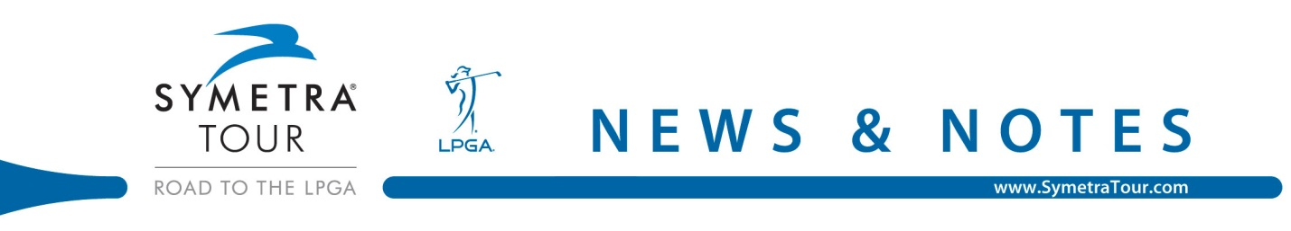

My Marsh Golf Classic
The Hawthorns Golf & Country Club
Final Round News & Notes
June 3, 2012

Sara Brown Captures Win at My Marsh Golf Classic
“Volvik Race For the Card” Continues At My Marsh Golf Classic
Sara Brown Wins PeakVision Sunglasses For Final Round Low Score
Tweet of the day

Sara Browns Captures Win at My Marsh Golf Classic
Known for her contagious smile and bubbly personality the normally outgoing Sara Brown was filled with emotion after shooting a final-round 3-under par 69 at The Hawthorns Golf & Country Club to win the inaugural My Marsh Golf Classic.

Filled with confidence after the purchase of new irons Brown came into this tournament with an inclination she was going to walk away with the trophy.

“Awesome,” said Brown of her first Symetra Tour victory. “To be honest I guess you should go into every tournament thinking you are going to win but this one is on a new golf course and I was just ready to play. I got some new wedges in the bag and I just hit them good, hit my drives good and the greens were amazing.”

When Brown began the day with a 5-under par front nine that included three consecutive birdies on Nos. 7, 8 and 9 it looked as if the former Michigan State University Spartan was going to walk away with the title. It wasn’t until a few missed up-and-down opportunities that Brown’s lead dwindled to one.

Playing in the group behind her Victoria Elizabeth rebounded from a double-bogey on the 10th hole with back-to-back birdies on 14 and 15 to move her to within one stroke of the lead.

“I played steady but hit three shots over the green coming down the stretch and just didn’t get up-and-down,” said Brown. “I thought the person closest to me was Jean (Chua) so I’m playing with her and thinking I’m going to make her make birdies and I’m going to make pars, that’s it.”

Brown attempted to avoid looking at scoreboards all day but a brief backup forced her to take a glance at Elizabeth’s score and that is when she realized her lead was down to one.

“She (Elizabeth) birdied 15 to go to 4-under then she just missed a birdie chance on 16, I could see it all happening in front of me and I’m just thinking be calm and do what you have to do,” said Brown.

Elizabeth came into the par-4 18th one-stroke behind Brown until an unfortunate bounce left her in the hazard and forced her to take a drop. Elizabeth then knocked her third shot on the green and two putted for bogey.

Brown capitalized on Elizabeth’s mistake and pared the last hole to fire rounds of 75-67-69 and secure a 2-stroke victory for her first Symetra Tour win.

While Elizabeth narrowly missed notching her first victory on the Symetra Tour, the second year professional feels confident heading into the next two tournaments in Iowa and Illinois.

“I feel really good about my game, I learned a lot this week,” said Elizabeth. “I’m hitting it good, putting good and I feel like everything is finally coming together so I’m just going to keep hitting good shots and putting myself in position.”

“Volvik Race For the Card” Continues At My Marsh Golf Classic
The Symetra Tour’s annual “Volvik Race For the Card” continued with the conclusion of the My Marsh Golf Classic. The “Volvik Race For the Card” spotlights movement on the Tour’s 2012 season money list as players jockey for position among the top-10 money winners. Players finishing in the top-10 at the conclusion of the tournament season will earn exempt status on the 2013 LPGA Tour.

Brown has already gotten a taste of the LPGA Tour during her rookie season in 2011 and a return next year is right up there on her priority list.

“It would be amazing,” said Brown of earning her LPGA card through the Volvik Race for the Card. “I missed my card again last playing on Tour and I didn’t make it through Q-School so it would be awesome to get my card again, I would love it.”

A victory this week launched Brown up the Volvik Race for the Card standings from No. 60 to No. 4. Other notable moves this week were Victoria Elizabeth who jumped from No. 41 to No. 9 and Paola Moreno who moved from No. 40 to No. 13.

At the conclusion of the My Marsh Golf Classic, players moving into the top 10 spots on the money list are as follows: 1. Esther Choe of Scottsdale, Ariz., $33,750; 2. Megan McChrystal of Stuart, Fla., $20,868; 3. Jean Chua of Kuala Lumpur, Malaysia, $17,600; 4. Sara Brown of Tucson, Ariz., $16,532; 5. Nicole Smith of Riverside, Calif., $14,845; 6. Sara Maude Juneau of Quebec, Canada, $13,153; 7. Mi Hyang Lee of Incheon, South Korea, $12,932; 8. Ginger Howard of Bradenton, Fla., $11,596; 9. Victoria Elizabeth of Daytona, Ohio, $11,526; 10. Cara Freeman of Chandler, Ariz., $11,324

Lee Wins PeakVision Sunglasses For Final Round Low Score
For her final-round low score of 3-under 69, Sara Brown of Tucson, Ariz. was the recipient of a pair of PeakVision patented Dual-Zone lens sunglasses designed specifically for golfers. The “Official Sunglass of Symetra Tour,” PeakVision will provide sunglasses for the season-long promotion Sunday Low Round Award. Brown shot rounds of 75-67-69 to notch her first Symetra Tour victory.

Tweet of the day…Love seeing a @ROAD2LPGA event being recognized along with the other professional tours on @golfchannel #SymetraTour – Natalie Sheary (@NatSheary)

