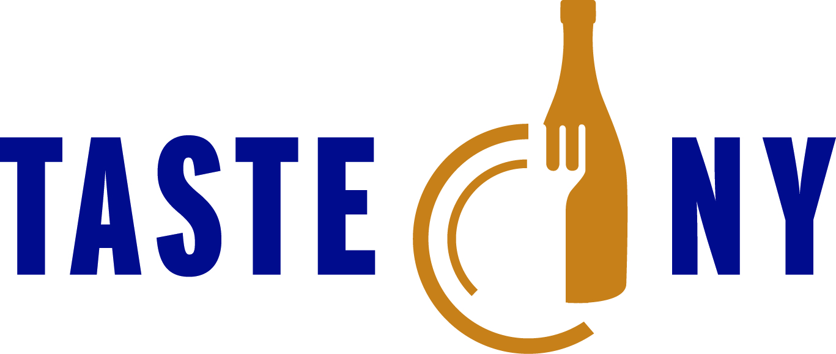

TASTE NY Brunch Participating Chef Bios

Brud Holland
Food Bank of the Southern Tier

A graduate of New England Culinary Institute with 25 years of restaurant industry experience highlighted by 10 years as a restaurant and bakery owner in Watkins Glen, New York and 15 years as a Culinary Instructor at 171 Cedar Arts, a community based Arts organization in Corning, New York. Currently working with the Food Bank of the Southern Tier developing a youth program called "Fresh Futures" exposing school aged students to fresh fruits & vegetables through weekly cooking lessons and visits to local farms in the Finger Lakes Region.
http://www.foodbankst.org/

Marc Murphy
Ditch Plains

Chef Marc Murphy has logged more than 20 years in the restaurant business, working in some of the world’s most highly esteemed kitchens. Today, he serves as Executive Chef and Owner of Benchmarc Restaurants (Landmarc + Ditch Plains) and Benchmarc Events by Marc Murphy. He is the Vice President of the Manhattan chapter of the New York State Restaurant Association, a board member of City Harvest, Culintro and Passport NYC at the 92nd Street Y Culinary Camp. As well as a member of the Food + Finance High School Industry Advisory Board, a member of the Leadership Council for Share our Strength’s No Kid Hungry campaign and the national spokesperson for Share Our Strength’s Dine Out For No Kid Hungry. In 2012, Marc joined the U.S. Department of State’s Diplomatic Culinary Partnership, where he takes part in public diplomacy programs that engage foreign audiences abroad as well as those visiting the United States.
http://www.marc-murphy.com/

Peter Hoffman

Back Forty

Peter Hoffman is the chef owner of Back Forty (2007) and Back Forty West (2012) the restaurant he opened on Prince St. after operating Savoy (1990) in the same location for over 20 years. Both restaurants work with a simple premise - to create delicious and memorable meals by sourcing the very best seasonal ingredients from local farmers, serving it in a casual intelligent setting. Termed by the New York Times “A Locavore Before the Word Existed”, Hoffman has a long commitment to seasonal cooking along with an awareness of the environmental impact of his sourcing. Hoffman served on the advisory board of the Greenmarket from 1986 - 1999 and Chefs Collaborative, the organization of culinary professionals promoting sustainable food choices in the restaurant industry from 1997 until 2010, acting as its national chair from 2000-2006.

Joe Realmuto
Nick and Toni's

Joseph Realmuto began his culinary career at the Culinary Institute of America. While attending CIA in 1991, he interned and then worked under John Laughran at the River Cafe in Brooklyn. Upon graduation in 1993, he spent his first summer in the Hamptons, NY at Nick & Toni’s. Realmuto returned to Manhattan for the off-season and landed at Park Avalon in Manhattan. At Park Avalon, Realmuto worked all kitchen stations for owner Steve Hansen, under chef Jim Botsokis.

In early 1994, Realmuto returned to his summer job and began what was to be a long relationship at one of Long Island’s most critically acclaimed restaurants, Nick & Toni’s. Joe was initially hired as a line cook and for the next two years he honed his skills as sous chef under executive chef Paul Del Favero before becoming the chef de cuisine in 1996. During his stint as sous chef under Del Favero, Nick & Toni’s received two stars from the New York Times’ Ruth Reichl, was awarded the Golden Dish Award from GQ and received high praise from Food & Wine when they claimed that “Nick & Toni’s is the best Italian restaurant on the East End.” Late in 1996, Realmuto was named Nick & Toni’s executive chef. In 2001, Nick & Toni’s received a three star review or an “excellent” from The New York Times. In 2008, Realmuto was a guest chef at the James Beard House. Realmuto has created and overseen the opening of three additional restaurant concepts with Honest Management Company – Rowdy Hall, an English-style, French bistro pub; La Fondita, an authentic Mexican takeout spot; and Townline BBQ, an authentic Texas style BBQ joint.

Realmuto has appeared alongside several celebrity chefs on the Food Network. He appeared on three episodes of Ina Garten’s show Barefoot Contessa, cooking signature dishes from Nick & Toni’s, La Fondita and Townline BBQ. He also was selected as a judge alongside Bobby Flay on The Next Food Network Star. Giada de Laurentis featured Nick & Toni’s and Realmuto on a 2007 episode of Giada’s Weekend Getaways. He was also recently commissioned to participate in The Q, a BBQ festival hosted by Paula Deen and her sons in Miami Beach as part of the South Beach Food & Wine Festival.

Realmuto has a devotion to local and organic produce in his menus. He helps maintain the 1-acre organic garden behind Nick & Toni’s, where he harvests items in season that go right to the plate. He is also involved with the Hayground School’s “Young Chef’s Program,” a chef-lead workshop for young children. He maintains relationships with many local farmers and produce suppliers supporting East End farms such as EECO farms, Satur Farms and Quail Hill Farms. Most recently, Realmuto spearheaded the creation and establishment of the Springs School Seedling Project. The Seedling Project has built a greenhouse at a local public school, Springs School, where Realmuto’s children attend. The mission of the project is to teach children about growing produce, cooking healthy and eating healthy.

Realmuto is currently the executive chef for all Honest Man Company establishments: Nick & Toni’s, Nick & Toni’s Café, Rowdy Hall, La Fondita, Honest Catering and Townline BBQ.
http://www.nickandtonis.com/

Orlando Rodriguez
Veraisons Restaurant at Glenora Wine Cellars

A New England native of Dominican heritage, Chef Orlando Rodriguez grew up in Connecticut. His early interest in cooking led him to attend the renowned Culinary Institute of America in Hyde Park, New York. After graduating with skill in classroom cooking, Orlando went home to Connecticut to start a career.

To be a chef is to be an apprentice first. The first ten years Orlando apprenticed, picking up invaluable hands-on culinary lessons and inspirations in Connecticut with two of the Country’s top chefs, first with the award-winning Chef Brandon Walsh at the Elm Restaurant & Tavern, in Ridgefield; then, with Chef Albert DeAngelis at Mediterraneo, in Greenwich.
Ready to make his own mark in the kitchen, Orlando discovered the intriguing wealth of local produce and wines in New York’s Finger Lakes Region. In 2007 Orlando accepted the position as Executive Chef at Veraisons Restaurant at Glenora Wine Cellars. Over the past 6 years Orlando has established a rapport with area farmers asking them to produce the finest, freshest products for Veraisons.

As Executive Chef, Orlando creates recipes, cultivates sources of local foods, oversees a kitchen staff of full-time and part-time, lends a hand managing wait staff, steps out front to the kitchen to meet customers at special dinners and on special dining evening, and overall ambassador for quality at both Veraisons and The Inn at Glenora Wine Cellars.

Howard Kalachnikoff
Gramercy Tavern

A native of New York City, Howard’s mother owned a catering business and gourmet food shop, Pasta Inc. Howard’s first restaurant job was as a dishwasher at Morton’s in Amagansset, Long Island followed by a stint cooking at Dean & Deluca. Howard then completed his undergraduate degree at Northeastern University in Boston, MA in 1995, later returning to New York City to serve as a Production Manager/Partner at Northcott Productions, an independent record company.

After cooking at La Grenouille as Garde Manager, Howard decided to go to culinary school and enrolled at The French Culinary Institute. Upon graduation in 2005, he went to work for Peter Hoffman at Savoy. He began as a prep cook and worked his way up to Sous Chef over the course of two years. Howard’s passion for seasonal cooking emerged during this time, as he learned about cooking at a restaurant where the seasons dictated the menu. After his time at Savoy, he spent four months in Spain, traveling, eating, visiting family, and completing a short stage at Arzak in St. Sebastian.

Howard then returned to New York and, after trailing at several restaurants, he joined the Gramercy Tavern team in 2009 to work with Executive Chef/Partner Michael Anthony. Howard began in the kitchen as a line cook, working his way up to Sous Chef, and eventually to his current position as Executive Sous Chef.

Tom Schaudel
Jewel

After graduating from The Culinary Institute in 1973 and working in various restaurants, Tom opened his first restaurant, Panama Hatties (Huntington), in 1983. He has since been the driving force behind such acclaimed restaurants as Spring Close House (East Hampton), Downtown Grille and Wine Bar (Montauk), 107 Forest Avenue (Locust Valley), Lemongrass (Roslyn), Coolfish (Syosset), Thom Thom (Wantagh), Rockfish (Huntington), Angelfish (Long Beach), Passionfish (Westhampton Beach), and The Mansion at the Woodlands (Woodbury).
Growing up on Long Island has seriously influenced Tom's culinary sensibilities, and his style has been described by Michael Todd of Grapezine magazine as "Atlantic Rim." At Jewel he combines classical technique with the best produce, fish and game the North Fork has to offer. Tom and Chef de Cuisine Michael Ross have created a series of menus that reflect the four seasons, tasting menus paired with Long Island wines, and a series of guest chef dinners and special events. Tom also has his own line of wines, under the Tom Schaudel "Reserve" label, made here on the North Fork and served at his restaurants.
He has been featured on such television shows as Gordon Elliot's Door Knock Dinners on Food Network, Chef's Night Out on Metro Channel, and has been a frequent guest chef on Long Island's own Channels 12 and 21, The James Beard House in New York City, and Ed Lowe's Morning Show. He is currently writing a cookbook based on his experiences on Long Island and his book on his 100 worst customers, "Playing With Fire," was published in 2009.

Liz Neumark (replaced Matthew Riznyk)

Sylvia's Table

As founder and CEO of Great Performances, NYC’s premiere catering and event planning company, Liz Neumark is a culinary visionary in bringing food politics to the table, with great taste and memorable flavors.

She conceived of Great Performances in 1979 as a waitress service for women in the arts. Today the company is one of the largest off-premise catering companies in the city, serving a wide range of corporate, social, and non-profit clients, including Jazz at Lincoln Center, Brooklyn Academy of Music, Apollo Theater, Sotheby's, and The Plaza Hotel.

Katchkie Farm, the company's 60-acre organic farm in Columbia County, NY, provides ingredients of unmatched freshness to a citywide corporate CSA program and line of artisanal products. The Farm is also home to The Sylvia Center, an educational non-profit dedicated to inspiring children to eat well through farm visits and garden-to-table cooking workshops.

A Barnard graduate, Liz currently serves as Chairman of the Board for The Sylvia Center; on the Boards of GrowNYC, Just Food and Women’s Forum New York; on the Governor’s Food Policy Council and on the Advisory Boards for the West Side Campaign Against Hunger, Food and Finance High School, Barnard’s Athena Center for Leadership Studies and Hudson Square Business Improvement District. Liz has been honored with the Food Arts Silver Spoon Award, Crain’s 100 Most Influential Women, BizBash’s Hall of Fame and Event Innovators 2011 and Ernst & Young New York Entrepreneur of the Year Award.

In addition to blogging about food politics for The Huffington Post, Liz is the author of Sylvia's Table, a cookbook published by Knopf in August 2013.

Damon Baehrel
Damon Baehrel

Chef/Grower/Owner Damon Baehrel works completely alone in his restaurant, cooking and serving, on the 12 acre property/Native farm that is the only source of ingredients for his original Native Harvest Cuisine.

Opened in 1989 as Damon Baehrel at The Basement Bistro, the name was recently shortened to DAMON BAEHREL, in honor of its sole employee. Damon is completely self-taught, and is also an organic vegetable, fruit & mushroom farmer, Master Forager as well as a Native plant & Mushroom expert. He also make over 3 dozen varieties of his own aged cheeses, and dozens of varieties of unique, non-salted cured meats.

He is also the restaurant's wine specialist! Earlton is about 2 hours north of New York City in beautiful Greene County in the upper Husdon Valley region of New York State. The tiny 20 seat restaurant, located in the basement of Damon & Elizabeth's family home, has become a major destination for food enthusiasts from around the world. There is currently a 4+ year waiting list of national & international guests eager to take in the 5 hour Native Harvest Tasting experience with Damon. There is no other dining experience like this anywhere in the world. Damon has no suppliers other than the occasional east coast seafood delivery.

All unusual flours, pressed oils, vinegars, seasonings, spices and curing mixtures are created by Damon only from native and cultivated ingredients found on the 12 acre property also known as Sagecrest Native Gardens. All cooking & curing techniques, as well as preparations & presentations are completely self-derived. He even creates many unique plates & serving implements as well as drinking vessels from items found on the property.

Damon was nominated for a James Beard Award in 2013 and is currently in the process of writing his first book.

