FOR IMMEDIATE RELEASE
April 4, 2017
Contact: Tara Hernandez, Marketing and Communications Director
O: (616) 233-6053 | thernandez@grr.org

American Airlines Starts Nonstop Service from Grand Rapids to Reagan National Airport

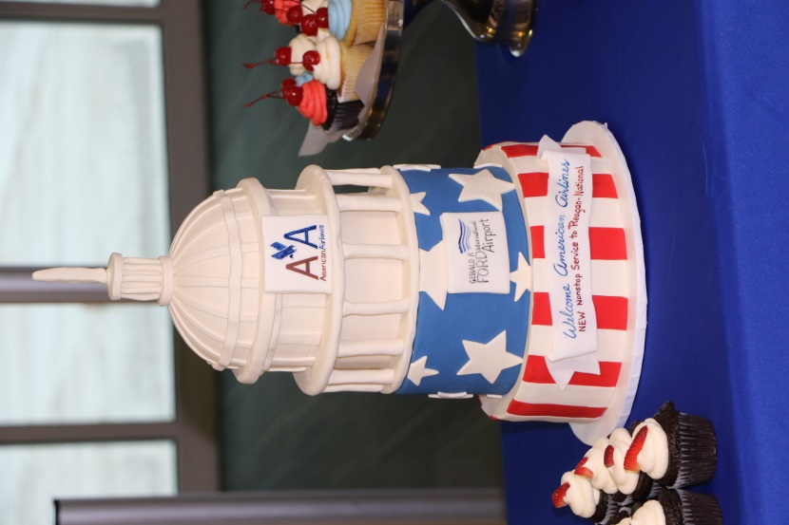
A celebratory cake from The Cakabakery, was a part of today’s celebration

GRAND RAPIDS, Mich. – Nonstop service from the Gerald R. Ford International Airport (GRR) to Ronald Reagan Washington National Airport (DCA) began today with a celebratory press conference, water canon salute, and capitol building-themed cake.
American Airlines announced the service in December, which is operated by American Eagle. The service features 13 weekly round trips.
“Nonstop service to Reagan National Airport has been a target market of ours, and we are happy to see American Airlines continue to invest in the Grand Rapids market,” said Gerald R. Ford International Airport President & CEO Jim Gill. “American has grown 74% at the Ford Airport since 2015, nearly tripling its seat capacity – that says a lot about American’s desire to expand here, and our community’s response to supporting new routes.”
The flight schedule for the new service includes departure times from Grand Rapids twice daily at 7:20 a.m. and 12:50 p.m. Sunday through Friday, and one daily departure at 9:40 a.m. on Saturdays. Service departing DCA and returning to GRR is twice daily at 10:00 a.m. and 5:45 p.m. Sunday through Friday, with a 4:00 p.m. daily departure time on Saturdays.
American Airlines has served Gerald R. Ford International Airport passengers for over 25 years, and also has nonstop service to Chicago-O’Hare, Dallas Fort Worth, Charlotte, and Philadelphia.
For more information or interviews, please contact Tara Hernandez.
###
About GFIA
The Gerald R. Ford International Airport (GFIA) is the second busiest airport in Michigan. The airport served over 2.6 million passengers in 2016 and over 7,000 travelers pass through GFIA each day. The Gerald R. Ford International Airport offers nonstop service to 24 major market destinations with more than 120 daily nonstop flights. The Gerald R. Ford International Airport is managed and operated by the Gerald R. Ford International Airport Authority. GFIA generates over $3.1 billion in annual economic output throughout West Michigan and employs over 1,500 people. For more information on GFIA visit: www.flyford.org or follow the airport on Twitter: @FlyGRFord

