**Journey at Pechanga Set to Celebrate its 5th Anniversary**

**Course gets an all new fleet of Yamaha carts, pricing structure, promotions and course upgrades**

**Robert Bledsoe – Public Relations Manager**

**Journey at Pechanga**

**(951) 770-2776**

[**rbledsoe@pechanga.com**](mailto:rbledsoe@pechanga.com)

January 9 2013, Temecula, CA – As the Journey at Pechanga course gets ready to hit its five year milestone, the course unveiled an all new cart fleet, upgrades to the course and more affordable pricing.

Course prices now range from $99 to $129. Twilight rates are $59 to $69. In addition, hotel guests receive a significant discount, with normal rounds $89 to $99 and twilight $49 to $59.  The course also routinely runs seasonal discounts, such as the current specials:

* $899 ‘Annual Pass’, good for 12 rounds, any day, any time. Only four rounds can be used on a single visit.  That comes out to be $74.92 per round.
* $85 per round, Monday through Friday, for Temecula Valley residents (Murrieta, Fallbrook, Bonsall, Lake Elsinore, and Menifee).
* Winter Swing Special: Open to all. Mon. – Thurs. 7:00am - 11:00am $179 for two players; 11:10 - 1:50, $169 for two; Fri. 7:00am - 11:00am, $189 for two; 11:10am-1:50pm, $179 for two; Saturday & Sunday 7:00am - 11:00am $209 for 2 players. 11:10am - 1:50pm $199 for 2 players.

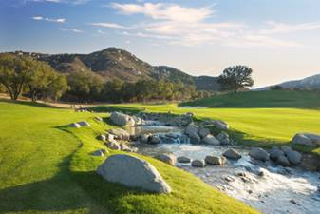***Journey’s picturesque 5th / by Aidan Bradley***

“Unfortunately, Journey opened at the absolute worst time during the Great Recession,” said Director of Golf Scott Mallory about the 2008 opening, “but by providing a world class course at a great value and unparalleled customer service, we received outstanding word-of-mouth and industry recognition that allowed us to thrive.”

The course has consistently been ranked as one of the top in all of California by both GOLF Magazine and Golfweek, which also ranks Journey as one of the best resort courses. Other Southern California golf magazines and newspapers have ranked Journey and its amenities at the top of their reader polls.

Upon its five-year anniversary, the course is continuing to improve and freshen all of its amenities. The brand new, custom Yamaha golf carts are in use now, handling the rugged terrain of Journey’s celebrated elevated tees. The course itself has also seen a few changes, including to the greens themselves. Specialty greens mowers capture the type of cut that preserves Journey’s high-quality condition.

“I have never seen the management of a course so dedicated to maintaining its pristine conditions year around,” said course Superintendant John Martinez. “When you think of the desert climate of Temecula, you might expect some browning as temperatures reach the triple digits, but my team is given the resources to make the greens as quick in the summer as they are in the spring.”

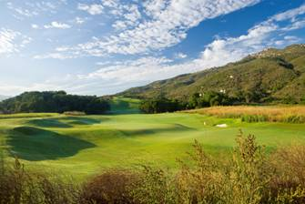  *Journey’s final challenge, the 18th/ by Aidan Bradley*

Martinez’s team closed Journey at the end of September for three weeks to overseed and aerify the greens, leaving the course at its most pristine of the year. Those looking to plan their annual trip can expect quick greens and lush fairways.

The Journey Pro Shop is continually evolving as the area’s premier high-end golf shop, carrying such brands as Taylor Made, Adidas and Ashworth. In 2009, the Pro Shop won the prestigious Southern California PGA’s “Merchandiser of the Year”  Resort Category award for the southern California section. It again won in 2011, in the Resort Category award, for the Inland Empire.

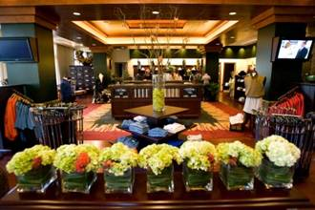 *World class equipment and apparel is available in the 2,800 sq. ft. Journey Pro Shop / by William Vasta*

Journey’s End, the clubhouse restaurant has received its own share of awards and accolades in the local region. In addition to providing the resort’s premiere breakfast and lunch menu, it is also routinely rented for tournaments, weddings, banquets and other events.

*Journey at Pechanga is the ultimate outdoor recreation at Pechanga Resort & Casino, a 7,219-yard, Par-72, championship 18-hole golf course open to the public. Ranked as one of California’s best courses, the impressive Arthur Hills-designed course winds along a spectacular boulder-strewn mountain and boasts a dramatic, 62,000 square-foot Clubhouse with high-end resort amenities, including the Pro Shop and  Journey’s End restaurant.*