**For Immediate Release**Media Contact:  
Kristian Sonnier  
504-481-7933, [**ksonnier@neworleanscvb.com**](mailto:ksonnier@neworleanscvb.com)

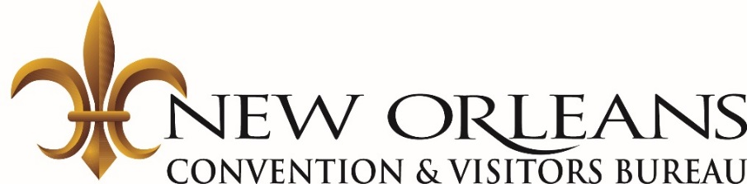

**New Orleans CVB Partners with Travel South USA to keep New Orleans top of mind in Australia and New Zealand**

**NEW ORLEANS** (July 18, 2017) -  The New Orleans Convention and Visitors Bureau continued its marketing efforts in Australian and New Zealand through a recent sales mission in partnership with Travel South USA. Most recently, Kim Priez, Senior Vice President of Tourism at the New Orleans Convention and Visitors Bureau, traveled to Auckland, New Zealand; Brisbane and Sydney, Australia for a Travel South USA Sales Mission with 27 additional delegates from Southern U.S. states.

While visiting both countries, Priez conducted appointments with local travel agents and tour operators selling international travel. The goal of this international sales mission is to entice travel professionals abroad to sell travel to New Orleans.

“We’ve seen a significant growth in visitation from Australia and New Zealand over the past four years due to the increased marketing and public relations efforts, as well as the new direct air service through Quantas and Air New Zealand into Houston and Dallas and increased seat capacity on American into Los Angeles,” said Kim Priez, Senior Vice President of Tourism at the New Orleans Convention and Visitors Bureau. “The New Orleans CVB’s representation on this recent Travel South USA mission will help contribute to increased bookings in international travelers to New Orleans.”

In an effort to bring a special touch of the South to the targeted travel professionals attending Travel South’s events, New Orleans was a co-sponsor of the entertainment by Southern musician, Damien Horne, to perform onstage at all three events including Auckland on Monday, June 19; Brisbane on Tuesday, June 20; and Sydney on Wednesday, June 21. Horne performed three 45-minute concerts regaling the audience with songs and stories of the South.

**The** **New Orleans Convention & Visitors Bureau** (NOCVB) is a nationally accredited, 1,100-member destination marketing organization and the largest and most successful private economic development corporation in Louisiana. The CVB and its members influence thousands of decision-makers and millions of visitors to choose New Orleans through direct sales, marketing, public relations, branding and visitor services at our New Orleans headquarters and offices in Chicago, Louisville, KY, Washington, D.C., the United Kingdom, France, Germany, Canada, Brazil and China. Consistently recognized as one of the top five CVBs in the country, the New Orleans CVB celebrates its 57th anniversary in 2017. For more information, please visit [**www.neworleanscvb.com**](http://www.neworleanscvb.com); [**www.facebook.com/neworleans**](http://www.facebook.com/neworleans)**;** [**www.twitter.com/visitneworleans**](http://www.twitter.com/visitneworleans).

**About Travel South USA:** Travel South USA is America’s oldest and largest regional travel promotion organization, formed in 1965. The long-standing regional collaboration of the state tourism offices of Alabama, Arkansas, Georgia, Kentucky, Louisiana, Mississippi, Missouri, North Carolina, South Carolina, Tennessee, Virginia and West Virginia provides a foundation to positively position tourism as a vital and dynamic element in the region’s economic development. Tourism ranks throughout the region as one of the top three industries, behind manufacturing and agriculture, and is responsible for $133 billion in spending by visitors, generating 1.4 million direct jobs, $30 billion in worker paychecks, and almost $16 billion in state and local taxes. For more information, visit www.TravelSouthUSA.com for consumer information and travel industry information, [**www.TravelSouthUSA.org**](http://www.TravelSouthUSA.org).

###