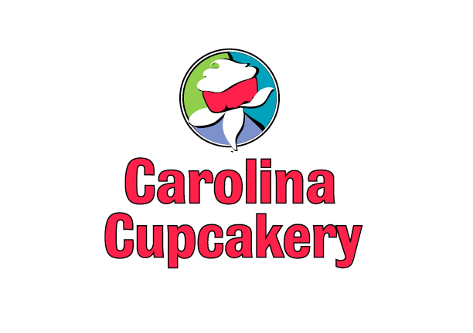FOR IMMEDIATE RELEASE
Media Contact: Dawn Eskins Carolina Cupcakery LLC
December 9, 2010 Norfolk 757-351-1548
Chesapeake 757-204-4773
Cell 252-267-1380
Fax 888-275-9614
info@carolinacupcakery.com

Fabulous little food trend
Carolina Cupcakery goes full-miniature
(Chesapeake, VA) Carolina Cupcakery in Chesapeake, Hampton Road’s original cupcake bakery, is welcoming the latest food trend to the area by miniaturizing two-thirds of its traditional fare, and offering exciting new demi-desserts.
Holiday guests feel like a bit like Gulliver, peering into the Cupcakery’s long display of tiny, elegant (and, decadent!) desserts. Miniaturized goodies in the Chesapeake (only) location are new, inspired by faves from their own employee’s families including; mousse-filled brownie cups, white chocolate pumpkin cheesecakes, pink champagne whoopie cakes and double-dipped brownie bites, not to mention traditional iced cookies, kolaches, cheese pennies and truffles.
Sized and priced to sell like a dollar menu, the bakery’s informal smorgasbord allows customers to select individualized, fresh-baked party platters or personalized box gifts that they may not otherwise have the time, or budget, to bake.
Both stores will continue baking their signature, monster-jumbo cupcakes that garnered the attention of Modern Bride, Extreme Home Makeover and TLC. “We are rapidly approaching 200 flavors — and nowhere near done!
The holidays are the perfect time to share,” says owner Dawn Eskins. “Since our Ghent location has only been open a few weeks, nothing will change there. It is a brand-new Kosher-certified kitchen, and we are focused on baking in that tradition. You can buy and order cupcakes and holiday platters from either store, any time.”
“Who knows? This could become a tradition we look forward to, each year, pulling out family recipes, to share with friends.”
Market trends show that customers prefer portion control sizes that aid them with weight management. The hottest trends in the food service industry are individualized food products such as sliders, single-serve meals and dessert shots.
“Health-conscious customers also understand Amish butter and Fair Trade chocolate — they understand that real food is important, even when they are indulging,” says Eskins. “We are especially proud of the tasteful cupcakes we’ve devised for folks on sugar-free, gluten-free and vegan diets.”
Custom orders, and any order over 2 dozen, may be called in to the bakery at 757 204-4778 and picked up from either location.
Located in Edinburgh Commons, in southern Chesapeake, their hours of operation are: Mon- Sat. 9am-7pm, closed on Sunday. The Norfolk store, located on Colley Ave. in Ghent, is open: Mon-Thurs. 9am-7pm, Fri- Sat. 9am-9pm, Sunday 10am-6pm.
About Carolina Cupcakery: Founded in Chesapeake in 2008 by Dawn Eskins and daughters Kyndall and Lindsey, the bakery has become wildly popular in a very short time. Known for local, scratch-baked cupcakes available in over 180 flavors, varieties include cupcakes that are; spiked with liquors, stuffed with pie, cookie and brownie dough. They regularly appear in local publications and on television, were nationally featured in Modern Bride magazine, and have been approached for television by Discovery Channel and the Food Network.
For more information on Carolina Cupcakery call 252 267-1380, email info@carolinacupcakery.com or visit online at www.carolinacupcakery.com

