Beaumont Birding Press Kit
Southeast Texas has the views and the species unlike anywhere else. From the beaches of the coast to the piney woodlands, including our vast 900-acre wetlands, that offers a diverse population of wildlife and vegetation.
Thanks to Beaumont’s location smack in the path of two migratory bird flyways – the Central and Mississippi – hundreds of species call the region home either permanently or seasonally. Gulf habitats are essential to the annual cycles of many species of breeding and migrating including waterfowl, wading birds, shorebirds and songbirds where over 350 species of birds are spotted annually. With a multitude of locations and different environments, this area is perfect for any adventurer who loves nature.
Beaumont, Texas is the “best kept secret” for those who love birding and nature, however, the Beaumont Convention and Visitors Bureau is looking to change that with many new promotions designed to spread the word. Southeast Texas is teeming with wildlife and the CVB invites visitors to see it. Visit Beaumont and the rest of southeast Texas to explore all the nature tourism attractions that Beaumont and Southeast Texas offers.
http://www.beaumontcvb.com/birder/

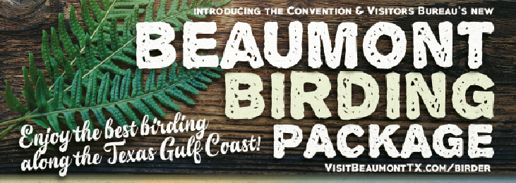
Beaumont Birding Package
Birdwatchers are invited to enjoy the best birding along the Texas Gulf Coast plus take advantage of exclusive hotel rates and added perks. The Package Includes lots of extras including: Beaumont Itinerary, souvenir photo book, checklist, trail maps, and of course, their own (adorable) Beaumont Birdie.

The Beaumont CVB has coordinated sleeping room block available at two hotels. Each hotel is highly rated and offers a distinctive hotel rate for this Special Birding Overnight Package: “BMT Birding 2018”
When making your reservation, either on the phone or online, be sure and identify that you are booking a sleeping room as part of the group package “BMT Birding 18” or online with Group code: BMT

The Beaumont CVB offers group tour planning assistance when a group uses Beaumont hotel rooms. Contact Rebecca Woodland for more information.

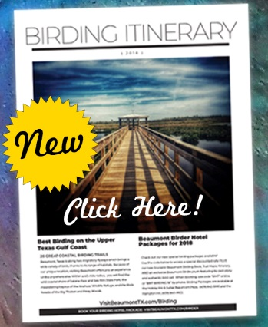
Birding Itinerary
This four-day Birding Itinerary takes visitors to Beaumont’s regional hotspots. Because of Beaumont’s unique location along two migratory flyways, it offers an experience unlike anywhere else. Within a 40-mile radius, guests will find diverse habitats and hundreds of bird species. Some of the birding hotpots include the wild coastal shores of Sabine Pass and Sea Rim State Park, Anahuac Wildlife Refuge, Big Thicket National Preserve, Piney Woods, Sabine Woods and Cattail Marsh Wetlands.

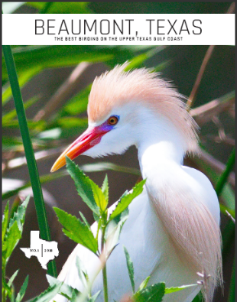
Beaumont Birding Book

The Beaumont Birding Book was published to showcase the birding area and what it offers, but more importantly to serve as a way to take a piece of Beaumont and the rest of Southeast Texas home. The nature photography in the book was taken post-Hurricane Harvey (Fall 2017) by locals who graciously allowed the CVB to publish their photos to help promote the area’s vast offerings.
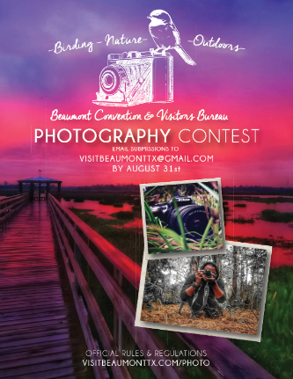
Photography Contest
The Beaumont CVB is proud to host the 1st Annual “Capturing the Nature of Southeast Texas” Digital Photo Contest. The contest is open to all professional and amateur photographers who are interested in capturing the wildlife, nature and overall serene environment of southeast Texas. By submitting an entry to the Photo Contest, entrance certify that their participation in this contest is not illegal or in violation of any law, regulation, treaty or administrative act, and that the laws of their governing jurisdiction of resident at the time of entry do no prohibit or restrict the receipt of any prize under this photo contest.
The contest will run for 12 weeks, starting June 1, 2018 at 12:00 PM and ending August 31, 2018 at 12:00 PM. Details for entry are online at: http://www.beaumontcvb.com/things-to-do/birding/photography-contest/

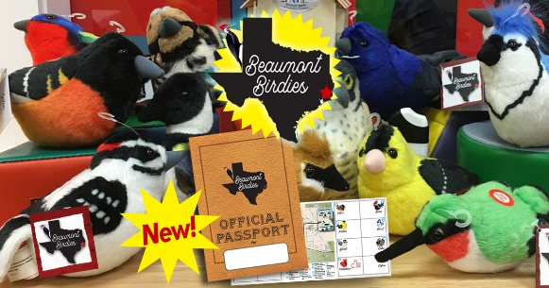
Beaumont Birdies and Official Birdie Passport
Introducing the cute cast of characters which represents some of the region’s most sought-after bird species. Each Beaumont Birdie comes with its own custom profile tag, webpage, name and plays its own unique birding call. Every Beaumont Birdie is named to highlight its favorite local hangout.

The Beaumont Convention and Visitors Bureau (CVB) would like to officially introduce the newly released Beaumont Birdies! Beau, Mamie, Gladys, Edison, Arthur, Neches, Spot, Gator, Patillo, Ben J, Tyrrell, Babe, Clifton and Mirabeau represent some of the area’s most sought-after species. Each Beaumont Birdie plush toy comes with its own custom tag including the Birdie’s name, favorite local hangout, birth date and profile. Each bird also features its species unique birding call sound.

The Convention and Visitors Bureau’s newly released Official Beaumont Birdie Passports will provide a fun tool for young summer explorers to tour Beaumont and visit each of the Beaumont Birdies. The Passports are free and available at the CVB office and at each Birdie’s home attraction. Stamps for the passport may be collected at each Birdie location, where visitors are also encouraged to check-in and share their photos with @VisitBeaumontTX on social media. After passport holders collect eight stamps, they will earn their very own Beaumont Birdie plush from the Convention & Visitors Bureau. Adults can participate as well by collecting all 14 stamps. Details are available at www.VisitBeaumontTX.com/Birdies

The Beaumont CVB hopes to spark an interest in birding and encourage families to get out and explore the many heritage and culture offerings within the city.

The Beaumont Birdies are part of a new tourism marketing initiative designed to capture the interest of a broader audience in the birding community and increase awareness of Beaumont’s birding hot-spots. Typically, birders are a mature audience, however the younger generation has become fascinated with identifying birds and spending time outdoors. The CVB’s Beaumont Birdies seek to bridge the demographic gap in the birdwatching market and find a new way to introduce birding to a new generation.

- How can I get a Beaumont Birdie?
Beaumont Birdies are not for sale. They are earned either by completing the Official Passport Scavenger Hunt or by booking a room using the Beaumont Birding Package rate.
- Where do I get a Passport?
Passports are free and available at any one of the Birdie attraction locations. They may also be picked up at the Beaumont CVB Office, M-F, 8am-5pm.
- Where do I submit my completed Passport?
Beaumont Birdie Passport Beaumont CVB 505 Willow St., Beaumont, TX 77701
- How does the Passport work?
Each Birdie lives in its own special birdhouse at a location attraction. Visit each one to collect a stamp for your passport. You’ll even have fun learning about Beaumont’s history and heritage along the way! Ask your parents to take your picture with the Birdie when you’re at each destination and share it with @VisitBeaumontTX on Instagram or Facebook. Once you’ve gotten 8 stamps on your Beaumont Birdie Passport, submit it to the Beaumont Convention & Visitors Bureau. We’ll send it right back to you along with your very own Beaumont Birdie! Adults are welcome to earn a Birdie by collecting all 14 stamps.

