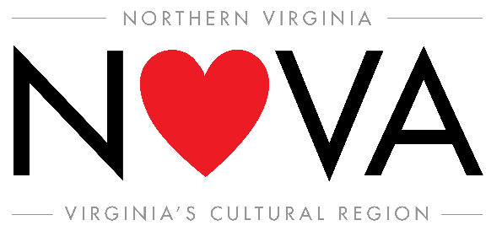

FOR IMMEDIATE RELEASE:
Add date it will be distributed to media here

MEDIA CONTACT:
Leah Spellman
LSpellman@VisitAlexVA.com 703-652-5363

Northern Virginia Rallies in Support of $9.4 Billion Travel & Tourism Industry

Community, Business and Political Leaders Endorse Travel’s Economic Benefits
During U.S. Travel Association’s National Travel and Tourism Week

Northern Virginia—Each May, tourism offices across the country celebrate the travel industry during National Travel & Tourism Week (May 6-12, 2018). Northern Virginia is no different. What makes this region unique is the five destinations that come together year-round to promote “Virginia’s Cultural Region” in both domestic and international travel markets.

The Northern Virginia Visitors Consortium (NVVC), comprised of the destination marketing organizations from the City of Alexandria and Counties of Arlington, Fairfax, Loudoun and Prince William, is responsible for promotional marketing campaigns to attract international and domestic visitation. NVVC has chosen to harness the power of regionalism to fulfill the visitors’ needs and expectations to the greatest degree possible, allowing a seamless travel experience throughout Northern Virginia.

As one of the leading industries in the Commonwealth, tourism and travel in Northern Virginia is responsible for:
- $9.4 billion in total travel related expenditures*
- 89,381 jobs*
- $546 million in local & state tax revenue*

*For accuracy, data includes economic impact results from the independent cities of Fairfax, Falls Church, Manassas, and Manassas Park of which are not members of the NVVC, but are part in the Northern Virginia region.
Source Virginia Tourism Corporation.

“Just look at the eye staggering numbers! Travel supports one in nine American jobs, including 89,381 right here in Northern Virginia,” said Patricia Washington, president of the Northern Virginia Visitors Consortium. “This week, we are celebrating what travel means to our communities. We’re calling on everyone, from elected officials to residents to front line hospitality workers, to join us in saluting this important industry, and to support travel-friendly legislation at the local, state and national levels.”

During the 35th annual National Travel and Tourism Week (NTTW), events will be held throughout the region to honor and acknowledge tourism industry partners that have allowed tourism to continue to thrive.

The theme of this year’s NTTW, “Travel Then and Now,” highlights the travel industry’s history of economic impact in every corner of America. Across Northern Virginia, travel employs a prosperous and diverse workforce, from airline and hotel employees to restaurant, attraction and retail workers, and supports related sectors such as construction, manufacturing and finance.

In addition to its benefits for the local economy, travel can also have a positive effect on personal well-being for residents and visitors of Northern Virginia. Numerous research studies have confirmed the positive health effects of travel and time off, from reducing the risk of heart disease to decreasing depression. Using time off to travel with family is good for everyone, especially our children—kids who travel with their families are more likely to attend college and earn more as adults.

“Many aspects of the U.S. travel experience may have changed over the years, but one thing hasn’t: its impact on the lives of American workers all over the country,” said Roger Dow, president and CEO of the U.S. Travel Association, the umbrella organization representing the U.S. travel industry. “Whether we’re talking about 1968 or 2018, travel jobs have been a gateway to the middle class for millions—and they’re completely non-exportable, no matter how much the global economy changes. This National Travel and Tourism Week, we’re saluting travel’s long history as an economic engine in our country, and calling on our nation’s leaders to prioritize travel-friendly legislation, for the sake of millions of American workers.”

To learn more about National Travel and Tourism Week happening May 6-12, 2018, visit ustravel.org/events/national-travel-and-tourism-week.

About U.S. Travel Association
The U.S. Travel Association is the national, non-profit organization representing all components of the travel industry that generates $2.3 trillion in economic output and supports 15.3 million jobs. U.S. Travel's mission is to increase travel to and within the United States. Visit www.ustravel.org.

About the Northern Virginia Visitors Consortium
The Northern Virginia Visitors Consortium (NVVC), comprised of the destination marketing organizations from the City of Alexandria and Counties of Arlington, Fairfax, Loudoun, and Prince William, partner regionally to share resources to attract domestic and international visitation to the Northern Virginia region. Home to two world-class airports, Reagan National and Washington Dulles International, and an easily “road trip friendly” accessible location near the Nation’s Capital, the Northern Virginia region showcases an energetic mix of history, culture, dining, shopping, and the largest collection of Virginia’s spirits, wine, and craft beer industry. Known internationally as Virginia’s Cultural Region, the combined efforts allow visitors an opportunity to experience Northern Virginia and work together to invite even more visitors to experience it for themselves. Learn more at NorthernVA.org.

# # #

