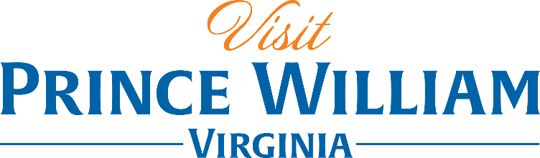

Locally Sourced – Arts & Farms

One of the most diverse counties in Northern Virginia, Prince William County is so rich in culture. Find an array of locally sourced art and farm experiences throughout the year from patriotic Marine Corps galleries to Little Goat Yoga you are sure to make some unforgettable memories.

Day One:
Start your adventure at the Historic Occoquan Arts & Craft Festival. Hosted every Spring & Fall this quaint small town welcomes hundreds of visitors to meet and greet local artists, enjoy live music and local food. If you prefer to check out the local farmers markets while visiting, you can check out the Tackett’s Mill Farmer’s Market or the Dale City Farmer’s Market to browse the fruit, vegetables, flowers and more from neighboring farms. Next head to the National Museum of the Marine Corps where you can explore their ever changing art gallery featuring custom artwork created by Marines themselves. Cap off your day at Farm Brew Live/2 Silos Brewing to check out some of the best local live music in Northern VA while sipping on seasonal craft beers and stay for dinner so you can sample some of their farm fresh menu too.
Day Two:
Find your center at The Little Goat Farm at the Lake where you can start the day with a goat yoga class, choose to make cheese, lotion or soap using the goat’s milk or just plan a relaxing afternoon picnicking and listening to live music by the lake surrounded by chickens, llamas and of course little goats! Stop by Hidden Julles Café for a quick lunch where you will find an always fresh seasonal menu as well as made to order smoothies and coffees. Spend a the afternoon sipping craft cocktails at The Winery at La Grange or The Farm Brewery at Broad Run where you can taste your way through your choice of Virginia wines or craft beers and enjoy the serene farms that surround them. Catch a show at Hylton Performing Arts Center where you can take your pick from a range of unique acts from the ballet to live country music.

