

**10/23/18**

**Killer Boo-quet: 10 American Wineries With Haunted Histories**

**[Blane Bachelor](https://vinepair.com/author/blaneb/" \o "Posts by Blane Bachelor)**

6 minute Read

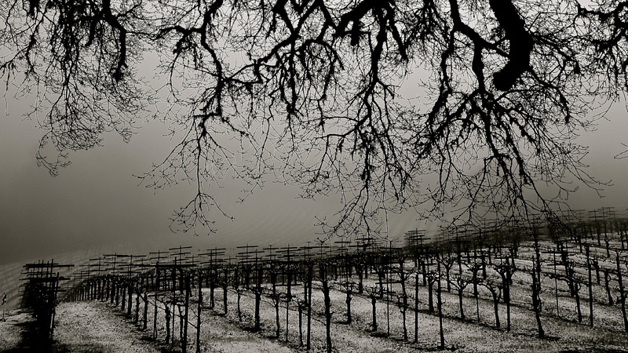

Photo By STEVE ALDEN

[Wine](https://vinepair.com/wine-101/) and storytelling are often entwined. Winemakers spin yarns about a noble relative who planted the family plot centuries earlier, while sommeliers rave about the magical quality of sea breezes.

As temperatures cool and [Halloween approaches](https://vinepair.com/articles/halloween-drinking-holiday/), there’s no better time to uncork a few spooky tales from wineries with spine-tingling pasts. To get into the spirit of the season, pour yourself a glass. From centuries-old murder scenes to on-site cemeteries, here are 10 wineries that celebrate their haunted histories.

[**Murder Ridge**](http://murderridge.com/)

**Mendocino County, Calif.**

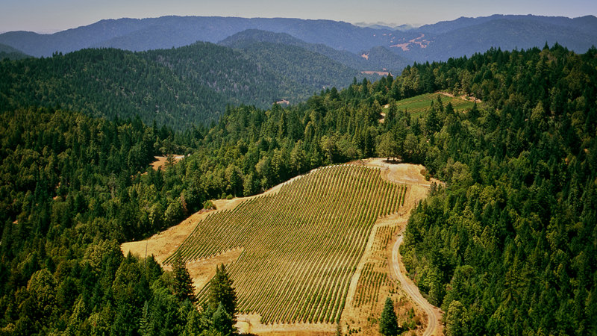

Credit: STEVE ALDEN

As the name suggests, this high-elevation Mendocino County winery doesn’t shy away from the dark history of its property. Per 1911 newspapers, local police had discovered an “unassuming man” by the name of Joseph Cooper “foully murdered” at this location, near Signal Ridge. The sheriff eventually found Pete Gianoli nearby with Cooper’s jacket and a demijohn of wine. Today, one of the vineyards still bears Gianoli’s name. Under the current team of grape grower Steven Alden and winemaker Leslie Sisneros, Murder Ridge turns out some drop-dead delicious [Zinfandels](https://vinepair.com/wine-101/learn-zinfandel-red-white/) and a [Syrah](https://vinepair.com/wine-101/learn-about-syrah-shiraz-wine/) blend. The subtly sinister label is the perfect final touch, with mismatched, ransom-style lettering, a murder of crows perched in a scraggly tree, and, on the back, a stanza of a chilling poem about the murder written by Sisneros’s daughter, Maya.

[**The Winery at La Grange**](http://www.wineryatlagrange.com/)

**Haymarket, Va.**

The glass of red wine sitting on the mantle of The Winery at La Grange‘s tasting room wasn’t accidentally left by an over-served guest. It’s for Benoni Harrison, one of the original owners of the estate. Every day, winery staff set out a glass for Harrison, who bought the property in 1837 and lived there until he died in 1869. Rumor has it he’s still lurking around the historic property, which dates back to 1790; to keep him happy, the staff religiously pours him a daily tipple. (The stone cellar, called Benoni’s Lounge, is the perfect spot to raise a glass of Benoni’s Blend.) But Benoni isn’t the only presence on the property: The ghost of a young girl is believed to inhabit one of the upstairs rooms.

[**Buena Vista Winery**](https://buenavistawinery.com/)

**Sonoma, Calif.**

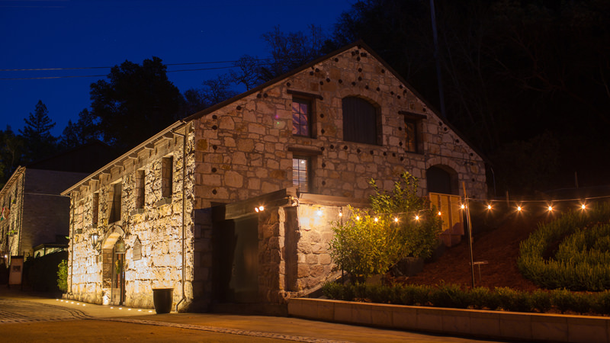

Credit: Buena Vista Winery

For more than 50 years, strange things have been happening at Buena Vista Winery. People have spotted ethereal figures in 19th-century clothing, and heard footsteps on the roof or ghostly sounds of crying babies. One of the most recent encounters involved a team member who spotted the full-body apparition — that’s a big-time score in paranormal circles, by the way — of a man in a black coat and distinctive mutton chops. He believes it may have been the spirit of General Vallejo, who also sported mutton chops and whose two daughters married sons of the winery’s original founder. Paranormal experts back it up: The property has been investigated by several ghost-hunting groups that have documented all sorts of activity. Psychic mediums also report the presence of spirits.

[**Howell’s MainStreet Winery**](http://www.howellsmainstreetwinery.com/)

**Howell, Mich.**

Keep an ear tuned for little footsteps during a visit to this history winery: The spirit of a 7-year-old boy named Thomas, whose parents ran a store on the property in the 1800s, is one of its resident ghosts. Winery employees and paranormal experts have witnessed various unexplained happenings on the premises: Objects move on their own, noises come from empty rooms, and lights flicker. One of the spookiest tales, staff say, happened when a group of visitors, one of whom was a staunch non-believer, came into the winery. While the group was chatting, a bottle of wine inexplicably cracked, and all of the wine drained out and encircled their table.

[**Valerie Hill Vineyard & Winery**](http://www.valeriehillwinery.com/)

**Stephens City, Va.**

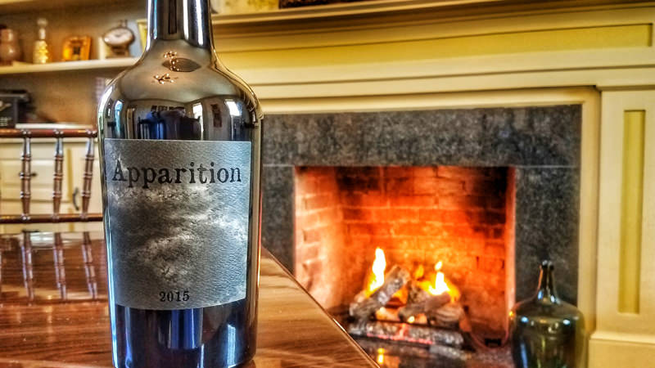

Credit: Valerie Hill Winery

At Valerie Hill Vineyard & Winery, ghost stories share the spotlight with wine. From fall through early spring, the winery’s History and Hauntings Tours feature wine tastings, a locally sourced meal (think Virginia oysters), and candlelit tours that delve into the property’s paranormal activity. You’ll hear about the four resident ghosts, including that of the most prominent specter, Benedict Rust, the son of the man who built the house. Sadly, Rust was declared insane and sequestered to the attic for most of his life; his spirit is still rattling around today. Other sightings might include a cantankerous old man and a gun-toting spirit of a Civil War soldier; all have made believers out of the formerly skeptical owners. And there’s no better way to drink up this chilling history than with a bottle of Apparition, the winery’s delicious, limited-production port.

[**Nello Olivo**](https://www.facebook.com/NelloOlivoWine/)

**Placerville, Calif.**

Unexplained noises, lights and faucets turning on and off by themselves, ghostly children running around: If you happen to notice something weird during a tasting at this El Dorado County winery, it might not be because you’ve had one too many. Indeed, the Sequoia Mansion where the winery is housed is a known paranormal hotspot. Built in 1853 and later expanded by Judge Marcus Bennett, the mansion is now a wedding site and also home to the Nello Olivo Winery tasting room, where visitors may feel the presence of a number of resident spirits, including Judge Bennett himself, or perhaps his young son, Marcus Jr., who sadly passed away at age 4.

[**Miles Wine Cellars**](http://mileswinecellars.com/)

**Himrod, N.Y.**

One of the most gorgeous wineries in [New York’s Finger Lakes](https://vinepair.com/articles/travel-guide-wine-finger-lakes/) has an especially haunted past — and a wine that honors it. Miles Wine Cellars dates back to the mid-1800s, when a young couple renovated the mansion in elegant Greek Revival style. Before the project was complete, both the man and woman died in the house — and they’re definitely still around, according to the current proprietors, the Miles family. Since the mid-1980s, the Miles’ have regularly seen apparitions of a man and a woman. The supernatural encounters inspired the family to produce a wine called Ghost: a semi-dry Chardonnay-Cayuga blend. The wine is quite tasty, but the real showstopper is the custom-designed silk-screened bottle. Shine a flashlight on it, and the ethereal image of the ghostly woman who roams the home appears.

[**Ravenswood Winery**](https://www.ravenswoodwinery.com/)

**Sonoma, Calif.**

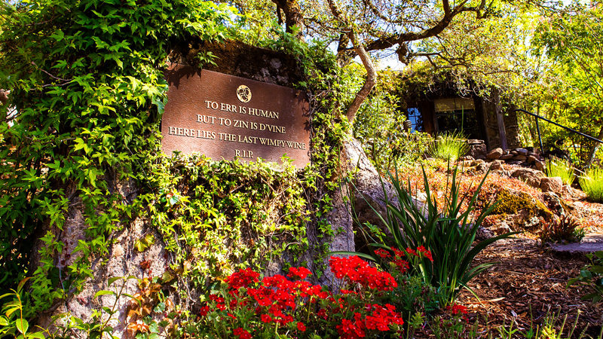

Credit: Ravenswood Winery

Ravenswood is one of Sonoma’s most recognizable wineries, as is its bottle, which bears the company’s distinct logo of an interlocking trio of ravens. But there’s more to it than just a cool design. On a fall day in 1976, founder and winemaker Joel Peterson was rushing to help harvest some four tons of grapes when an approaching thunderstorm hit. Peterson scurried around picking the fruit, watched by groups of ravens circling above. Just as he was wrapping up the harvest, Peterson noticed that, somehow, he was mysteriously dry while the surrounding areas were drenched from the rain. He went on to crush the fruit that was used for one of two single-vineyard Sonoma County Zinfandels, the first wines to bear Ravenswood’s signature ring of ravens. Three years later, those wines earned first and second place in a prestigious San Francisco tasting.

Whatever happened that night of the 1976 harvest — bizarre weather patterns or some strange protective spell from the birds — is anyone’s guess. Whatever the case, it’s a fascinating story to share over a glass of (what else?) Ravenswood Zinfandel on The Nest, the nickname for the winery’s patio.

[**William Chris Winery**](https://www.williamchriswines.com/)

**Hye, Texas**

An on-property family cemetery sets a spooky tone at this Texas Hill Country winery. Ever since the owners, William Blackmon and Chris Brundrett, bought it in 2008, staff and guests have experienced plenty of head-scratching happenings — like the old marbles that Carol Blackmon, the groundskeeper, finds in random