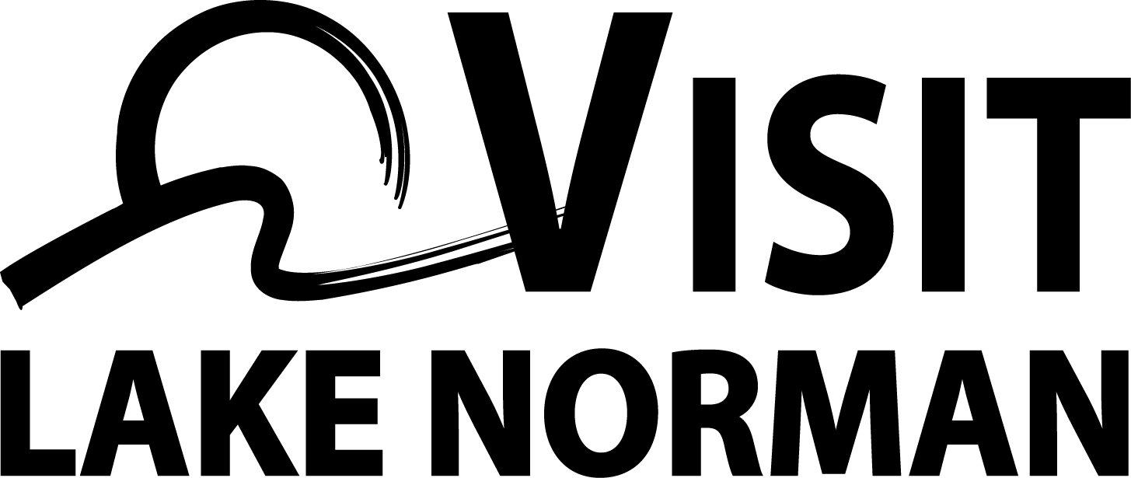

**Press Release**

**Visit Lake Norman Media Contact:**

Travis Dancy

Director of Sales

704-987-3300

[tdancy@lakenorman.org](mailto:tdancy@lakenorman.org)

**November 2, 2018**

**FOR IMMEDIATE RELEASE**

**Visit Lake Norman Wins Destination Marketing Achievement Awards**

**Cornelius, Davidson & Huntersville, NC –** Visit Lake Norman (VLN) was honored with four awards for exceptional achievement in destination marketing at the recent North Carolina Tourism Leadership Conference. The awards invite the 100 counties in North Carolina to submit and recognize the best in the state for marketing efforts in the travel and tourism industry. The award selection committee is comprised of peers from South Carolina, Virginia and North Carolina industry affiliates.

The awards were presented for marketing initiatives implemented between July 2017 and June 2018. VLN received a Gold award for best Community Relations for the Ambassador and Internship Program that recruits ambassadors and interns to work in the visitor center and promote the area’s attractions. Interns are also able to gain valuable experience through their work on marketing initiatives. VLN also received a Platinum award for best Meetings & Convention Marketing for the use of an interactive booth at the AENC tradeshow and another Platinum award for best Leisure Marketing for its E-Newsletter and Blog utilization. VLN received a fourth Platinum award for best Group Marketing for its partnership with Davidson College Athletics. VLN has won 10 destination marketing awards in the last four years. [VisitLakeNorman.org/visitors/contact-us/awards-accolades](https://www.visitlakenorman.org/about/about-us/awards-and-accolades/)

The North Carolina Tourism Leadership Conference is an annual joint conference between the Destination Marketing Association of North Carolina and the North Carolina Travel Industry Association. Awards are given annually at the conference to honor and showcase innovation, best practices, creativity, and outstanding efforts and results in destination marketing across North Carolina. [nctia.travel](http://nctia.travel/)

###