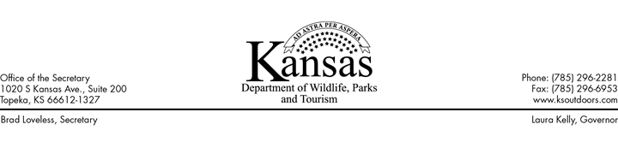

**NEWS RELEASE**

 For Immediate Release

May 1, 2019

**Media Contact:** Ron Kaufman, 785-296-2870, [ron.kaufman@ks.gov](mailto:ron.kaufman@ks.gov)

**Kansas Tourism Director Selected**

**TOPEKA** – Brad Loveless, Secretary of the Kansas Department of Wildlife, Parks and Tourism (KDWPT), announced today that Bridgette Jobe has been selected to become Director of the Division of Tourism. Jobe’s appointment will be effective in July 2019. She currently serves as Executive Director of the Kansas City Kansas Convention and Visitors Bureau, Inc. (KCKCVB) and will use the next couple of months to complete some important projects for the KCKCVB.

“We are very excited that Bridgette will be joining our team,” Loveless said. “She brings a wealth of knowledge and a genuine enthusiasm to promote statewide travel and tourism to our residents and to people around the nation and the world who are looking for an authentic Kansas experience.”

“I am thrilled to become a new member of the Kansas Wildlife, Parks and Tourism team. I look forward to being a part of the continued growth and economic impact that travel and tourism brings to Kansas,” Jobe said. “My goal is to take the experiences and relationship skills that I have built in Kansas City, KS and use them to move tourism forward for our entire state.”

Jobe attended Tennessee Temple University and Fort Hays State University. She has been with the KCKCVB since 1998, when she started as the Tourism Manager. She was appointed Executive Director in 2005. During her tenure as the Executive Director, she led the KCKCVB through significant organizational transformation, spurred by the phenomenal growth of tourism in Kansas City, KS.

Jobe serves on several tourism-related boards. She is the Chair of the Governor’s Council on Travel and Tourism and was recently reappointed by the third consecutive Kansas Governor. She was the 2017 President of the Travel Industry Association of Kansas and continues to serve on the board for that organization. Bridgette was recently awarded the 2019 Hospitality Leadership Award from the Kansas City Hotel & Lodging Association.