“PARTY ON THE PLAZA” MUSIC SERIES RETURNS TO AVENIDA HOUSTON

After more than two years, “Party on the Plaza” at Avenida Houston has returned to its in-person music series, which will have a revamped concept and design for guests to enjoy.

Attendees will be able to enjoy live music, beverages, a massive 14-foot selfie display for unique photo opportunities, and an array of festive lighting throughout the space. While in years past the event would include live performances by local, regional, and national bands, this year’s series will headline popular cover and tribute bands featuring all-star musicians and vocalists, who have worked with some of today’s top artists and companies. Musical genres will range from R&B, Latin, rock, pop, alternative, and more.

This year’s lineup includes:

- April 8 ─ Simply Irresistible
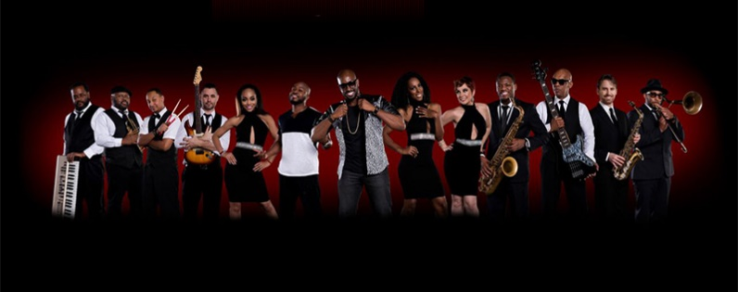
Due to the incredible success of Party on the Moon, producer Dennis Smith decided to create a sister band. With over a year in the making, he introduces Party on the Moon's SISTER ACT...Simply Irresistible! Same song list, same great musicians, same Grammy-nominated line-up. The band's front line features an all-star cast of vocalists and musicians, including Toni Braxton's sister, Trina, a canadian idol, a chicago idol winner, a former Party On the Moon lead vocalist, a male vocalist just off Broadway, and a Grammy-nominated band leader and drummer.

- April 15 ─ We Got the Beat
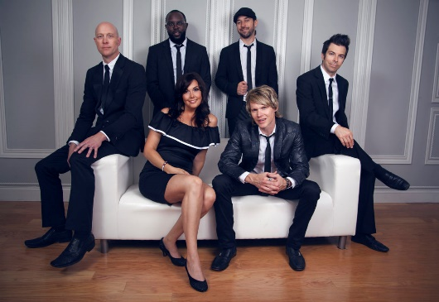
We Got the Beat is the perfect band of charismatic and professional party leaders to help you make it unforgettably awesome. With performances across the nation for esteemed clients, including Google, Microsoft, Ted Turner, Wells Fargo, Mercedes-Benz, and hundreds of brides seeking the perfect wedding experience.

- April 22 ─ Claremont Heir
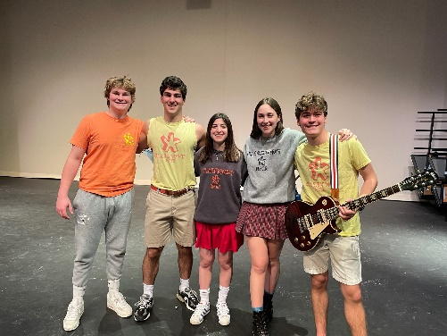
Claremont Heir is one of Houston's best up and coming rock groups. Their original songs come from an influence of alt rock, pop punk, and even some psychedelic sounds. Their covers span a wide range of genres from the 80s to modern-day hits. In short, it's a group unified by its common love of playing and sharing music.

- April 29 ─ Breakfast at Tiffany’s
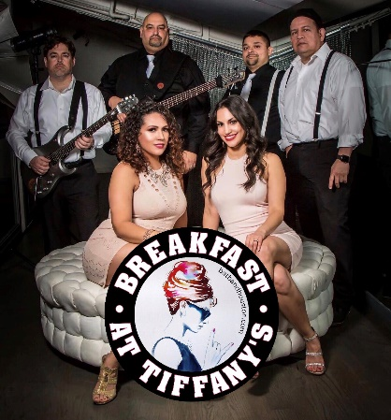
Breakfast at Tiffany's is a Houston-based variety band that understands that the show is just as important as the music. Showcasing 6 talented musicians, they provide an exceptional variety of dance and party music, including the ‘60s, ‘70s, ‘80s, Latin, pop, rock, country, and today's top hits. Their song list is tailored to accommodate and please audiences of all ages and musical tastes, which they guarantee a best-in-class show.

- May 6 ─ She Wolf (Shakira Tribute)

She Wolf is a tribute band to the world-famous Colombian artist Shakira. Guests can expect a live performance of her greatest hits.

- May 13 ─ Reputation (Taylor Swift Tribute)
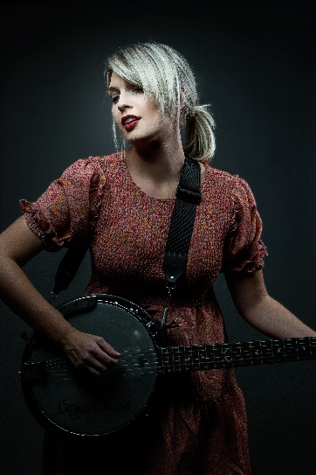
Reputation is a Dallas-based tribute band comprised of five hardcore Swifties that bring you non-stop Taylor Swift hits all night long. With her distinct style, legendary catalog of music, and a stage presence like no other, it’s easy to see why Swift is one of the most successful and influential artists of the 21st century. Since the beginning of her career, she has sold out venues worldwide and has managed to connect fans through her incredible storytelling.

- May 20 ─ Big Swing and The Ballroom Blasters (Earth, Wind, & Fire Tribute)
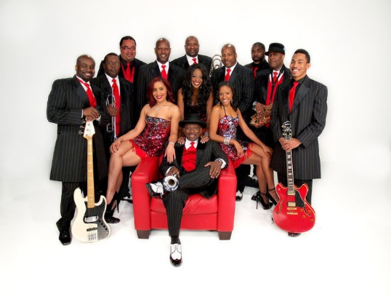
Big Swing and the Ballroom Blasters, the country's newest "oldest" sound, features high-energy performances of swing, jazz, soul, Motown, rock, and pop.

