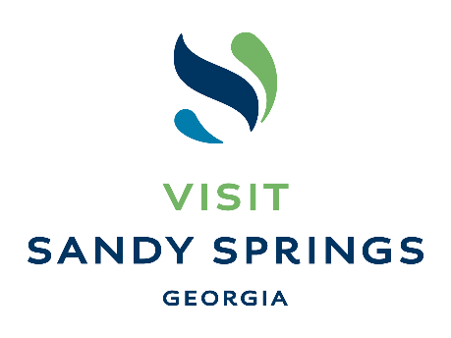

Visit Sandy Springs Launches Dine Like a Local Program
From January to March Enjoy the City’s Electric Dining Scene & Win Prizes with New Digital Passport, Featuring 21 Not-To-Be-Missed Restaurants

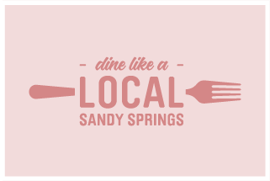
SANDY SPRINGS, Ga. – December 29, 2022 – Visit Sandy Springs, the destination marketing organization (DMO) for the thriving city that borders Northern Atlanta, today announced the launch of its new Dine Like a Local program. Those who sign up online will lock in their free digital passport, which will serve as an insider’s guide to the Sandy Springs dining scene. Then, from January 2 through March 31, diners will have the opportunity to curate and track their dining experiences, along with a chance to win a variety of prizes for participating.

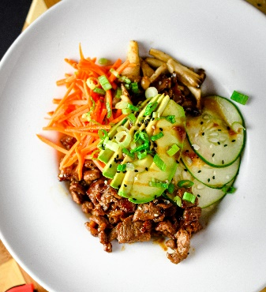
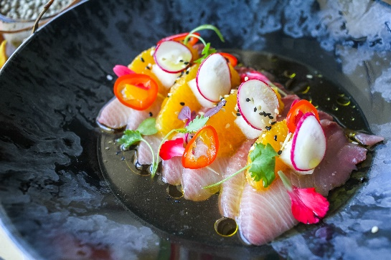
"We are thrilled to launch the Dine Like a Local passport and invite all foodies to experience the exquisite dining scene in Sandy Springs,” said Jennifer Cruce, Executive Director at Visit Sandy Springs. “This three-month long celebration is sure to tantalize the tastebuds and intrigue even the pickiest palates. Our goal was to create a fun way for residents and visitors alike to explore the delicious and diverse culinary offerings of Sandy Springs while also supporting our vibrant restaurant community, and this was the perfect opportunity to do that."

Anyone can sign up for the free digital passport program online at VisitSandySprings.com/DineLikeALocal. Powered by technology company Bandwango, the passport features 21 local restaurants and showcases the best of Sandy Springs dining in an easy, convenient way. The passport also features a bucket list of two to three signature dish recommendations from each participating restaurant.

Throughout the Dine Like a Local initiative, participating diners will earn points by checking into restaurants, and can spend those points on entries into the following giveaways from Visit Sandy Springs:

- Tier 1: Bi-Weekly Giveaways (Costs 100 points per entry for the pass user)
  - 21 $25 gift cards, one for each participating restaurant, to be randomly awarded to three participants every other week.
- Tier 2: Monthly Giveaways (Costs 200 points per entry for the pass user)
  - Three prizes each valued at roughly $150, to be randomly awarded to one participant each month.
- Tier 3: Grand Prize Giveaway (Costs 300 points per entry for the pass user)
  - One grand prize valued at roughly $400, to be randomly awarded at the end of the campaign to one participant.

Sandy Springs' dining scene has become a renowned foodie paradise, with more than 100 locally owned restaurants. A few of the restaurants participating in the Dine Like a Local program include The Select Restaurant + Bar, il Giallo Osteria & Bar, Battle and Brew, and The General Muir. For a full list of participating restaurants, click here.

Those who wish to participate can sign up at www.VisitSandySprings.org/DineLikeALocal by providing their name, e-mail address and mobile phone number. A link is then sent to their mobile phone, which opens the passport and directs the user to add the passport icon to their home screen, where they can access it any time.

For more information, visit www.VisitSandySprings.org. Stay up-to-date on the latest Sandy Spring news by following @VisitSandySprings on Facebook, Instagram and Twitter. Diners can share their experience on social media using #DLALSandySprings.

About Visit Sandy Springs
Visit Sandy Springs is the Destination Marketing Organization for the city of Sandy Springs, Georgia. Bordered by Atlanta to the south and the Chattahoochee River to the north, Sandy Springs offers the perfect mix of city life and outdoor adventure. Stay in one of the city’s 21 hotels, and enjoy its celebrated dining scene, 950 acres of parks and greenspace, 22 miles of Chattahoochee River shoreline, and convenient access to downtown and metro Atlanta attractions.

About City of Sandy Springs Economic Development Department
Sandy Springs is Georgia’s seventh largest city. The City’s Economic Development Department is a resource to all who are currently operating a business in the city and is positioned to help businesses of all sizes locate, start, and grow in Sandy Springs.

# # #

Media Contact
Cameron Trice, Hemsworth Communications
770-286-2207 | VisitSandySpringsPR@hemsworthcommunications.com

