

**DENVER ARCHITECTURE AND DESIGN**

Denver truly offers something for everyone, including architecture aficionados. The city was founded in 1858 and what started as a collection of humble cabins during the Gold Rush era has morphed into one of the most impressive and innovative city skylines in the country. Learn more about some of Denver’s most striking architecture [**here**](https://www.denver.org/blog/post/architecture-tour/).

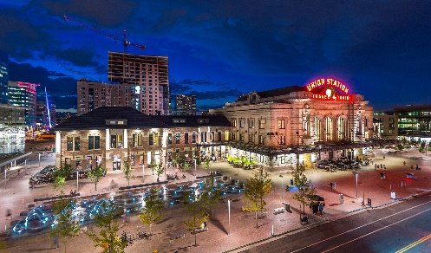[**DENVER UNION STATION**](https://www.denver.org/things-to-do/attractions/union-station/) is the heat of the city. It was built in 1881 and has undergone renovations in 1914 and most recently in 2010. Denver Union Station was designed by D.H. Burnham & Co. in the ornate Beaux-Arts style made famous in 19th century Paris, with terrazzo floors and a Columbine motif on the borders of the interior. As railway travel waned, the building fell into disrepair, but with the recent revitalization of downtown and a major renovation from 2010-14, Union Station is once again a hub for the city. In addition to traditional rail lines, Union Station also serves as a bus and light rail station, and is home to numerous bars, restaurants, shops and the [Crawford Hotel](https://www.thecrawfordhotel.com/).

[*Photo*](https://jwadepr.app.box.com/s/n2kafxsmjwa5j7aq7v6fv0z0gbbdl2au/folder/196183594568) *Credit: VISIT DENVER & Scott Dressel-Martin*

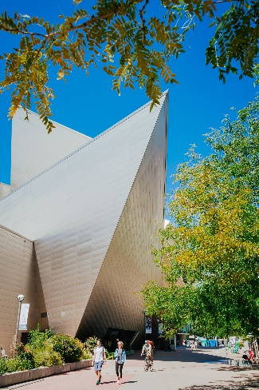[**FREDERIC C. HAMILTON BUILDING AT THE DENVER ART MUSEUM**](https://www.denver.org/listing/denver-art-museum/3817/) isa postmodern, deconstructivism work of art in and of itself. Architect Daniel Libeskind designed the building with 9,000 titanium panels covering its exterior, explaining that he was “inspired by the light and the geology of the Rockies, but most of all by the wide-open faces of the people of Denver.” The Hamilton Building was Libeskind’s first completed building in the United States, but he went on to oversee the rebuilding of the World Trade Center site in New York City.

[*Photo*](https://jwadepr.app.box.com/s/n2kafxsmjwa5j7aq7v6fv0z0gbbdl2au/folder/196183594568) *Credit: VISIT DENVER & TruBlu Images*

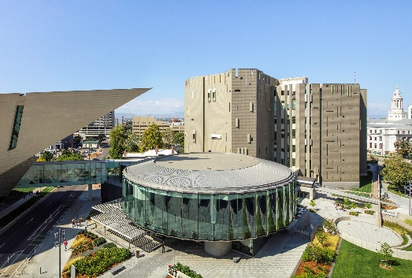The Denver Art Museum also recently expanded and reimagined its campus in 2021 which included the [**LANNY & SHARON MARTIN BUILDING**](https://www.denverartmuseum.org/en/martin-building-project). The building was designed by Italian architect Gio Ponti Denver-based James Sudler Associates. The Martin Building first opened in 1971. Its seven-story silhouette is one of the first-ever high-rise art museums and is the only completed building in North America by the renowned Italian modernist Gio Ponti.

[*Photo*](https://jwadepr.app.box.com/s/n2kafxsmjwa5j7aq7v6fv0z0gbbdl2au/folder/196183594568) *Credit: VISIT DENVER & James Florio*

[**COLORADO STATE CAPITOL**](https://www.denver.org/listing/colorado-state-capitol/3679/)was designed by Elijah E. Myers and completed in 1894. The Colorado State Capitol was meant to mirror the look of the U.S. Capitol Building in Washington, D.C., but the building is also an ode to all things Colorado. The glittering, exterior dome is gilded with gold from a Colorado mine, commemorating the Colorado Gold Rush that originally brought settlers to the area. The wainscoting and column plinths inside the building were made from what is believed to be the entire supply of Colorado Rose Onyx, a rare, rose-colored marble from Beulah, Colorado. White Yule Marble, the state rock of Colorado, was used throughout the building for the floors.

[*Photo*](https://jwadepr.app.box.com/s/n2kafxsmjwa5j7aq7v6fv0z0gbbdl2au/folder/196183594568) *Credit: VISIT DENVER & TruBlu Images*

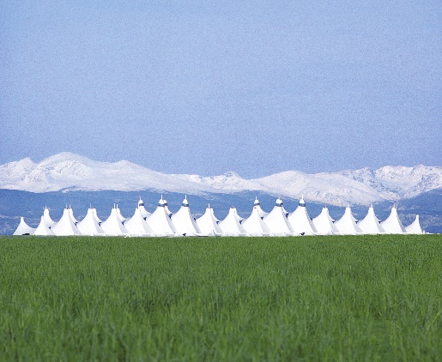[**DENVER INTERNATIONAL AIRPORT**](https://www.flydenver.com/) **(DIA)** is the 3rd busiest airport in the United States with nearly 70 million travelers each year. Fentress Architects reportedly had only three weeks to create the terminal’s conceptual design, but they still managed to produce one of the world’s most innovative, efficient and visually stunning airports. Built in 1995, DEN boasts the largest structurally integrated tensile-membrane roof in the world, with white peaks that rise 130 to 150 feet into the air, meant to mimic the snowy peaks of the Rocky Mountains. To achieve this canopy-like structure, the architects relocated the building’s mechanical infrastructure from the roof to underground, inverting traditional building design and eliminating the need for thousands of pounds of structural steel and building materials. The airport also features nearly 40 site-specific works of art, including sculptures, murals and other installations. The pieces are displayed on the grounds outside, inside Jeppesen Terminal, on concourses, in the train tunnels and on the trains themselves. DIA is currently undergoing a $1.8 billion redesign and expansion of its Great Hall that will relocate and enhance security, make capacity and infrastructure improvements and add new retail and amenities.

[*Photo*](https://jwadepr.app.box.com/s/n2kafxsmjwa5j7aq7v6fv0z0gbbdl2au/folder/196183594568) *Credit: VISIT DENVER*

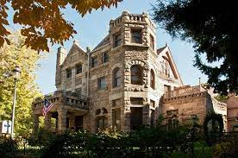[**CASTLE MARNE**](https://www.denver.org/blog/post/architecture-tour/)is an honest-to-goodness castle in the middle of Denver! Built in 1889 by architect William Lang, Castle Marne sits on the corner of 16th and Race Streets in the historic Capitol Hill neighborhood. Lang designed and built more than 300 homes in Denver during the Victorian Era, including the famed Molly Brown House Museum, many in similar Queen Anne and Richardsonian Romanesque styles. In 1988, the building was purchased by the Peiker family, who lovingly restored and renovated it, opening Castle Marne Bed and Breakfast on the 100th anniversary of the construction of the house.

[*Photo*](https://jwadepr.app.box.com/s/n2kafxsmjwa5j7aq7v6fv0z0gbbdl2au/folder/196183594568) *Credit: Trip Advisor*

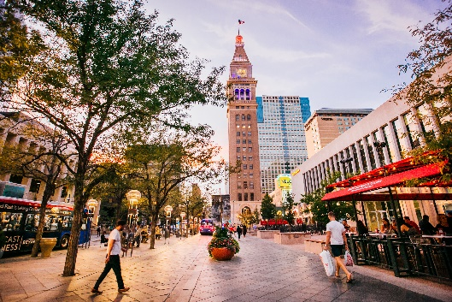[**DANIELS & FISHER TOWER**](https://www.denver.org/blog/post/architecture-tour/)was built in 1911 and was the tallest structure west of the Mississippi. It was built by architect F. G. Sterner, the Daniels & Fisher Tower reaches 393 feet into the sky as part of the Daniels and Fisher Department Store. The store itself was demolished in the 1970s, but the Italian Renaissance-style clock tower, constructed from brick, stone and terracotta, remains. Over the years, the tower, located on the popular 16th Street Mall, has become a Denver landmark and has earned a spot on the National Register of Historic Places. It’s now home to office space, an event venue on the top floors and the Clocktower Cabaret in the basement**.**

[*Photo*](https://jwadepr.app.box.com/s/n2kafxsmjwa5j7aq7v6fv0z0gbbdl2au/folder/196183594568) *Credit: VISIT DENVER & TruBlu Images*

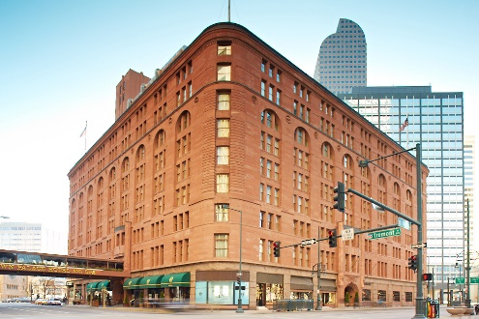[**DENVER’S BROWN PALACE**](https://www.marriott.com/en-us/hotels/denak-the-brown-palace-hotel-and-spa-autograph-collection/overview/?scid=f2ae0541-1279-4f24-b197-a979c79310b0) was built in 1892 to accommodate the brave who were flocking west in search of precious metals. The Brown Palace is pure gold, from its distinctive triangular shape to its soaring eight-story-high atrium, and because almost every president since 1905 has paid a visit (it has three commander-in-chief-sized suites). The six on-site restaurants utilize honey supplied by the rooftop beehives, and the artesian water comes from the hotel’s own well.

[*Photo*](https://jwadepr.app.box.com/s/n2kafxsmjwa5j7aq7v6fv0z0gbbdl2au/folder/196183594568) *Credit: VISIT DENVER*

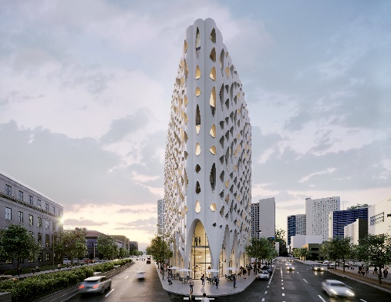**COMING SOON –** [**POPULUS AT CIVIC CENTER PARK**](https://studiogang.com/project/Populus)will be the firstcarbon positive hotel in the United States. Developed by Urban Villages, a leading real estate developer and environmental steward, the 265-room hotel will feature a rooftop restaurant and bar offering spectacular views of the mountains and city skyline, distinct retail destinations and event spaces, and an iconic Aspen tree-inspired design by AD100 architecture firm, Studio Gang. Populus will open in Denver in early 2024 and will serve as an architectural landmark and milestone for sustainable travel.

[*Photo*](https://jwadepr.app.box.com/s/n2kafxsmjwa5j7aq7v6fv0z0gbbdl2au/folder/196183594568) *Credit: Studio Gang*