Don’t Miss It: The Solar Eclipse in Rockford
During the afternoon of Monday, April 8th, a solar eclipse will be visible across North America. The moon will pass directly between the Earth and the sun, and its shadow will give the illusion of dusk falling in the middle of the day!

Even though the moon is constantly circling the Earth (it actually comes between the Earth and the sun every month), solar eclipses are very rare. This is because the moon’s path is slightly tilted relative to Earth’s orbit around the sun. Usually, the moon passes either above or below Earth, so it doesn’t impede Earth’s view of the sun. During solar eclipses, however, the moon is perfectly aligned between Earth and the sun, and its shadow produces the amazing phenomenon we experience during the eclipse.

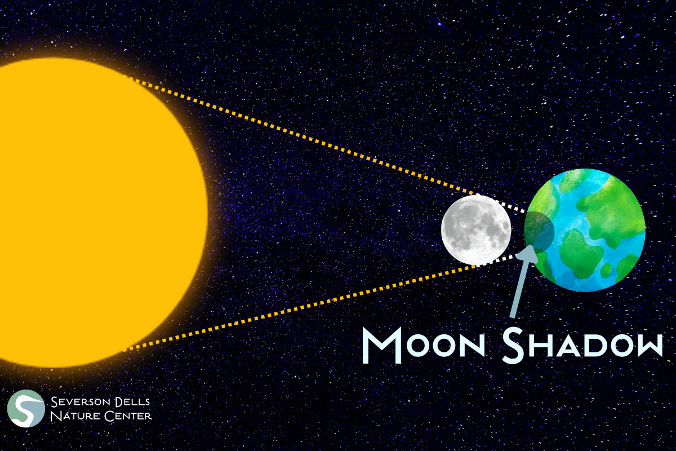

The direct path of the eclipse will pass through southern Illinois, so places like Carbondale will experience full coverage of the sun for about four minutes. Here in Rockford, we will see the partial solar eclipse, meaning the moon will never entirely cover the sun from our point of view. Even so, we are close enough to the direct path that we will witness about 90% of the sun being covered, so we can expect to notice a significant darkening of the sky. For northern Illinois, the eclipse will begin around 12:50 PM, peak at 2:05 PM, and conclude by 3:20 that afternoon.

If you’re planning to watch the eclipse on April 8th, there are a few safety measures to keep in mind. First off, since northern Illinois will not experience a total eclipse, it will never be safe to look at the sun without eclipse-approved eyewear. Sunglasses, telescopes, and binoculars will not protect your eyes from the sun’s UV light, so unless you have access to eclipse glasses, keep your gaze away from the sun. Additionally, if you happen to be driving during the peak eclipse, make sure you’re using your headlights.

The last time our area was treated with a solar eclipse was in August of 2017, and we won’t see another until 2044, so if you can, try to get outside and make the most of this incredible experience! To learn more about solar eclipses, check out the Discovery Center’s Solar Eclipse Preview on April 6th and the Solar Eclipse Experience hosted by Nature at the Confluence, South Beloit Public Library, and Welty Environmental Center on the 7th! If you’re looking for a place to observe the event itself, Byron Forest Preserve District and Boone County Conservation District are hosting viewing parties!
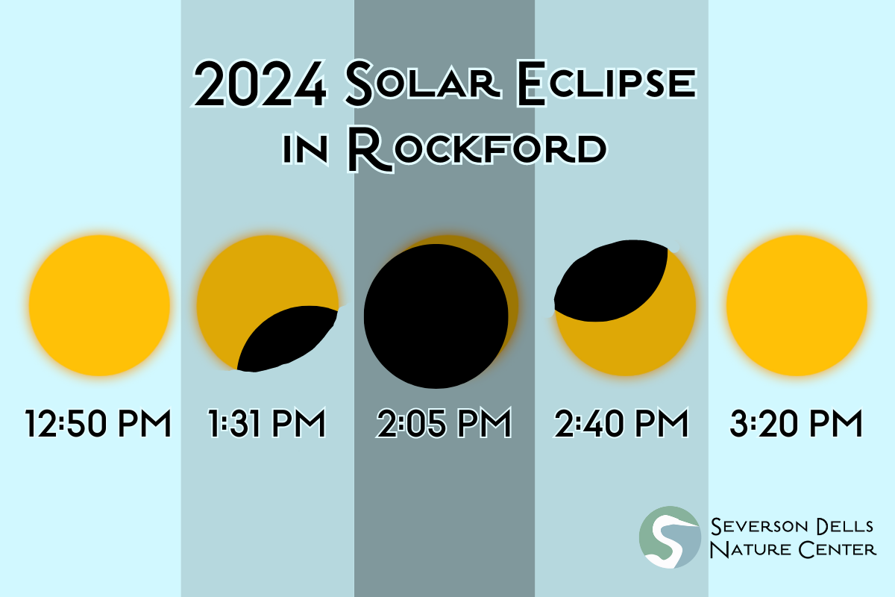

This blog was authored by Jillian Neece, Natural Resources AmeriCorps member with Severson Dells Nature Center. Severson Dells is a non-profit nature education center in Rockford, IL. For more information on Severson Dells’ programs and activities, visit SeversonDells.org.

