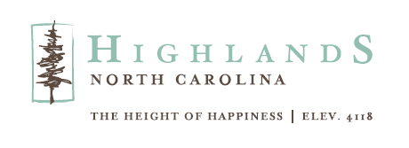
HIGHLANDS CHAMBER OF COMMERCE PARTNERS WITH
THE TOWN OF HIGHLANDS TO REVITALIZE DOG PARK
HIGHLANDS, NC, April 24, 2024 – The Highlands Chamber of Commerce/Visit Highlands, NC and the Town of Highlands announce collaborative project to revitalize the Highlands Dog Park. This joint effort, paid for by Visit Highlands, NC funds, will focus on enhancing the park's aesthetics to provide a better experience for residents and visitors and their canine companions.

The project aims to address feedback from park users. The drainage improvements will ensure the park remains dry and safe even after rainfall, while the expanded area around the pavilion will offer additional space for relaxation and socializing. New lawn areas will create a more comfortable environment for both dogs and their owners. Moreover, repairs will be made to fencing and an additional entrance will be added from the upper parking area.

“The Town of Highlands is pleased to work with the Highlands Chamber of Commerce to enhance the Dog Park,” says Jeff Weller, Town Commissioner. “We know this park is a favorite destination in our community, and we look forward to the positive impact these updates will have.”

Work by Tate Landscaping Services, Inc. is scheduled to run from April 29 through May 3, during which time the Dog Park will be closed.

“We appreciate the community's patience and support during the process,” says Kaye McHan, executive director, Highlands Chamber of Commerce/Visit Highlands, NC. “Once completed, the updated Highlands Dog Park will offer an even more welcoming and safe space for all who visit.”

For more information about the Highlands Dog Park project or to learn more about the Highlands Chamber of Commerce/Visit Highlands, NC call 828-526-5841 or visit www.highlandschamber.org.
###
About the Highlands Chamber of Commerce/Visit Highlands, NC:
Formed in 1931 to serve as the voice of business, the Highlands Chamber of Commerce has grown to provide services and support to businesses, residents and visitors. Hosting various events and programs throughout the year, including the Plateau Pick-Up, Leadership Highlands, Business After Hours, Outdoor Concert Series, and July 4th Fireworks and an array of holiday and winter festivities, the Chamber strives to make Highlands, NC a better place to live, visit and conduct business.

MEDIA CONTACT: Johanna Fein
Marketing and Communications Director
communications@highlandschamber.org
828-526-5841

