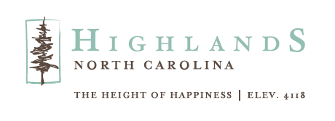
MONKEE’S OF HIGHLANDS TO KICK OFF GRAND OPENING
WITH RIBBON CUTTING
Upscale Women’s Boutique Opening on Main Street
HIGHLANDS, NC, April 26, 2024 – The Highlands Chamber of Commerce will host a traditional ribbon cutting ceremony at Monkee’s of Highlands on Friday, May 10. The event is free and open to the public and will take place at 10am at 383 Main Street, Highlands.

Monkee's of Highlands will offer upscale women's apparel as well as a wide selection of shoes and accessories from leading fashion designers and brands.

“We are pleased to expand our presence on Main Street with the launch of Monkee’s of Highlands,” says Vance Wood, Managing Partner. “Building on the success of our existing store, Elena’s Activewear and Golf, we look forward to introducing a fresh array of brands and options to cater to the diverse tastes of Highlands shoppers.”

“It's impressive to see local business owners bringing new ideas and energy to our community,” notes Kaye McHan, Executive Director of Highlands Chamber of Commerce/Visit Highlands, NC. “Their efforts reflect the strong appeal Highlands holds for businesses looking to thrive.”

Operating hours for Monkee’s of Highlands will be Monday–Saturday from 10 am to 5 pm, and Sunday from 12 pm to 5 pm. For more information call 828-482-5140, visit their website monkeesofhighlands.com.

To learn more about the Highlands Chamber of Commerce/Visit Highlands, NC call 828-526-5841 or go to highlandschamber.org.
###
About the Highlands Chamber of Commerce/Visit Highlands, NC:
Formed in 1931 to serve as the voice of business, the Highlands Chamber of Commerce has grown to provide services and support to businesses, residents and visitors. Hosting various events and programs throughout the year, including the Plateau Pick-Up, Leadership Highlands, Business After Hours, Outdoor Concert Series, and July 4th Fireworks and an array of holiday and winter festivities, the Chamber strives to make Highlands, NC a better place to live, visit and conduct business.

MEDIA CONTACT: Johanna Fein
Marketing and Communications Director
communications@highlandschamber.org
828-526-5841

