Farmer’s Markets and Summer Farm Experiences in the Rockford Region

Summer is the best time of year for fresh fruits and vegetables and shopping hand crafted items in the Rockford region. In addition to produce, many of these markets offer unique crafted items, baked goods, home goods and more. The colorful vegetables and delectable fruits make for beautiful grazing boards or elevate any summer grilling. What’s better than fresh sweet corn blackening on the grill? These locations are where you can find fresh items multiple days a week. Some of these amazing markets are open until September and October. There’s also places to visit if you want to pick fresh fruit or get a donut.

Wednesdays
Edgebrook Farmers Market | 1639 N. Alpine Road Rockford, IL 61107
Edgebrook Farmers Market is every Wednesday from 9 a.m. to 1 p.m. from early May to late October. This is one of Rockford longest running farmer’s market. Vendors include fresh fruit, vegetables, flowers, plants, baked goods and food trucks. After shopping at the market, walk around Edgebrook and check out their many shops and restaurants.
https://edgebrookshops.com/events/farmers-market/
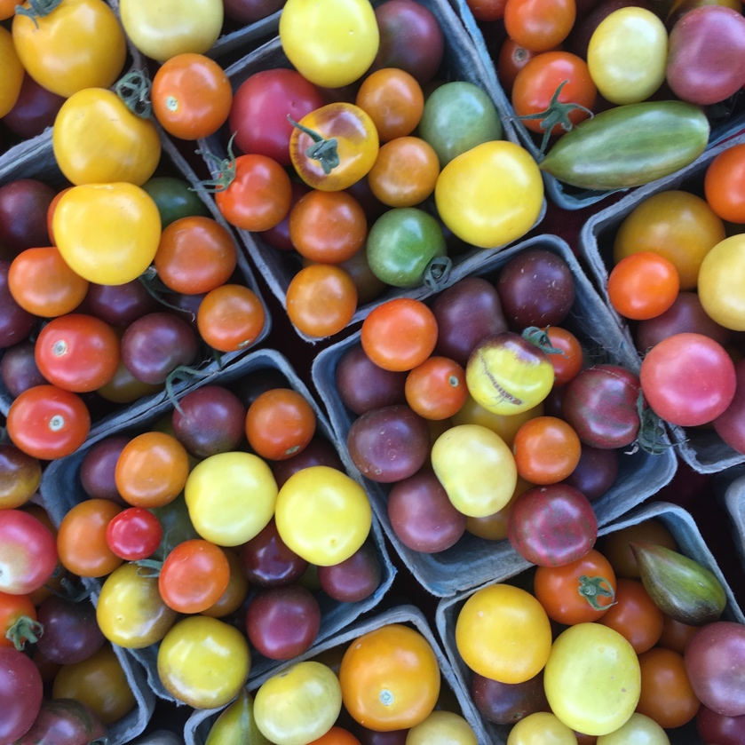

Rockton River Market Settlers Park | 150 E. Hawick St. Rockton, IL 61072
From late May to early September, the Rockton River Market is the place to be on Wednesday evenings. The market is held from 5 p.m. to 8 p.m. Bring a chair and listen to the sweet sounds of summer. Vendors are available to purchase food, beverages and more. Fresh brews are available as well as delicious ice cream.
RocktonRiverMarket
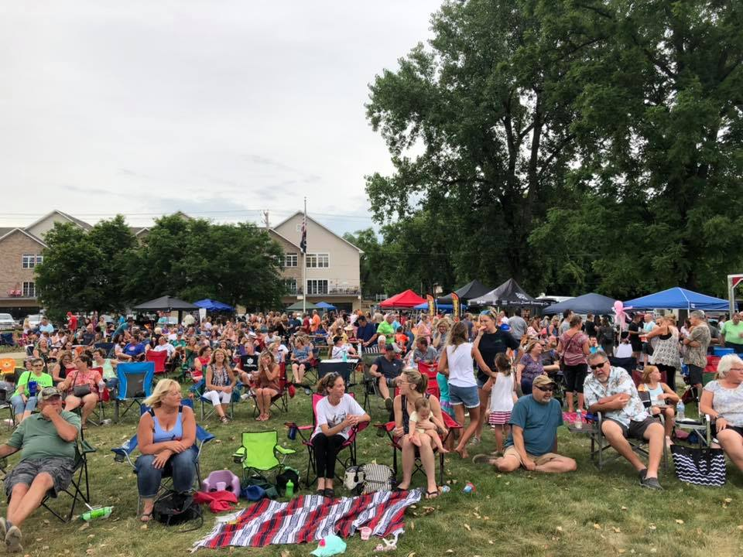

Thursdays
Rockford Midtown Market | 502 Seventh Street Rockford, IL 61104
Starting in June until August, Rockford Midtown Market is the place to grab some lunch and produce. The market is open from 9 a.m. – 1 p.m. and shoppers can find ethnic food, fruits, vegetables, coffee, and kid’s activities. Plus, several local shops and restaurants are nearby.

Fridays
Forest City Farmer’s Market | 1280 S. Alpine Rd. Rockford, IL 61108
Every Friday from 9 a.m. – 1 p.m. at the Forest City Farmer’s Market shoppers will find a selection of fruits, vegetables, baked goods, handmade jewelry, cheese, honey and more. The market is held from May to October. After shopping grab a coffee or pastry from Banana Cherry Bakery or some chocolate from The Little Chocolatier.

Rockford City Market | Water Street and E. State Street Rockford, IL 61104
The Rockford City Market is held every Friday from May to late September. There are over 70 vendors at the market to provide an array of hand-crafted products, baked goods and local growers. Try cuisine from a variety of food trucks and pair with a fresh brew from a local brewery. Live music and socializing with friends make the market the place to be every Friday. Open from 4 – 8:30 p.m. until Labor Day and 4 – 7:30 p.m. after Labor Day.
Winnebago Farmers Market | N Elida Street & Bluff Street Winnebago, IL 61088
A variety of vendors flock to the Winnebago Farmers market held May through October from 3:30 p.m. – 7 p.m. Woodworkers, soap makers, sewers and growers make this a fun stop on a Friday afternoon. After shopping, try an ice cream flight at the Scoop.

Saturdays
North End City Market | North Main and Auburn Rockford, IL 61103
One of Rockford’s longest running farmer’s markets, the North End Market is a weekly market open 8 a.m. – Noon. The market touts a variety of vendors selling hand-crafted items, baked goods, vegetables, fruits, and more. Plus, the market is close by to several restaurants to grab breakfast or lunch. Enjoy this market from May to mid-October.

Pecatonica Farmers Market 4th & Main, Pecatonica, IL. 61063
Head to Pecatonica every Saturday from 8 a.m. to Noon to pick up baked goods, flowers, fresh fruit, vegetables, and more. Rosie’s Coffee Company is across the street to fuel your shopping experience. Pecatonica Farmers Market is held Memorial Day to Labor Day.

Other Farm Experiences in the Region

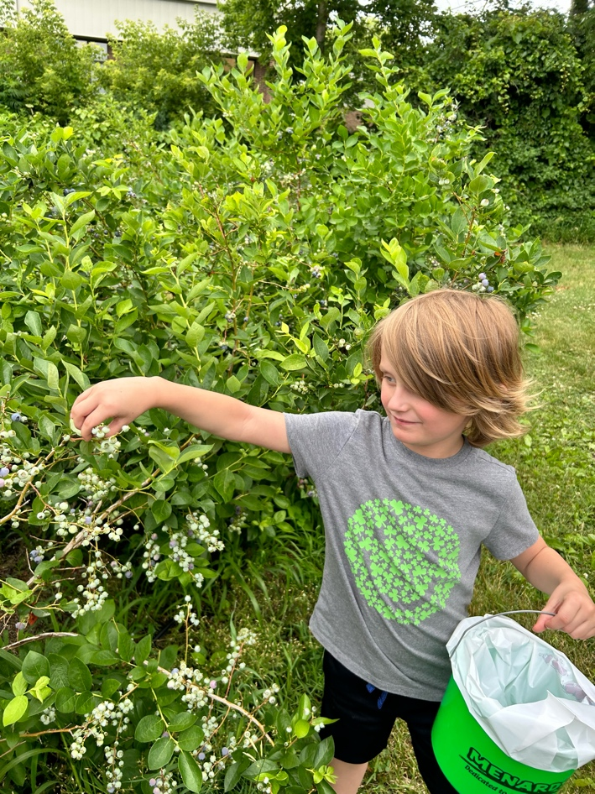
Curran’s Orchard | 6385 Kilburn Avenue Rockford, IL. 61101
Curran’s Orchard is not just a visit for the fall. Their summer hours are Fridays from 1-6 p.m. and Saturdays from 9 a.m. – 1 p.m. Pick up apple, cherry, or lemon donuts and try an apple cider slushie. Their outdoor farm is open for kids to play. Also available is gluten free muffins and gift items.

Valley Orchard | 811 East State Street Cherry Valley, IL. 61016
Valley Orchard has summer fruit picking that makes for a fun afternoon. Depending on the month, they have cherries, raspberries, blueberries, and blackberries available. Check their Facebook page for you pick updates and open times. (Pictured)

Ox Berry Farm | 2820 Yale Bridge Road South Beloit, IL 61080
Ox Berry Farm is a unique location to pick fresh blueberries in the summer. The beautiful farm also sells beeswax candles.

Gretta’s Goats | 498 N Farwell Bridge Rd, Pecatonica, IL 61063
Gretta’s Goats offers a unique encounter with goats including baby goat cuddle sessions in the Spring and goat hikes throughout the year. They offer soap or cheese making classes. Soap and farmstead goat cheese are available for purchase.

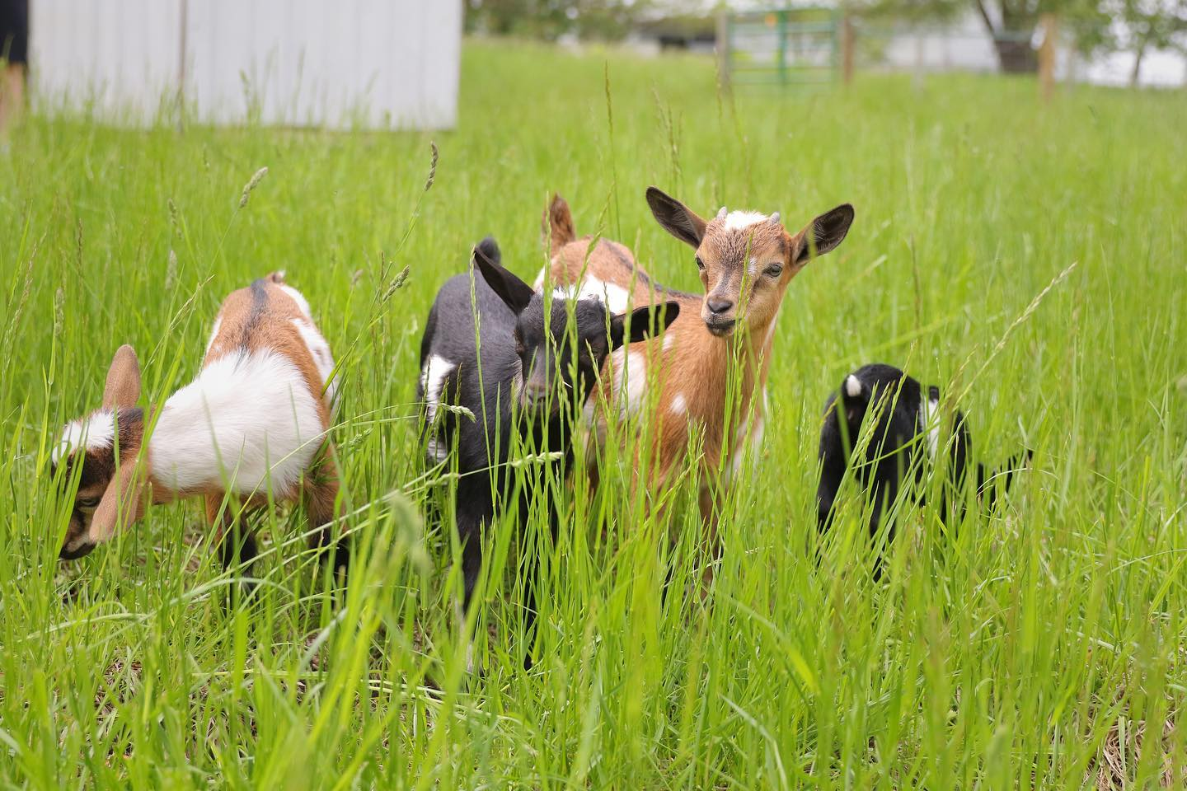

Sweet Corn Stands
Summer is the best time for sweet corn. Many local farmer’s markets sell sweet corn, but there are also sweet corn stands throughout the region. Check out Blackmer Sweet Corn in Cherry Valley, another stand 20th and Samuelson Road in Rockford, and Dorn’s Sweet Corn in Winnebago off of Highway 20.

